Logging on to Oxford Owl to access all of the decodable books to support your child’s reading at home.
Access the website at www.oxfordowl.co.uk
Click the student tab
Sign in using
Username: EatonClass
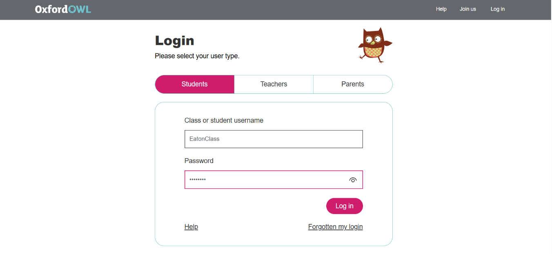
Password: Eaton123
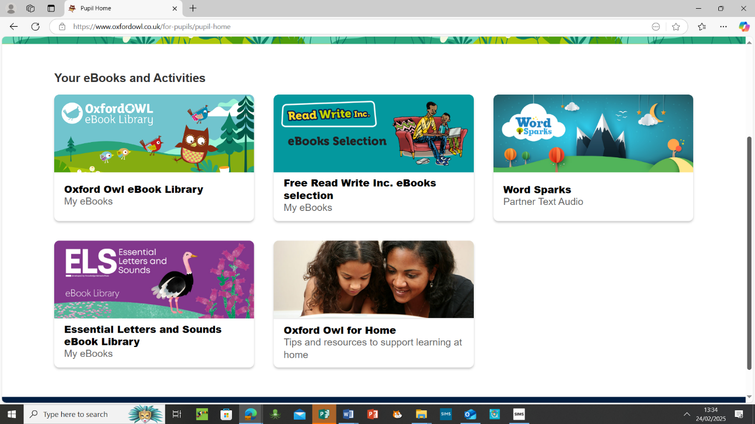
Below are links to books that will support your child’s reading.
If you click the Essential Letters and Sounds eBook Library this will give you access to all the decodable books we send home to read. As well as accessing other schemes too.

