Questions to ask your child when reading – Key Stage 2 Before reading the book:
- What do you think this story will be about?
- What might happen in the story?
- What genre will this story be? E.g. fantasy, comedy, horror.
- What do we call the writing on the back of the book? (Blurb) or What does the blurb tell us?
During the reading of the book:
- What has happened so far? Is it what you expected to happen?
- What might happen next?
- How do you think the story might end?
- Who is your favourite character? Why?
- Who is the character you like least? Why?
- Find 2 sentences, which describe the setting.
- Is the plot fast or slow moving? Find some evidence in the text, which supports your view.
•
Questions to ask your child when reading – Key Stage 2 At the end of the book:
- Which part of the story is your favourite / least favourite? Why?
- Would you change any part of the story? How?
- Would you change any of the characters? How?
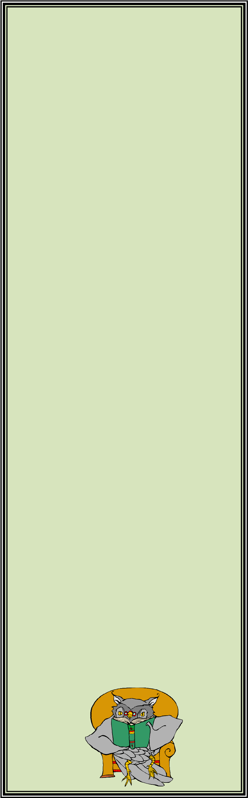
- Which part of the story was the funniest, scariest, saddest, and happiest? Find some evidence in the text to support your opinion.
- Would you like to read another book by this author? Why?
- Does your opinion of this character change during the story? How? Why?
- If you met one of the characters from the story, what would you say to him / her?
- Find 2 things the author wrote about this character that made him / her likeable or unlikeable?

