Holy Cross Catholic Primary School
Year 4 Autumn Curriculum
Subject & web link | Key teaching
  RE Curriculum | All teachings will reflect our Catholic ethos. Children will also take part in daily collective worship.  Come and See topics for Autumn will be People, Called and Gift.
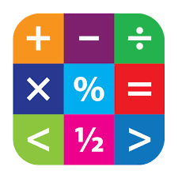  Maths Curriculum | In Autumn term Year 4 will be covering; Place Value, Addition, subtraction, Measurement, Multiplication and Division.
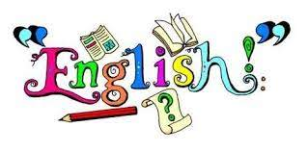  English Curriculum | Reading:  A World Full of Animal Stories by Angela McAllister – 50 Folktales and Legends​  Writing:  The Whale by Ethan and Vita Murrow. Outcome 1 – Setting narrative Outcome 2 Newspaper report.  Leaf by Sandra Dieckmann . Outcome 1 – Narrative. Outcome 2 – Information text
  PSHE Curriculum  RSHE | No Outsiders: To help someone accept difference.  One Decision: Cycle Safety  PATHS  A Journey in Love: Social and Emotional
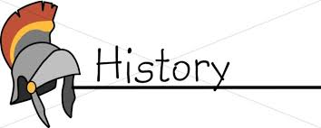  History Curriculum | Anglo Saxons
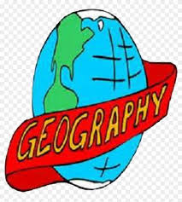  Geography Curriculum | Mountains
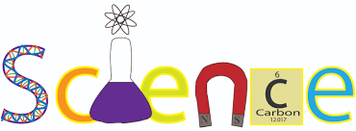  Science Curriculum | Living things  Electricity
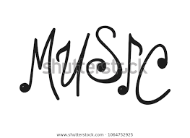  Music Curriculum | Unit 1 – Musical structures  Unit 2 – Exploring feelings
  Computing Curriculum | Online detectives  Dancing robots
  Art and Design Curriculum | Painting Landscapes  Artist – Claude Monet
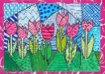    Design Technology Curriculum | Electrical Systems
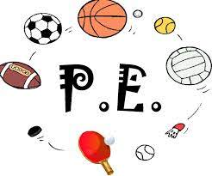  PE Curriculum | Athletics, Football, Gymnastics and Circuits
Spanish  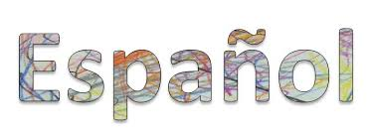 | Descriptions or hair and eyes  Big green Monster Story  Brothers and sisters  School subjects  Simple opinions  Time
Enrichment | Black History Month, International Day of Peace, International Day of Democracy, Remembrance Day, Anti-Bullying Week, Road safety week, Human Rights Day, Christmas performance

