Friday 26th February 2021 | 
Can I describe what lives in a desert habitat?
✍ How would you describe a desert?
Deserts are _______________________________________________________
_________________________________________________________________
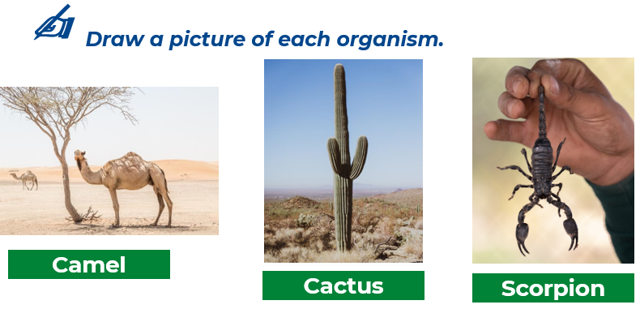
Picture
_______________________________________________________
_______________________________________________________
_______________________________________________________
_______________________________________________________
_______________________________________________________
_______________________________________________________
_______________________________________________________
_______________________________________________________
_______________________________________________________
_______________________________________________________
_______________________________________________________
_______________________________________________________
_______________________________________________________
_______________________________________________________
_______________________________________________________
_______________________________________________________
_______________________________________________________
_______________________________________________________

