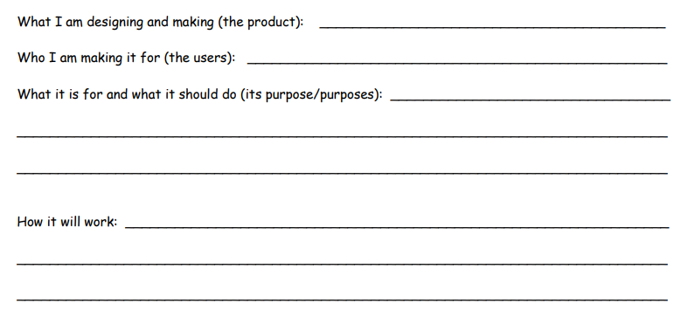
The Curiosity Shop –
My Product

