
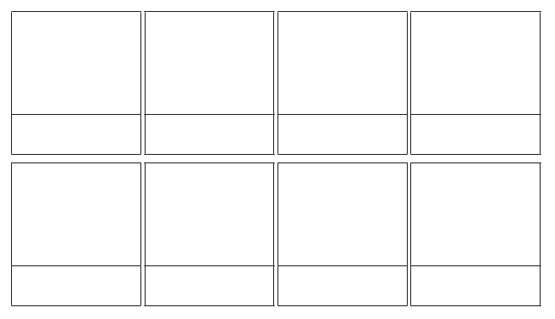
Create a scene explaining how we can stay safe online. You might want to include characters and speech bubbles to help you.
How to Stay Safe Online:

