Year 6  Toucans  Week beg. 22nd June | Before 9:00am | 9:00 – 10:00 | 10:00-11:00 | 11:00-12:00 | Lunchtime – 12:00 -12.30 | 12:30 – 1.00 | 1:00 – 2:00 | 2:00 – 3:15 | 3.15 – 4:00
Monday | Eat breakfast, make your bed, get washed and dressed, any laundry in the basket. | Family walk with the dog (if you have got one!)  Five-day/indoor exercises/indoor yoga or other exercise if wet.  https://www.youtube.com/user/CosmicKidsYoga  https://www.gonoodle.com/  https://www.nhs.uk/10-minute-shake-up/shake-ups  www.5-a-day.tv USERNAME: 5-a-dayAtHome PASSWORD: AtHome123 | Work from the packs that have been sent home/CGP books/First4Maths activities/fluency grids/any specified work from the daily blog  TT Rock Stars - https://play.ttrockstars.com/auth/school  White Rose Maths https://whiterosemaths.com/homelearning  I See Reasoning lessons http://www.iseemaths.com/home-lessons/ | Creative Time – Lego, drawing, crafting, music, cooking, baking, coding, painting.  coding - https://www.scratchjr.org/ https://code.org/  Ted Ed https://ed.ted.com All sorts of engaging educational videos.  Blockly https://blockly.games Learn computer programming skills - fun and free. | Lunchtime – 12:00 -12.30 | Tidy Time – Wipe down kitchen table and chairs, wash and dry kitchen dishes, tidy bedroom and lounge | Quiet Time – Reading, Puzzles, Nap (No Electronics) | Languages/Art  German Website: www.atantot.com User name: lostockgralam Pass: 1443 | Afternoon Fresh Air – Bike, Walk the dog, play outside. Have a go at some of the active challenges https://www.youthsporttrust.org/pe-home-learning  https://www.youthsporttrust.org/60-second-physical-activity-challenges  https://www.youthsporttrust.org/active-learning
Tuesday |  |  |  |  |  |  |  | Science/PSHCE  https://mysteryscience.com/
Wednesday |  |  |  |  |  |  |  | History/Geography
Thursday |  |  |  |  |  |  |  | Science  https://mysteryscience.com/
Friday |  |  |  |  |  |  |  | RE/Geography

Home Learning – this timetable is intended as a guide to support learning at home during a prolonged period of school closure. We appreciate that you will have differing demands on your time but hope that this helps in continuing ‘a love learning’ at home. We will also be updating the class blog daily with any specific activities that you can do each day and further resources that you may need.
Mrs Downing & Mrs Whittingham
If you have issues with usernames and passwords, please contact admin@lostockgralam.cheshire.sch.uk
Monday | Art/Geography – Spirit of the Rainforest  Continuing with our South American project work, today you will explore rainforest wildlife.  Take your time to work through the attached slides, answering the questions and learning the facts as you go.  This links nicely with our Science work on adaptations.  In Art you will learn about tone and texture and then have a go at drawing some of the rainforest wildlife. |  | 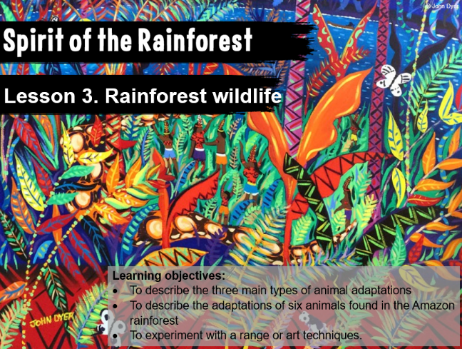
Tuesday | PSHCE - Transition  Today I would like you to continue looking at the Transition videos on the BBC website. Focus on the ‘Getting Lost’ and ‘Favourite Things’.  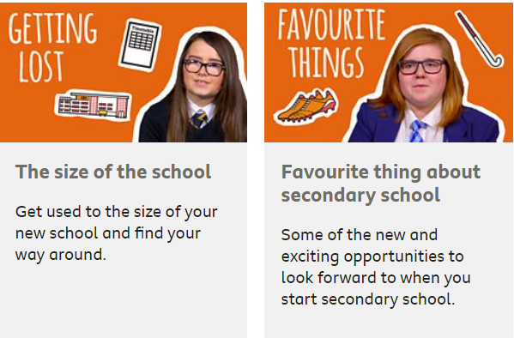  https://www.bbc.co.uk/bitesize/tags/zh4wy9q/starting-secondary-school/1 | 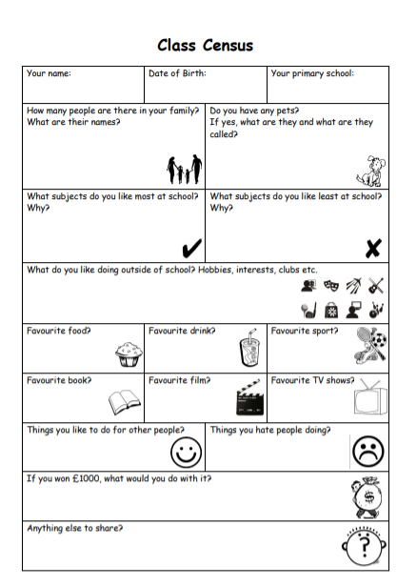  When you start High School you will have lots of opportunities to get to know new people and to tell them about yourself. In preparation for this I would like you to complete the attached activity so you can start thinking about some of your answers about yourself now. Remember, it is always good to be prepared!
Wednesday | Geography - Biomes  Today I would like you to do this Geography lesson from the BBC Bitesize website on biomes.  https://www.bbc.co.uk/bitesize/topics/z849q6f/articles/zvsp92p  What are biomes?  Biomes are areas of our planet with similar climates, landscapes, animals and plants. What lives in each biome depends on:  - how warm or cold it is  - how dry or wet it is  - how fertile the soil is  The animals in a biome depend upon plants for food. The plants in a biome often also depend upon the animals for spreading pollen and seeds so that new plants can grow. So both plants and animals rely on each other to stay alive. |  | 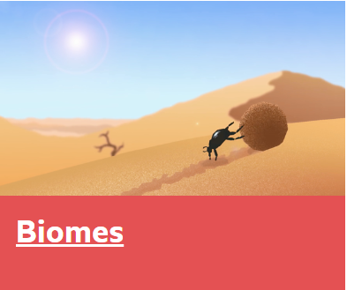
Thursday | Science – Fossils  Have a look at this lesson from the Oak Academy as it follows on from our work done last week on fossils.  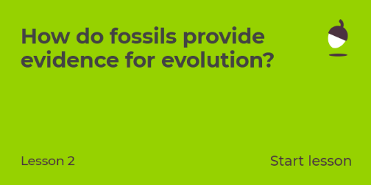  https://classroom.thenational.academy/subjects-by-year/year-6/subjects/foundation  Useful websites/video clips  https://www.bbc.co.uk/bitesize/topics/z9bbkqt/articles/z2ym2p3 - how are fossils made  https://www.bbc.co.uk/bitesize/topics/z9bbkqt/articles/z22g7p3 - what can we learn from fossils  Explore habitats with this game  https://www.bbc.co.uk/bitesize/topics/z6bqkmn/articles/zj7s6v4
Friday | PSHCE – No Outsiders – Odd Dog Out  Blurb:  It’s a dog’s life in this busy world- and one small dog does not fit in. But she’s prepared to go around the world to find her place in it, in this sublimely sunny and exquisitely illustrated tale about fitting in and standing out, from the award wining and tremendously talented Rob Biddulph  No Outsiders links: Belonging, fitting in, being proud to be who you are, challenging discrimination and prejudice about difference.  Use this link to hear the story read by Tom Hardy -  https://www.youtube.com/watch?v=kUayOnHldv0&t=19s    There are eight worksheets here, but I recommend that you look at worksheets 4-8 as these are aimed at KS2 children (Worksheet 8 is aimed at Year 5/ Year 6 children)

‘A Love for Learning’

