Challenge 1
Varied Fluency
1. Complete these sequences in your book.

a. ___, 9, 18, 27, ___, 45

b. 54, ___, 72, ___, 90

c. 36, ___, 54, 63, ___, ___

2. Circle the multiples of 9 in each of the clouds.

3. Colour the multiples of 9 in the 100 square.

What do you notice about the pattern created? Can you explain this pattern?

Challenge 1
Varied Fluency
1. Complete these sequences in your book.

a. ___, 9, 18, 27, ___, 45

b. 54, ___, 72, ___, 90

c. 36, ___, 54, 63, ___, ___

2. Circle the multiples of 9 in each of the clouds.

3. Colour the multiples of 9 in the 100 square.

What do you notice about the pattern created? Can you explain this pattern?

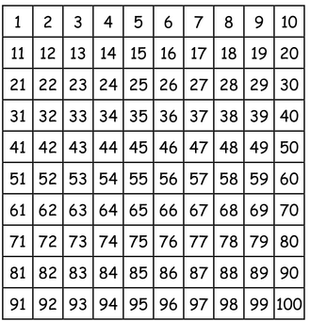
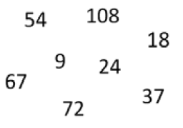

63
90
0
83
100
26
83
100

26
0
90
63

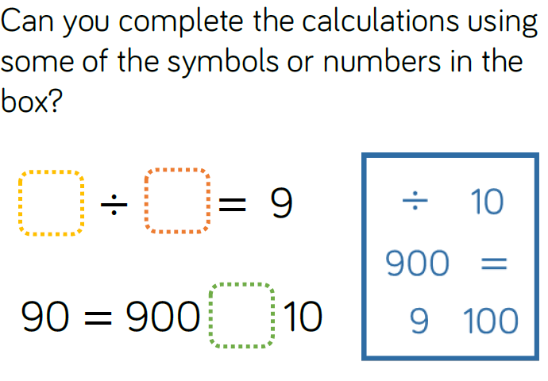
Challenge 2
Reasoning and Problem Solving

Challenge 2
Reasoning and Problem Solving

Challenge 3
Reasoning and Problem Solving
Always, Sometimes or Never?
All multiples of 9 have digits which have a sum of 9.
Prove it!

Challenge 3
Reasoning and Problem Solving
Always, Sometimes or Never?
All multiples of 9 have digits which have a sum of 9.
Prove it!

Extra Challenge
Reasoning and Problem Solving
I am thinking of 2 numbers where the sum of the numbers is 17 and the product is 72.
What are my numbers?

Extra Challenge
Reasoning and Problem Solving
I am thinking of 2 numbers where the sum of the numbers is 17 and the product is 72.
What are my numbers?

