Year 6  Toucans  Week beg. 1st June | Before 9:00am | 9:00 – 10:00 | 10:00-11:00 | 11:00-12:00 | Lunchtime – 12:00 -12.30 | 12:30 – 1.00 | 1:00 – 2:00 | 2:00 – 3:15 | 3.15 – 4:00
Monday | Eat breakfast, make your bed, get washed and dressed, any laundry in the basket. | Family walk with the dog (if you have got one!)  Five-day/indoor exercises/indoor yoga or other exercise if wet.  https://www.youtube.com/user/CosmicKidsYoga  https://www.gonoodle.com/  https://www.nhs.uk/10-minute-shake-up/shake-ups  www.5-a-day.tv USERNAME: 5-a-dayAtHome PASSWORD: AtHome123 | Work from the packs that have been sent home/CGP books/First4Maths activities/fluency grids/any specified work from the daily blog  TT Rock Stars - https://play.ttrockstars.com/auth/school  White Rose Maths https://whiterosemaths.com/homelearning  I See Reasoning lessons http://www.iseemaths.com/home-lessons/ | Creative Time – Lego, drawing, crafting, music, cooking, baking, coding, painting.  coding - https://www.scratchjr.org/ https://code.org/  Ted Ed https://ed.ted.com All sorts of engaging educational videos.  Blockly https://blockly.games Learn computer programming skills - fun and free. | Lunchtime – 12:00 -12.30 | Tidy Time – Wipe down kitchen table and chairs, wash and dry kitchen dishes, tidy bedroom and lounge | Quiet Time – Reading, Puzzles, Nap (No Electronics) | Languages/Art  German Website: www.atantot.com User name: lostockgralam Pass: 1443 | Afternoon Fresh Air – Bike, Walk the dog, play outside. Have a go at some of the active challenges https://www.youthsporttrust.org/pe-home-learning  https://www.youthsporttrust.org/60-second-physical-activity-challenges  https://www.youthsporttrust.org/active-learning
Tuesday |  |  |  |  |  |  |  | Science/PSHCE  https://mysteryscience.com/
Wednesday |  |  |  |  |  |  |  | History/Geography
Thursday |  |  |  |  |  |  |  | Science  https://mysteryscience.com/
Friday |  |  |  |  |  |  |  | RE/Geography

Home Learning – this timetable is intended as a guide to support learning at home during a prolonged period of school closure. We appreciate that you will have differing demands on your time but hope that this helps in continuing ‘a love learning’ at home. We will also be updating the class blog daily with any specific activities that you can do each day and further resources that you may need.
Mrs Downing & Mrs Whittingham
If you have issues with usernames and passwords, please contact admin@lostockgralam.cheshire.sch.uk
Monday | Art – Drawing - become an illustrator  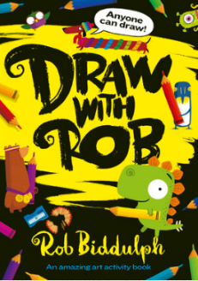  I know how much you have all enjoyed the drawing lessons that I have set and I have been amazed by your results! Thank you for sharing them with me. This is a fantastic website and you can choose which draw-a-long you would like to do. Maybe you will do an alien, or a sausage dog or Penguin Blue. Just have fun. I have done some draw-a-longs with Aoife whilst we have been in lockdown and I have found them very relaxing!  http://www.robbiddulph.com/draw-with-rob
Tuesday | PSHCE – No Outsiders  Can I accept being different and being proud of who I am?  The author of the book Anna Kemp reads “Dogs don’t do ballet” here especially for us! Thank you, Anna!  https://www.youtube.com/watch?v=U7BoyAJOYcE  Have a look at the attached worksheets and activities. Choose at least one to do to allow yourself to reflect on this story and the key messages of acceptance and belonging. | 
Wednesday | History – An introduction to the ancient Maya Civilisation  Find out where the Maya people lived and when, what did they build, believe in and do to entertain themselves.  Look at the video clip on this link and the pictures as an introduction to this ancient civilisation.  https://www.bbc.co.uk/bitesize/topics/zq6svcw/articles/zqv6msg  Find out what happened to the Mayas  https://www.bbc.co.uk/bitesize/topics/zq6svcw/articles/zndq7p3 | 
Thursday | Science – Everything Changes – How do living things survive?  - “Who lives where and why”? – using the environment cards attached could you draw the following in the correct habitat. (frog, fish, rabbit, goldfish, hamster, rat, fox, sunflower, cactus and cress). You could also just write the word if you don’t want to draw or simply call out the answer. Can you come up with other animals and plants that would live in these environments? How did you decide which plant/animal lived where? What makes this plant/animal suited to living in a particular place? Is there anything else you can think of that might make it difficult for living things to survive in a particular place? How do plants and animals survive in places where there isn’t much food or water? How do living things survive when they are not in a suitable habitat or the temperature is not right for them?  - Children choose an animal to research and explain how the animal’s physical and behavioural characteristics help it to survive in its environment. Choose a way to record information about your chosen animal, including information about the environment in which it lives and the conditions that may occur in the environment. Then describe the physical and behaviour characteristics of the animal, and explain how these characteristics help the animal to survive.  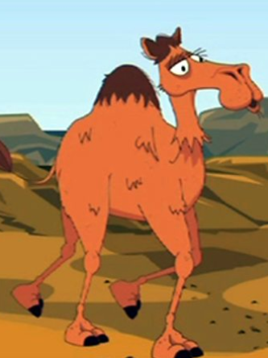  Which features/behaviour help this animal to survive? How do these features/behaviour help this animal to survive, for example, to catch its food or avoid being eaten? How might the characteristics/behaviour of the animal help it to compete more successfully against other animals?  Useful websites/video clips  https://www.bbc.co.uk/bitesize/clips/z3hxpv4 how animals have adapted to their habitat  https://www.bbc.co.uk/bitesize/clips/z33s34j Animal eyes adapted  https://www.bbc.co.uk/bitesize/clips/z4p6n39 how camels are adapted to living in the desert  Explore habitats with this game  https://www.bbc.co.uk/bitesize/topics/z6bqkmn/articles/zj7s6v4
Friday | 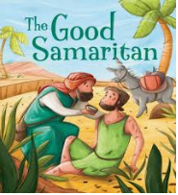  RE – The Good Samaritan  I’m sure like me you will agree that one of the positives of this lockdown has been getting to know our neighbours better. I have enjoyed chatting to my neighbours over the fence, clapping together on a Thursday, getting to know when some of them have had birthdays (clues on the door with balloons, banners etc.), meeting them out an about on our daily walks etc.  I’d like you to start this lesson by reading the Bible story of The Good Samaritan. See the parable on page 2 of the attached worksheets. Read it aloud using your tone and expression. Then have a go at completing the attached worksheets.

‘A Love for Learning’

