Year 3  Robins | Before 9:00am | 9:00 – 10:00 | 10:00-11:00 | 11:00-12:00 | 12 – 12.30 | 12:30 – 1.00 | 1:00 – 2:00 | 2:00 – 3:15 | 3.15 – 4:00
Monday | Eat breakfast, make your bed, get washed and dressed and put any laundry in the basket. | Family walk (with the dog - if you have got one!)  Five-a-day/indoor exercises/indoor yoga if wet.  https://www.youtube.com/user/CosmicKidsYoga  https://www.gonoodle.com/  https://www.nhs.uk/10-minute-shake-up/shake-ups | Maths/Writing work from the packs, blogs or any of the following links:  TT Rock Stars - https://play.ttrockstars.com/auth/school  White Rose - https://whiterosemaths.com/homelearning/  I see reasoning - http://www.iseemaths.com/home-lessons/  The literacy company - http://www.theliteracycompany.co.uk/free-resources/  Oak National Academy - https://www.thenational.academy/online-classroom/year-3/ | Creative Time – Lego, drawing, crafting, music, cooking, baking, coding, painting.  coding - https://www.scratchjr.org/  https://code.org/ | Lunchtime | Tidy Time – Wipe down kitchen table and chairs, wash and dry kitchen dishes, tidy bedroom and lounge. | Quiet Time – Reading, Puzzles, Nap (No Electronics) | History/Geography  (See tasks on the next page) | Afternoon Fresh Air – Bike, Walk the dog, play outside.
Tuesday |  |  |  |  |  |  |  | Science  (See tasks on the next page) | Afternoon Fresh Air – Bike, Walk the dog, play outside.
Wednesday |  |  |  |  |  |  |  | History/Geography  (See tasks on the next page) | Afternoon Fresh Air – Bike, Walk the dog, play outside.
Thursday |  |  |  |  |  |  |  | Science  (See tasks on the next page) | Afternoon Fresh Air – Bike, Walk the dog, play outside.
Friday |  |  |  |  |  |  |  | RE  (See tasks on the next page) | Afternoon Fresh Air – Bike, Walk the dog, play outside.
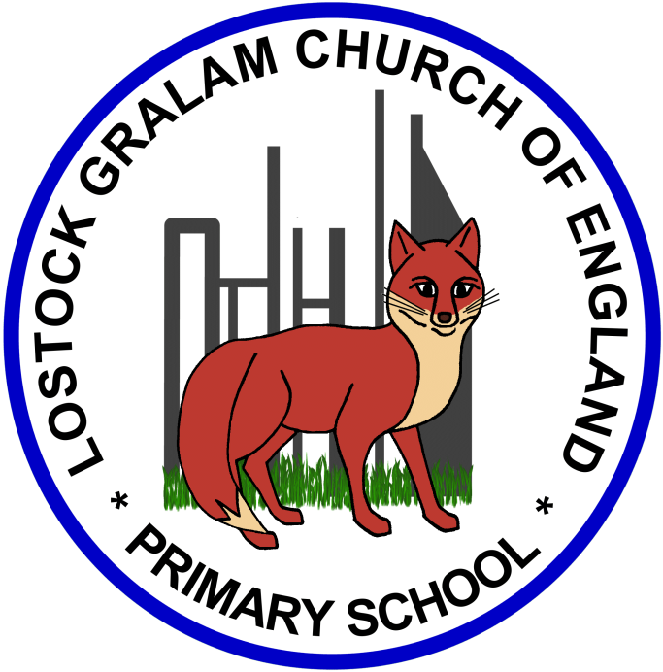
Home Learning – this timetable is intended as a guide to support learning at home during a prolonged period of school closure. We appreciate that you will have differing demands on your time but hope that this helps in continuing ‘a love learning’ at home. We will also be updating the class blog daily with any specific activities that you can do each day and further resources that you may need.
Under the timetable and suggested task list, I will also include a long list of free resources and websites that you may wish to use.
If you have issues with usernames and passwords, please contact admin@lostockgralam.cheshire.sch.uk

Weeks 5 and 6 (commencing 04.05.20 and 11.05.20):
Remember these projects will take you multiple days to complete – just do a little bit at a time
History and Geography | History/Geography Projects – Ancient Civilisations  - Research: What is a civilisation? What does the word ‘ancient’ mean? (Can you think of any synonyms for this word?)  - Over the next few weeks of home learning we are going to be learning about the following Ancient Civilisations: Ancient Sumer; The Indus Valley; Ancient Egypt; The Shang Dynasty.  - Find out when these civilisations were around and create your own timeline – you could even add in other eras/events we have learnt about (e.g. Stone Age, Bronze Age, Iron Age, first moon landing, Titanic, Thomas Edison inventing the first lightbulb, First aeroplane).  - Using a World Map, locate where in the world each of these Ancient Civilisations were. You could use the 8 points of a compass to describe where they were in relation to the UK.  - Most Ancient Civilisation were located close to a very – Why do you think this might have been? Can you find out which river each of the Ancient Civilisations were located nearby?  Useful Websites –  https://www.bbc.co.uk/teach/class-clips-video/history-ks2-lost-lands/zfp6gwx  https://www.theschoolrun.com/homework-help/shang-dynasty  http://www.ancient-chinese-dynasties-facts.com/Chinese-Shang-Dynasty-Facts/Shang-Dynasty-Achievements-Facts.html  https://www.bbc.co.uk/bitesize/topics/zxn3r82/articles/zcsbr82  https://www.theschoolrun.com/homework-help/ancient-sumer-and-mesopotamia  https://www.bbc.co.uk/teach/class-clips-video/history-ks2-introducing-ancient-sumer/zmgnvk7  https://www.bbc.co.uk/bitesize/topics/zg87xnb  https://www.ducksters.com/history/ancient_egyptian_pharaohs.php
Science | Science Projects – Plants  - In your garden or while out on your walk, use one of the ‘spotter sheets’ from this link to see how many seasonal plants and flowers you can spot: https://www.plantlife.org.uk/uk/discover-wild-plants-nature/spotter-sheets  - Draw two pictures – one of a human and one of a plant. Label each picture with what it needs to survive. What is the same? What is different? Do you think every plant has the same requirements?  - http://flash.topmarks.co.uk/3334 - Use this link to learn all about the different parts of a plant. Why not have a go at labelling the parts yourself?  - You could also create some art work showing your favourite plant or flower.  Useful Websites –  https://www.bbc.co.uk/bitesize/topics/zy66fg8  https://bbsrc.ukri.org/documents/the-plant-detective-teachers-pack-and-students-sheets/  https://www.plantlife.org.uk/uk/discover-wild-plants-nature/spotter-sheets
RE | RE Projects – What kind of World did Jesus want?  - Sketch your three favourite possessions and then list in order the things you like to do on the weekend.  - Now read/listen to the story of the calling of the disciples (Matthew 4:18–19) – Linked below.  - These men gave up everything they had to follow Jesus – Make a list of what they had to leave behind.  - How would you feel if you had to give up your favourite possessions and activities? What might you have done if you were in their position?  - Jesus told the men they were going to be ‘fishers of men’. What might Jesus have meant by this? Create an image of what a ‘fisher of men’ might do.  Matthew 4:18–19: http://www.dltk-bible.com/cv/twelve_disciples.htm OR https://www.youtube.com/watch?v=iypUNd5yTn0

Online classrooms:
https://www.thenational.academy/online-classroom
https://www.bbc.co.uk/bitesize/dailylessons

Maths
https://whiterosemaths.com/homelearning/year-3/
http://www.iseemaths.com/home-lessons/

Times Tables
https://ttrockstars.com/
https://www.topmarks.co.uk/maths-games/hit-the-button

Spellings
https://spellingframe.co.uk/

PE
https://www.youtube.com/watch?v=X655B4ISakg
https://www.youtube.com/user/CosmicKidsYoga
https://www.gonoodle.com/
https://www.nhs.uk/10-minute-shake-up/shake-ups

