BODY PARTS

BODY
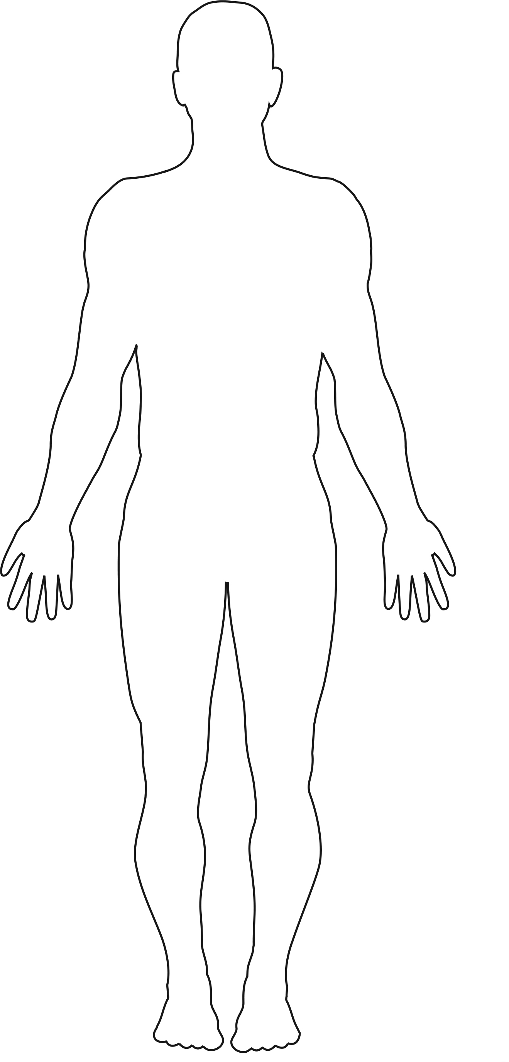

BODY PARTS

HEART

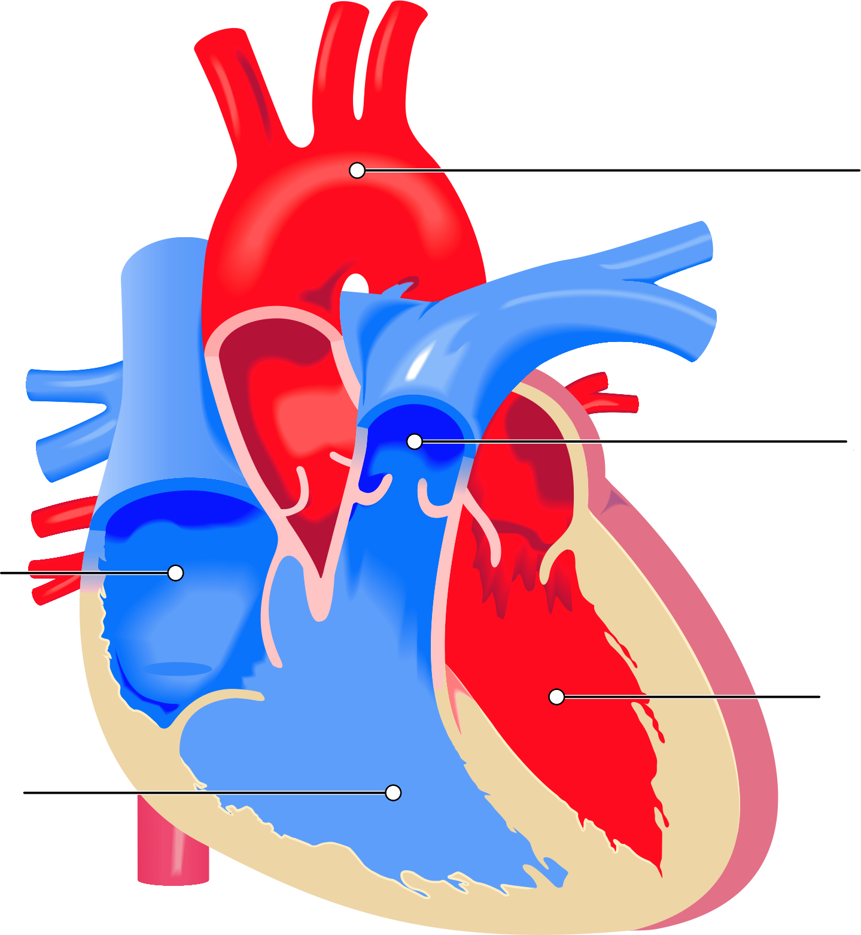
Left
Ventricle
Left
Atrium
Right
Ventricle
Right
Atrium
Aorta

BODY PARTS

LUNGS

