Before 9am | Wake up | 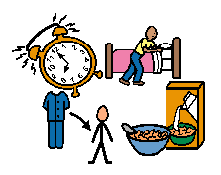 | Have breakfast  Get dressed  Brush your teeth  Make your bed
9 – 9:30am | Exercise Time |  | If possible: morning walk or indoor exercise.  Joe Wicks. Cosmic Yoga. 5-a-day, ‘Wake and Shake’
9:30- – 10:30am | Phonics Time |  | Daily Speed Sound session and  Daily Read Write Inc Go Writing (Information will be given on the blog each Monday with timetable of tasks)
10:30 – 12pm | Busy Time |  | Lego, drawing, colouring, craft activities, playdough, singing, music, cooking/baking/ together.  (It is an activity at school that they would chose that they want to do.)
12pm – 1pm | Lunch/Relax |  | Controlled Electronics  iPads/tablets, computers and games consoles.  Please remember online safety.

1pm -1:30pm | Exercise Time |  | See ‘Exercise Ideas’
1:30 - 2:00pm | Maths Time | 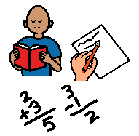 | Daily Maths Activity  (Set weekly on the blog)
2:00 – 3:00pm | Busy Time |  | You may want to choose an activity from the pack to complete linked to our topic.  Relax with a book, watch a TV programme or play a board game.
3:00 – 4:00pm | Fresh Air | 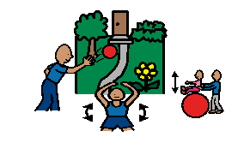 | Outdoor play or exercise indoors.
4:00 – 5:00pm | Electronics Time |  | Supervised Electronics  Supervised educational games/apps.
5:00 – 6:00pm | Tea Time | 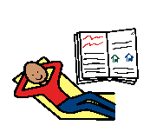   | Have tea and then relax and prepare for bed/story time.

Exercise Ideas
- Jump on trampoline
- Climbing activities
- Ride a scooter or bike
- Running/jumping games
- Create a ‘Go Noodle’ account it is free and has lots of fun and free physical activities: https://www.gonoodle.com/
- Dance along to a ‘Just Dance’ video on YouTube.
- Jack Hartmann Kids Music Channel on YouTube.
- Kids Yoga on YouTube
- Cosmic Kids Yoga www.cosmickidsyoga.com
- Play Dough/Playdough gym videos on youtube.
- 5 a day-login USERNAME: 5-a-dayAtHome
PASSWORD: AtHome123

