
In KS2, we use Number Sense Maths in our daily fluency times tables lesson. This is a ten minute session in addition to the daily maths lesson designed to systematically teach factual fluency. The programme has been carefully researched, trialled and iterated over the last decade and is modelled on the structure and pedagogy of phonics programmes. This systematic method of teaching times tables facts provides exactly what children need to achieve factual fluency in multiplicative facts. At Lostock, knowing your tables means that children can say facts quicky and easily without skip counting on their fingers or using a method to work it out.
Children learn their times tables up to 12 x 12 but we prioritise teaching the children to memorise the 36 essential facts up to 9 x 9. The 10 x table is very important too but follows an easy pattern so children don’t need to learn it in the same way. These facts are the essential building blocks for all other mental and written multiplication and division calculations the children will ever do - in school and beyond!
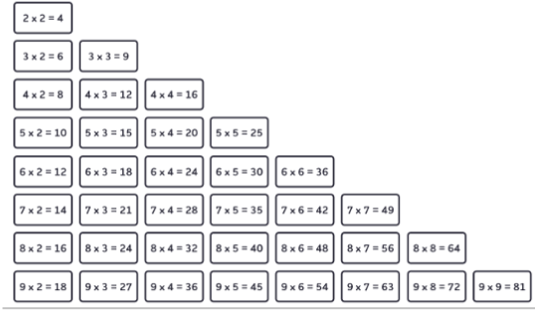

Children learn the facts like song lyrics, we want the facts to trip off the children’s tongues. The saying/chanting of the facts out loud and the practice trying to recall the facts and record them is what leads to memorisation. Over time, after saying each fact lots of times, the children remember them as a sound pattern. Learning just a few new facts at a time builds on prior learning, helps children to make connections between facts, to feel the facts are achievable and prevents them from feeling over whelmed. The children can see exactly where they are on the journey to knowing all of the facts which helps them to build confidence – a key part of this approach.
