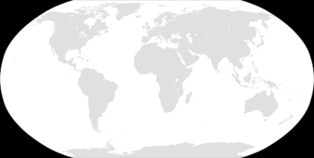
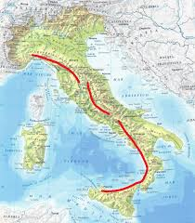
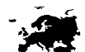
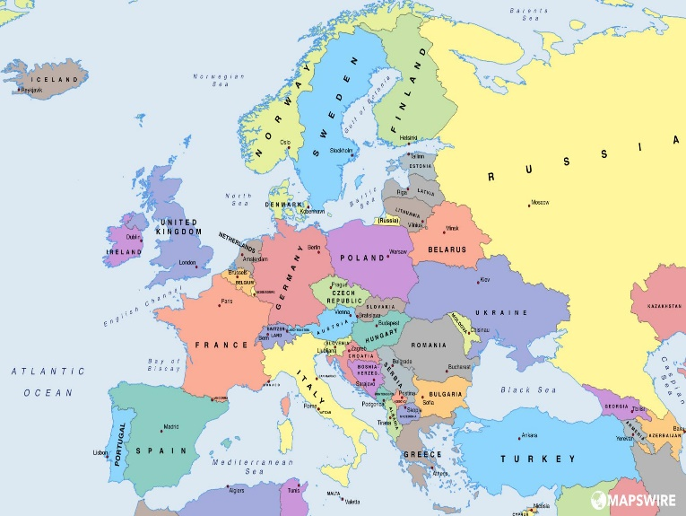
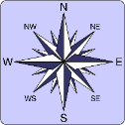
Europe: Italy

Physical Features
The Alps  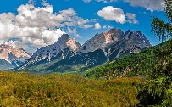 | These are the longest mountain range in Europe and the highest in western Europe (excluding Russia). They are 1200km across and pass through 8 alpine countries (Switzerland, France, Germany, Austria, Slovenia, Monaco, Italy and Liechtenstein).
The Apennines  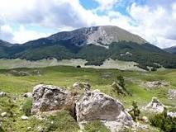 | The Apennines range runs north to south down the centre of the country.
River Po  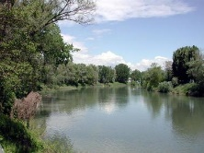 | The longest river in Italy is the River Po. It is approximately 670kmin length and its source is the many streams found in the Alps.
Human Features
European Union  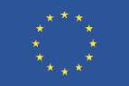 | The E.U. is a political and economic group of 28 countries who allow free trade and commerce between member states. It was created in 1948 after World War II to help Europe become more stable.
Colosseum  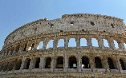 | The Colosseum in Rome, built in 70 A.D., as one of many built throughout Italy during the time of the Romans. This huge amphitheatre could hold 50,000 spectators and was often the scene of chariot races, gladiator and animal battles along with executions.
The ruins of Pompeii  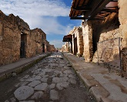 | A Roman town which was destroyed from the eruption of Mount Vesuvius in 79 AD.
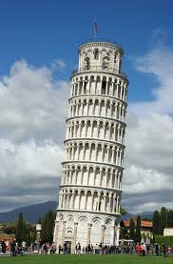  Leaning Tower of Pisa | The Leaning Tower of Pisa is a bell tower in Pisa, Italy. The Tower of Pisa is world famous for its prominent tilt to one side.

Key Vocabulary
borders | Political factors and physical (e.g. rivers, mountains and seas) affect where borders between countries are set
English Channel | A 560km stretch of sea which separates England from France - important for trade
euro | the unit of money used across most of Europe
equator | An imaginary line drawn around the middle of the earth an equal distance from the North Pole and the South Pole.
Mediterranean | southern areas of Europe which have mild winters and hot summers (e.g. Italy, Spain)
polar regions | northern Europe which is cold and dry all year
temperate | this middle section of Europe has cold winters and mild summers (e.g. U.K., Germany, Poland)
peninsula | A piece of land which is almost completely surrounded by water
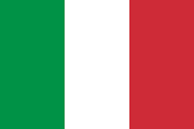
Climate
There are 44 countries in Europe and 4 main climate types.
- Polar regions near the Arctic Circle such as Iceland, Norway, Sweden, Finland and Russia where tundra and icy glaciers are common
- Temperate climates, much like the U.K. where there is rainfall and deciduous forests (trees which lose their leaves in the winter)
- Mediterranean climates which are dry and hot and attract many tourists.
- Alpine climates which are mountainous and cold.

Key Facts and Figures: Italy
Continent | Europe
Capital | Rome
Population | 60.48 million (2018)
Highest mountain | Mont Blanc, 4,810 m (the highest mountain in the Alps)
Volcanoes | Italy has three active volcanoes: Vesuvius, Stromboli and Etna
Longest river | River Po
Largest lake | Lake Garda, 370 km²
Seas | Mediterranean, Ligurian, Adriatic, and Ionian seas
Currency | Euro

