 |  |  | Autumn 2 – Celebrations
Themes/Interests/  Lines of Enquiry |  |  |  | AUTUMN BONFIRE NIGHT/FIRE SERVICE DIWALI CHRISTMAS        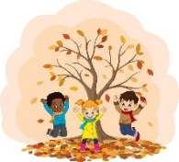
Suggested Texts | Books following possible themes. |  |  | 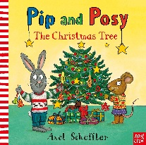  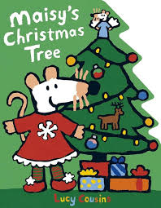  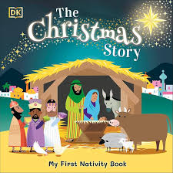  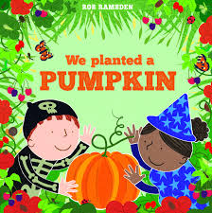  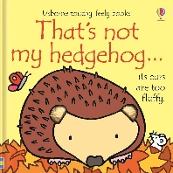  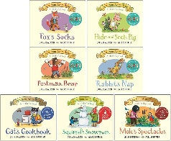  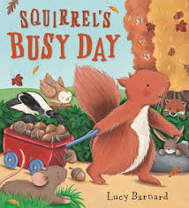
Suggested Texts | Autumn 2  Literacy texts |  |  | 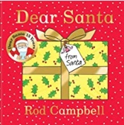  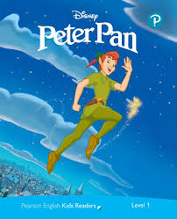  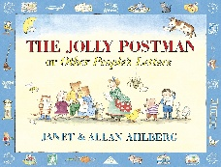  + Daily songs, nursery rhymes and school/class songs.
 |  |  | Prime Areas
Area of learning |  | Objectives/skills |  |  |  | Revisit/ongoing  throughout the year
Communication and Language   |  | Listening:  Enjoy listening to longer stories and remember much of what happens.  Attention:  Begin to sing a large repertoire of songs.  Recite and perform Nursery Rhymes.  Respond/ Understand/ Speaking:  Use a wide range of vocabulary.  Be able to start a conversation with a friend or an adult and continue it for many turns.  Use talk to organise themselves e.g. “Let’s play in the sand… you have the big spade”.  Use longer sentences (four to six words) |  |  |  | Tell children the names of things they do not know and choose books that introduce interesting new vocabulary to them.  Encourage children to talk.  Expand on children’s phrases, as well as adding language and new ideas.  Recast what children say grammatically correct.  Allow plenty of time to have conversations together.  Help children to express what’s angering them by suggesting words to describe their emotions.
Personal, Social  and Emotional Development   |  | Lula’s Listening Rules  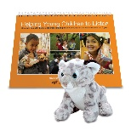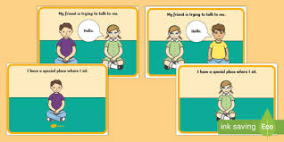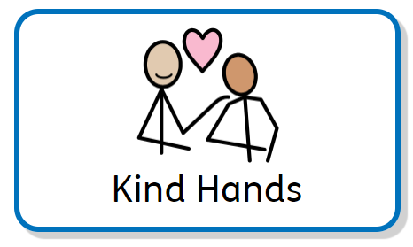  Manage behaviour:  Begin to learn the routines and rules of a new setting.  Self-awareness:  Settle into a new setting and be able to say goodbye to their adult (positive leave).  Be increasingly independent when using the toilet and washing hands.  Independence:  Select resources and activities in the setting independently.  Be increasingly independent when using the toilet and washing hands.  Collaboration:  Develop new relationships with the children and the adults in a new setting.  Social skills:  Show increasing confidence in new social situations.  Twinkl PSHE – Super Me, Positive Relationships |  |  |  | Help children develop positive attitudes towards diversity and inclusion.  Help all children to feel that they are valued, and they belong.  Support children to find ways into the play and friendship groups of others.  Recognise, talk about and expand on children’s emotions.  Model useful phrases like “Can I have a turn?” or “My turn next”.  Help children to feel emotionally safe with a key person and, gradually, with other members of staff. Develop a spirit of friendly co-operation amongst children and adults.
Physical  Development   |  | Use scissors to snip paper or dough.  Use and remember actions and sequences of movement which relate to music and rhythm. |  |  |  | Help young children learn what physical risks they are confident and able to take.  Provide materials and equipment that support physical development – both large and small motor skills.  Encourage children to try a range of foods as they become more independent eaters.  Provide lots of different things for young children to grasp, hold and explore.  Continuously build upon children’s core muscle strength.
Use large muscle movements to paint, wave streamers and make marks

Develop movement, balancing, riding bikes and trikes and ball skills.
To hop, skip and balance (hold a pose).

Be confident putting on own coat with increasing independence.

Outdoor Equipment: climbing, trikes and slide
 |  |  | Specific Areas
Literacy   |  | COMPREHENSION  Enjoy listening to longer stories and remember much of what happens.  Develop phonetical knowledge to spot and suggest rhymes. |  |  |  | Point out print in the environment and talk about what it means.
 |  | WORD READING  Begin to name the different parts of a book.  Hear general sound discrimination.  Understand that print carries meaning. |  |  |  | Offer children a daily story time as well as sharing books.  Provide a wide range of high-quality books, matching the many different interests of children in the setting.
 |  | WRITING  Emergent writing:  Enjoys making marks.  Begin to give meanings to marks they make.  Begin to record letters of their name. |  |  |  | Provide a wide range of stimulating equipment to encourage children’s mark-making.
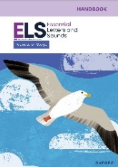  Phonics |  | Essential Letters and Sounds - Continue to teach Phase 1 Essential Letters and Sounds. |  |  |  | Song and rhyme times should happen spontaneously throughout the day, indoors and outside, with individual children, in pairs or in small groups.
Mathematics   |  | 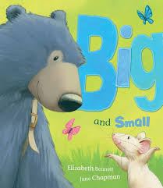  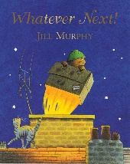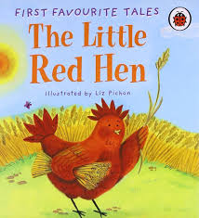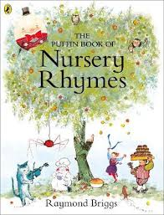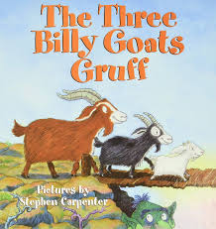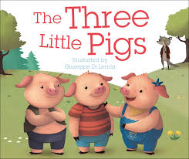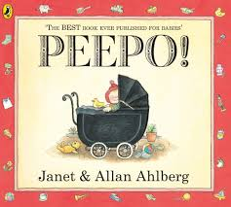  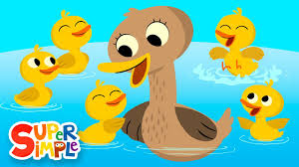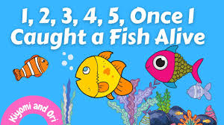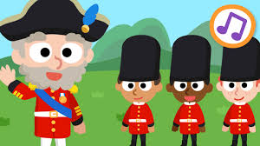 |  |  |  | Use the language of size and weight in everyday contexts.  Describe children’s climbing, tunnelling and hiding using spatial words like ‘on top of’, ‘up’, ‘down’ and ‘through’.  Help children to match their counting words with objects.  Offer repeated experiences with the counting sequence in meaningful and varied contexts.
Show fingers for numbers up to 5.
Subitise small quantities.
Say one number name for each item in order: 1, 2, 3, 4, 5.
Understand position through words alone e.g. the bag is under the table.
Select shapes appropriately for building, e.g. a triangle prism for a roof, etc.
Daily mathematical opportunities – Self-registration ‘Who is here today?’ using the five frames.
Singing the ‘Days of the Week’ song. Counting aloud when lining up, transitioning to a new area. Sharing equal amounts of snack, language associated with snack. Regular check in the daily visual timetable, remove each picture as it is completed to model the passing of time.
 |  | Coverage |  |  | Guidance (Subject Knowledge)
 |  | Explore and build with shapes and objects |  |  | Talk about and explore 2D and 3D shapes (for example, circles, rectangles, triangles and cuboids) using informal and mathematical language: ‘sides’, ‘corners’; ‘straight’, ‘flat’, ‘round’. Select shapes appropriately: flat surfaces for building, a triangular prism for a roof, etc.
 |  | Explore repeats (Nursery Rhyme Week) |  |  | Talk about and identify the patterns around them. Use words like ‘repeated’ and ‘the same’ over and over.
 |  | Hear and say number names |  |  | Using counting rhymes is an effective way to support children with the counting principle of stable order. This refers to knowing number names in order. Model counting on fingers so children begin to notice that we can show numbers this way. It is important to model counting forwards as well as backwards.
 |  | Begin to order number names |  |  | Support securing children’s understanding of the stable order counting principle to 3, although children may naturally verbally count beyond 3 during counting activities. Support children to use the correct pronunciation. Another counting principle that is developed in this block is the abstraction principle. This is the understanding that anything can be counted.
 |  | I see 1, 2, 3 |  |  | Perceptual subitising - this is the ability to recognise small quantities without counting, and children are born with this innate skill. Encourage them to focus on where they can see 1, 2 or 3 items. Support children to notice that they could instantly see these items and they did not have to count.
Understanding the World   |  | Explore how things work.  Use all senses in hands on exploration of natural materials.  Talk about what they see, using a wide vocabulary.  Winter Walks, Environmental Sounds/ Sound Discrimination  Begin to make sense of their own life story.  RE (NATRE):  How do Christians have special ways of welcoming babies?  Children will learn about how babies are welcomed, including by Christians.  What are special times? Why is Christmas Special for Christians? (Christianity)  Children will be able to talk about how and why Diwali and Christmas are celebrated and how Jesus helped.  Christmas Story |  |  |  | Communication: Encourage children’s exploration, curiosity, appreciation and respect for living things. Be open to children talking about differences and what they notice.  Observation: Encourage young children to enjoy and explore the natural world. Model positive attitudes about the differences between people including differences in race and religion. Support children’s acceptance of difference.
Expressive Arts and Design   |  | Music: Being Imaginative  Children will remember and sing entire songs, such as Nursery Rhymes and songs for the Nativity/ Christmas.  Play instruments with increasing control.  Being Imaginative  Make imaginative small worlds using construction kits and building blocks e.g. a castle, a city, a park.  Talk about what they have created.  Art and Design – Creating with Materials  Join materials and explore different textures  Draw with increasing complexity and detail |  |  |  | Encourage young children to explore materials/ resources finding out what they are/what they can do and decide how they want to use them.  Help children to develop their pretend play by modelling, sensitively joining in and helping them to elaborate it.  Introduce children to a broad selection of action songs from different cultures and languages. Sing songs regularly so that children learn the words, melody and actions off by heart.
Enrichment/ Experiences |  | Remembrance Day/ Nursery Rhyme Week/ Odd Socks (Anti-Bullying Week)/ Children in Need/ Nursery & Reception Nativity Performance/ Christmas Jumper Day/ Christmas Party/ Firefighters

