Autumn 1 – All About Me
Themes/Interests/  Lines of Enquiry |  | School Values School Rules Family Seasonal  (Kindness)  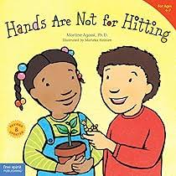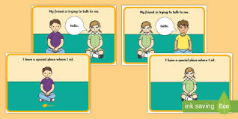
Suggested Texts | Baseline & Transition Themed Books | 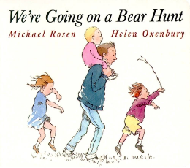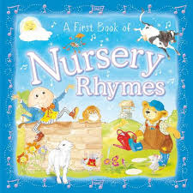
Suggested Texts | Autumn 1  Literacy texts | 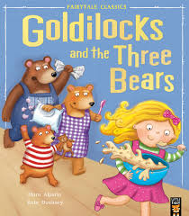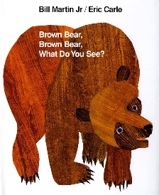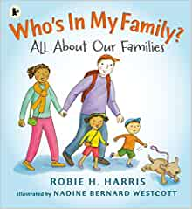  + Daily songs, nursery rhymes and school/class songs.
Prime Areas

Area of learning |  | Objectives/skills | Revisit/ongoing  throughout the year
Communication and Language   |  | Listening:  Enjoy listening to longer stories and remember much of what happens.  Attention:  Begin to sing a large repertoire of songs.  Recite and perform Nursery Rhymes.  Respond/ Understand/ Speaking:  Use a wide range of vocabulary.  Be able to start a conversation with a friend or an adult and continue it for many turns.  Use talk to organise themselves e.g. “Let’s play in the sand… you have the big spade”.  Use longer sentences (four to six words) | Tell children the names of things they do not know and choose books that introduce interesting new vocabulary to them.  Encourage children to talk.  Expand on children’s phrases, as well as adding language and new ideas.  Recast what children say grammatically correct.  Allow plenty of time to have conversations together.  Help children to express what’s angering them by suggesting words to describe their emotions.
Personal, Social  and Emotional Development   |  | Lula’s Listening Rules  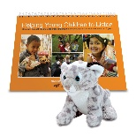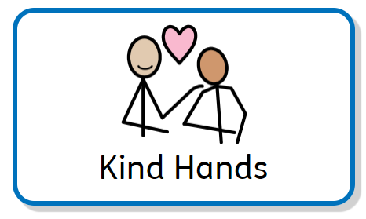  Manage behaviour:  Begin to learn the routines and rules of a new setting.  Self-awareness:  Settle into a new setting and be able to say goodbye to their adult (positive leave).  Independence:  Select resources and activities in the setting independently.  Be increasingly independent when using the toilet and washing hands.  Collaboration:  Develop new relationships with the children and the adults in a new setting.  Social skills:  Show increasing confidence in new social situations.  Twinkl PSHE – Super Me, Positive Relationships | Help children develop positive attitudes towards diversity and inclusion.  Help all children to feel that they are valued, and they belong.  Support children to find ways into the play and friendship groups of others.  Recognise, talk about and expand on children’s emotions.  Model useful phrases like “Can I have a turn?” or “My turn next.”  Help children to feel emotionally safe with a key person and, gradually, with other members of staff. Develop a spirit of friendly co-operation amongst children and adults.
Physical  Development   |  | Use scissors to snip paper or dough.  Use and remember actions and sequences of movement which relate to music and rhythm.  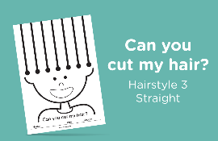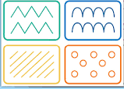 | Help young children learn what physical risks they are confident and able to take.  Provide materials and equipment that support physical development – both large and small motor skills.  Encourage children to try a range of foods as they become more independent eaters.  Provide lots of different things for young children to grasp, hold and explore.  Continuously build upon children’s core muscle strength.
Use large muscle movements to paint, wave streamers and make marks.

Develop movement, balancing, riding bikes and trikes and ball skills.

Be confident putting on own coat with increasing independence.

Outdoor Equipment: climbing, trikes and slide
Specific Areas
Literacy   |  | COMPREHENSION  Enjoy listening to longer stories and remember much of what happens.  Develop phonetical knowledge to spot and suggest rhymes. | Point out print in the environment and talk about what it means.
 |  | WORD READING  Begin to name the different parts of a book.  Hear general sound discrimination.  Understand that print carries meaning. | Offer children a daily story time as well as sharing books.  Provide a wide range of high-quality books, matching the many different interests of children in the setting.
 |  | WRITING  Emergent writing:  Enjoys making marks  Begin to give meanings to marks they make.  Begin to record letters of their name. | Provide a wide range of stimulating equipment to encourage children’s mark-making.
Phonics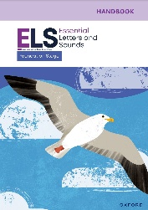 |  | Revisit Phase 1 – Listening to Familiar Stories, Rhyming and Nursery Rhymes (Week 1 – 6)  Essential Letters and Sounds (from Week 7) – Begin to teach Phase 1 Essential Letters and Sounds. | Song and rhyme times should happen spontaneously throughout the day, indoors and outside, with individual children, in pairs or in small groups.
Mathematics  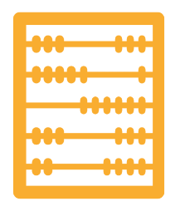 |  | 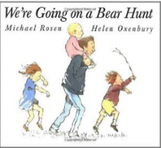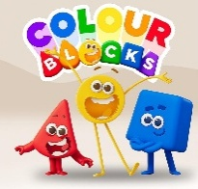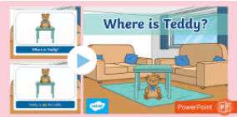 | Use the language of size and weight in everyday contexts.  Describe children’s climbing, tunnelling and hiding using spatial words like ‘on top of’, ‘up’, ‘down’ and ‘through’.  Help children to match their counting words with objects.  Offer repeated experiences with the counting sequence in meaningful and varied contexts.
 |  | Baseline – 3 weeks Opportunity to settle in, introduce the areas of provision inside and outside and get to know the children’s mathematical knowledge through play, introduce key times of day, class routines, Where do things belong? Positional language
Show fingers for numbers up to 5.
Say one number name for each item in order; 1, 2, 3, 4, 5.
Understand position through words along e.g. the bag is under the table.
Select shapes appropriately for building, e.g. a triangle prism for a roof etc.
Understanding the World   |  | Explore how things work.  Use all senses in hands on exploration of natural materials.  Autumn/ Halloween Sensory/ Topic Tray  Talk about what they see, using a wide vocabulary.  Autumn Walks, Environmental Sounds/ Sound Discrimination  Begin to make sense of their own life story. | Communication: Encourage children’s exploration, curiosity, appreciation and respect for living things. Be open to children talking about differences and what they notice.  Observation: Encourage young children to enjoy and explore the natural world. Model positive attitudes about the differences be-tween people including differences in race and religion. Support children’s acceptance of difference.
Expressive Arts and Design   |  | Music: Being Imaginative  Children will remember and sing entire songs, such as Nursery Rhymes and songs about Autumn.  Play instruments with increasing control.  Being Imaginative  Make imaginative small worlds using construction kits and building blocks e.g. a castle, a city, a park.  Talk about what they have created.  Art and Design – Creating with Materials  Join materials and explore different textures (Teddy bear masks)  Draw with increasing complexity and detail (Self Portraits) | Encourage young children to explore materials/ resources finding out what they are/what they can do and decide how they want to use them.  Help children to develop their pretend play by modelling, sensitively joining in and helping them to elaborate it.  Introduce children to a broad selection of action songs from different cultures and languages. Sing songs regularly so that children learn the words, melody and actions off by heart.
Enrichment/ Experiences |  | Autumn/ Halloween /Explore School Environment /School Staff/ Family Members

