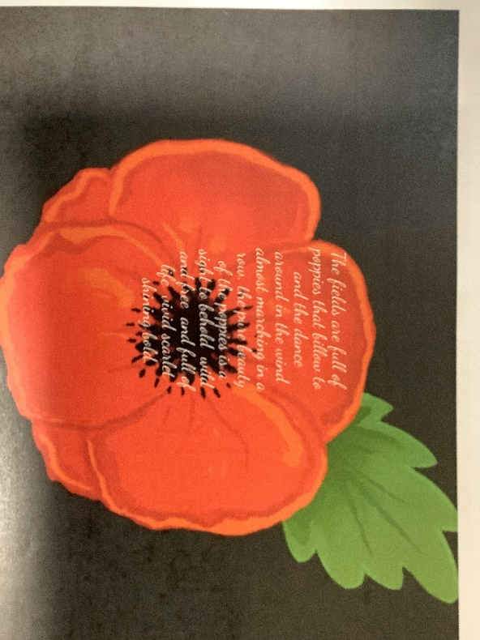
Remembrance day digital poppy art.

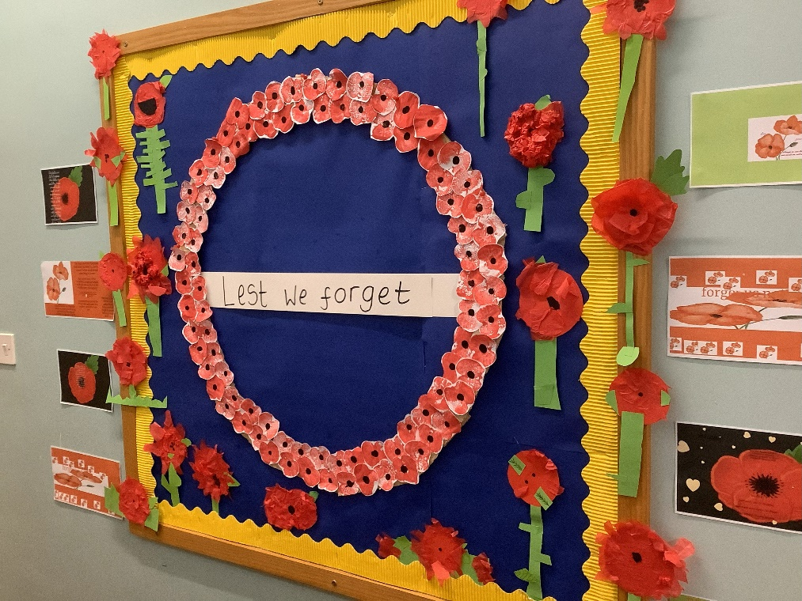

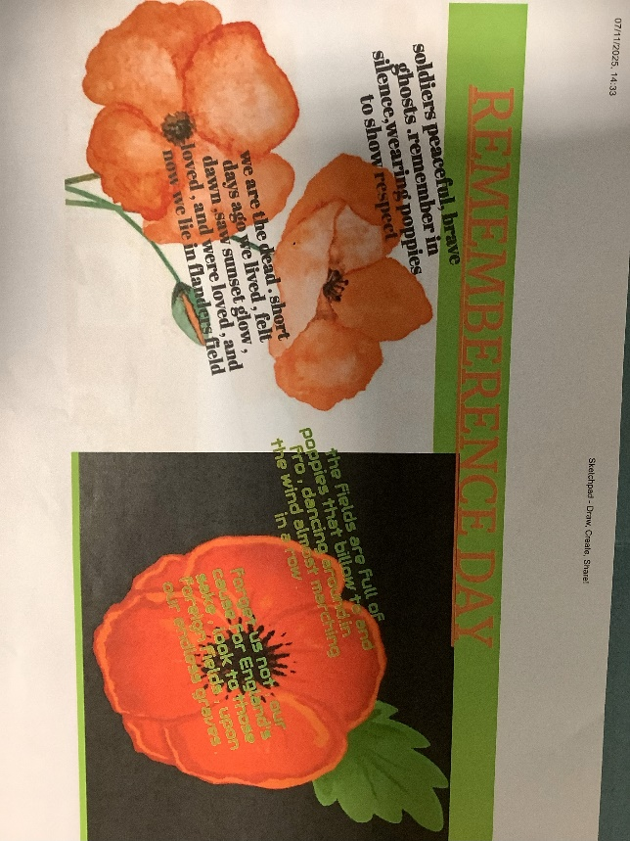

We used ‘sketchpad’ to create digital art using war poetry. We also made tissue paper poppies and added it altogether on a display with some work from Class 1 children.

