LO: To plan and write a leaflet about Bacup.
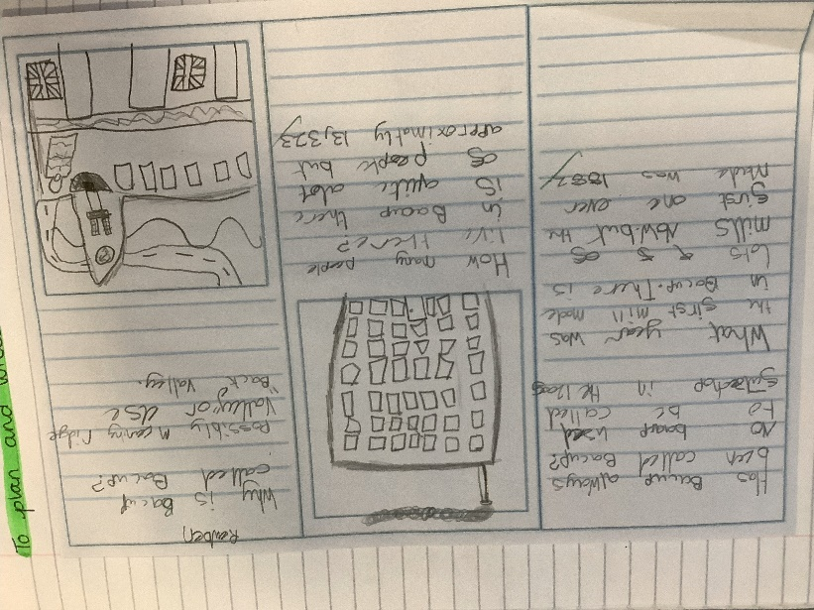

As part of our English lesson we have researched our local town Bacup and written a leaflet.

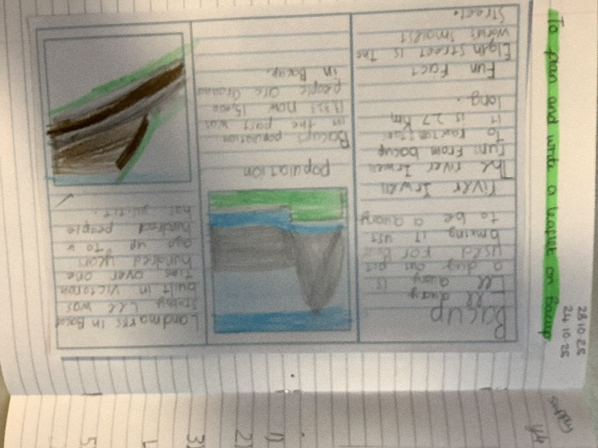
Children completed
lots of research about Bacup
before writing their leaflets.

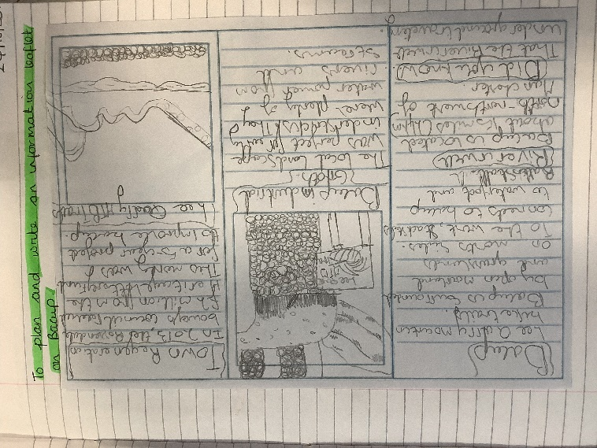

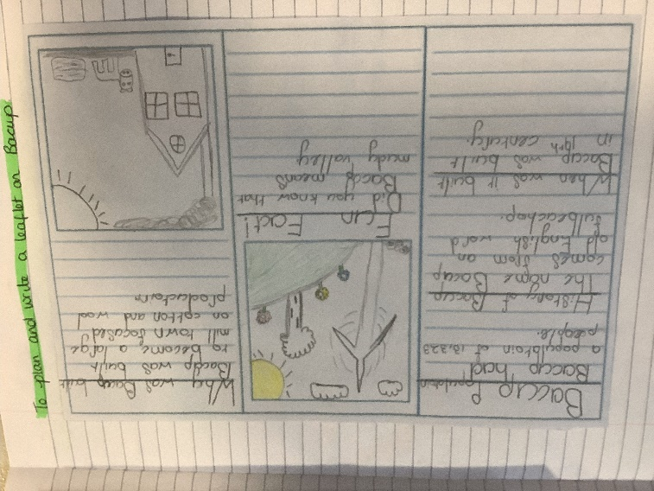
The leaflets are fantastic and presented beautifully!

