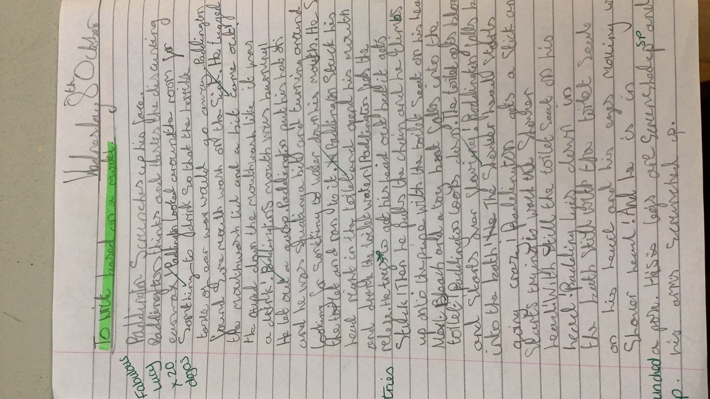**WB: 6th October**

Some AMAZING writing based on Paddington this week!

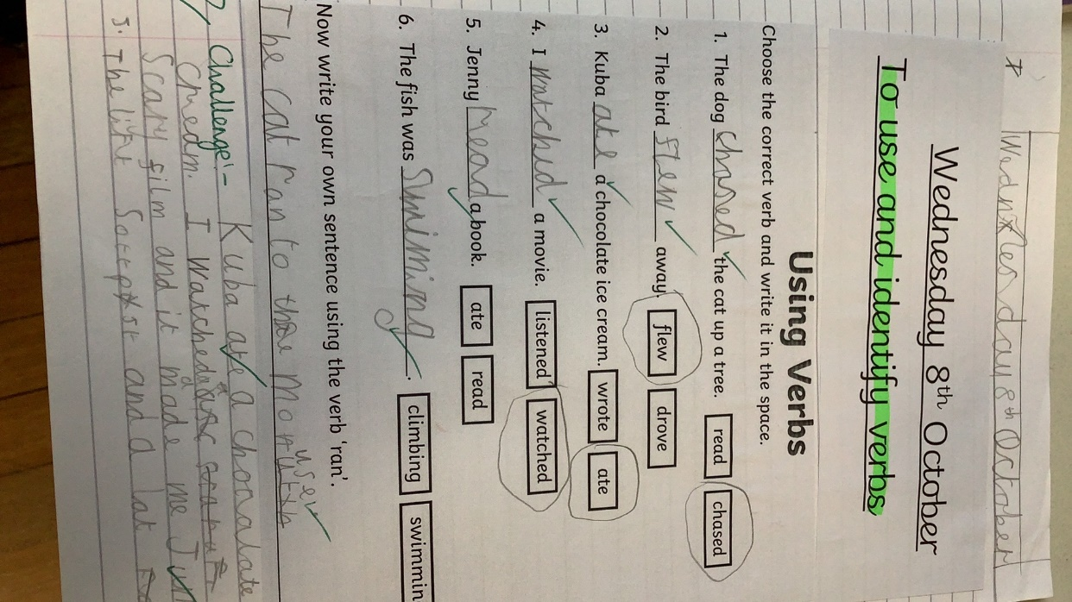

Grammar focus for the week has been verbs and selecting better verbs for our own writing.

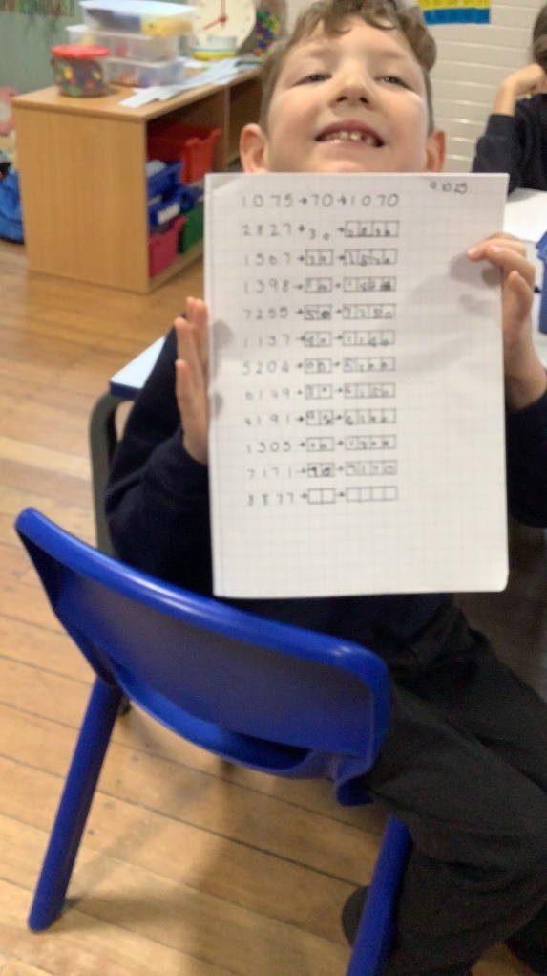

In maths we have been adding and subtracting 10’s, 100’s and 1000’s

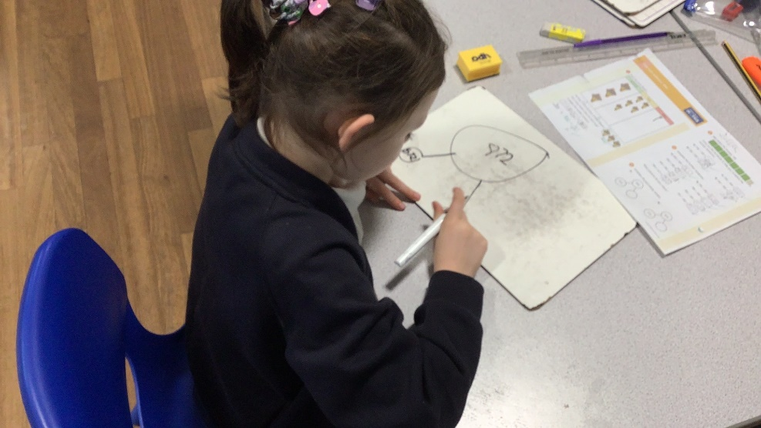

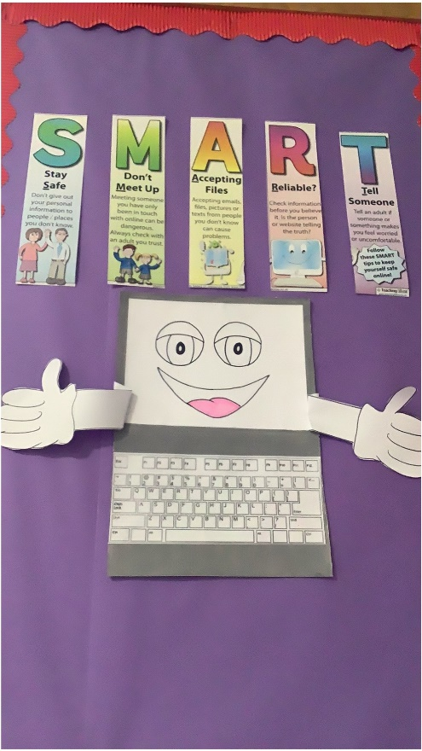Well done Jessie who used resources effectively to work out partitioning problems.

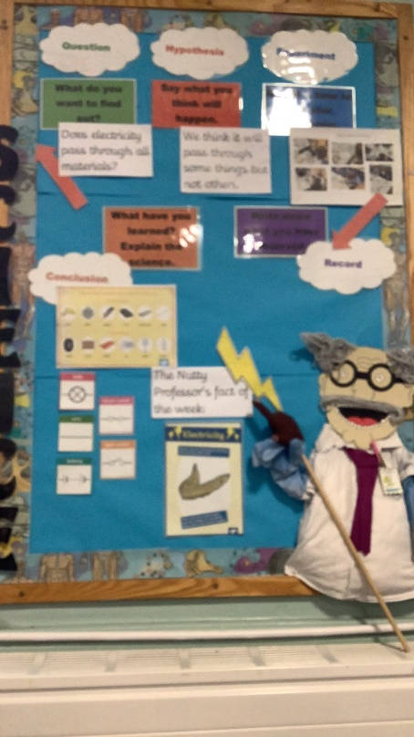

Class 2’s

Computing

and Science

Display.