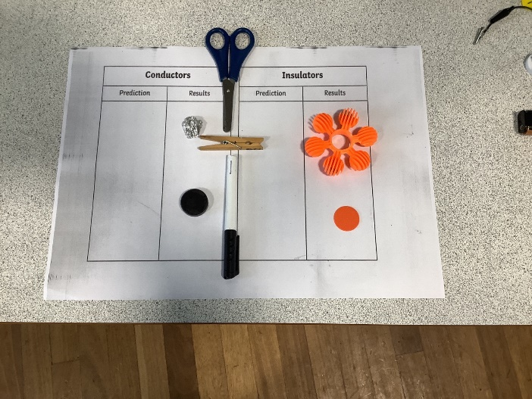Wednesday 1st October

LO: To explain the differences

between a conductor and

insulator.

SC1: To sort and classify.

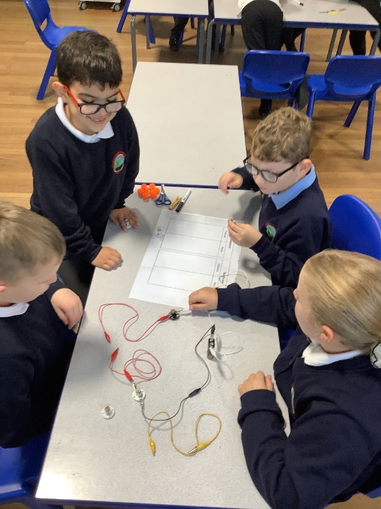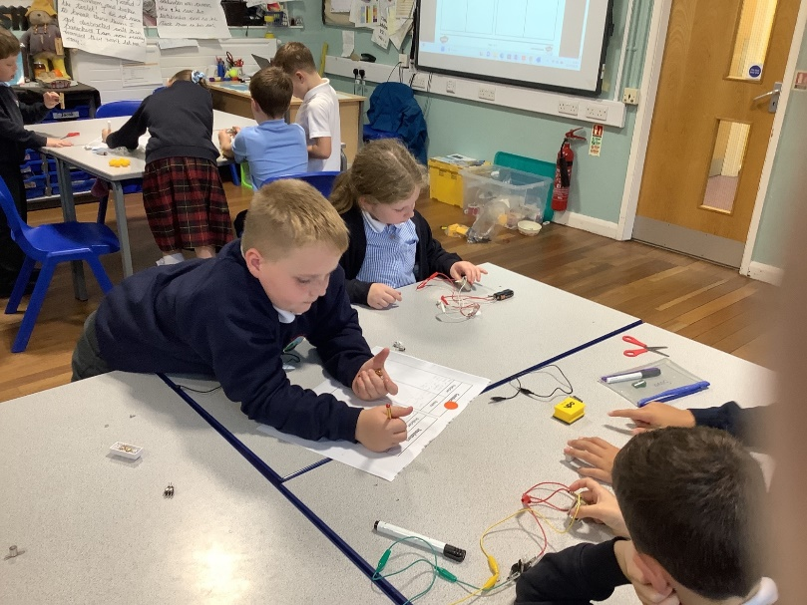

Can you remember what is special about the whiteboard pen, the peg and the scissors? Why are they in the middle?

Challenge: Why are wires to plug sockets coated in plastic?