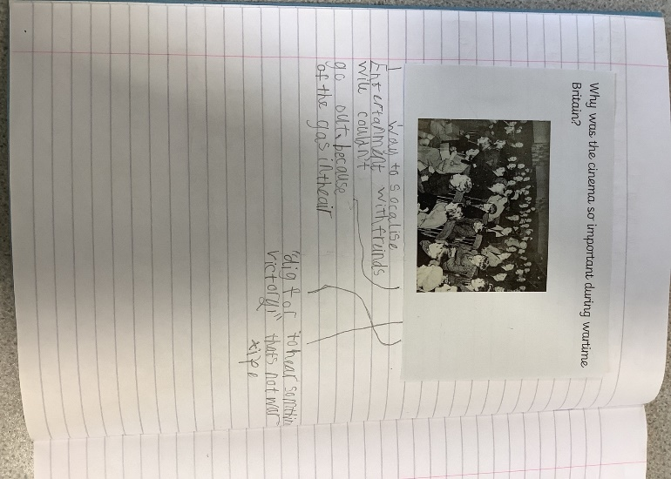 History wb: 21.09.25

In History we have been learning about the importance of the cinema during war time Britain.

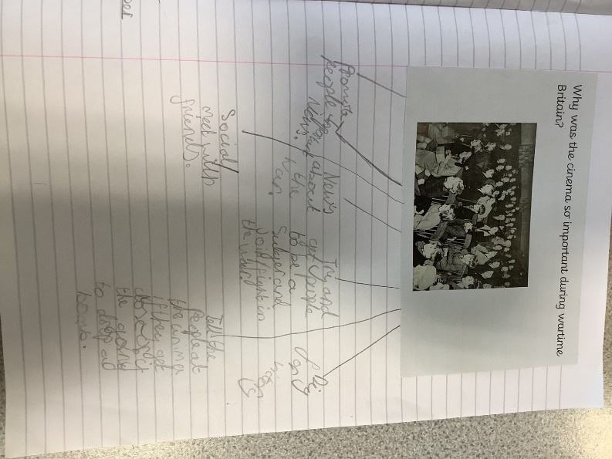

We discussed how the

Cinema was an important

escape from war time Britain, but

also how it helped boost morale.

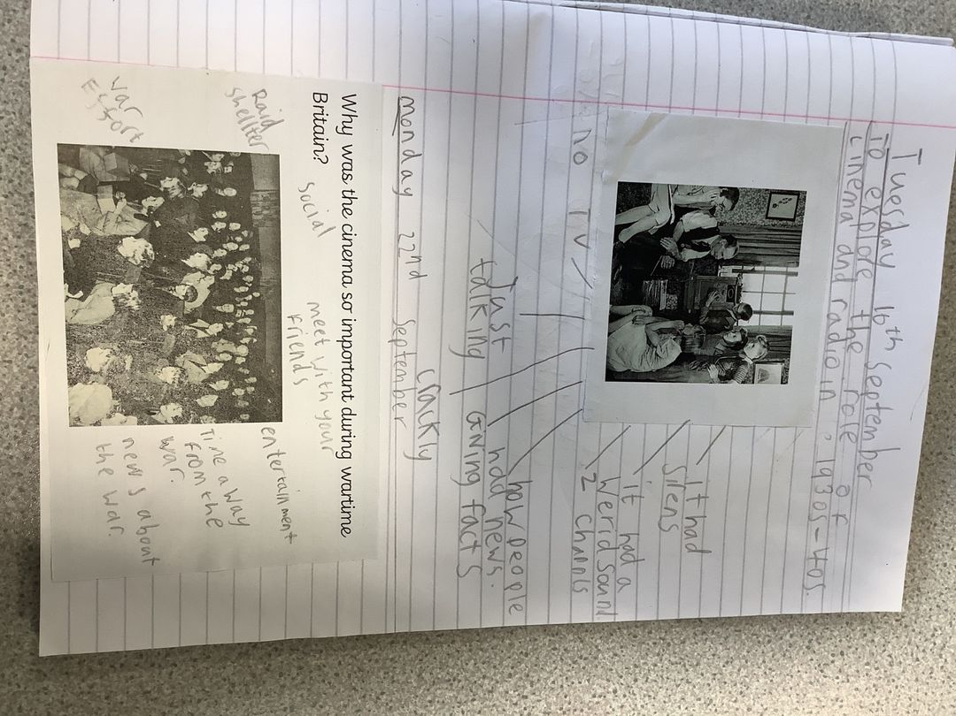

Fantastic work Class 2!