OPTION | MONDAY | TUESDAY | WEDNESDAY | THURSDAY | FRIDAY
A | Cheesy Pasta  & Garlic Bread | Brunch  Pork Sausage, Hash Browns, Scrambled Eggs, Mushrooms, Fresh Tomato & Baked Beans | Gammon Roast  with Seasonal Vegetables,  Roast & Mashed Potatoes & Gravy | Chicken Fried Rice | Pizza  with Chips and Seasonal Vegetables
B |  |  |  |  | Fish Fingers
 | Sandwich  with a choice of fillings (Cheese, Tuna Mayo or Ham) | Sandwich  with a choice of fillings (Cheese, Tuna Mayo or Ham) | Sandwich  with a choice of fillings (Cheese, Tuna Mayo or Ham) | Sandwich  with a choice of fillings (Cheese, Tuna Mayo or Ham) | Sandwich  with a choice of fillings (Cheese, Tuna Mayo or Ham)
C | Jacket Potato  with a choice of fillings (Cheese, Tuna Mayo or Baked Beans) | Jacket Potato  with a choice of fillings (Cheese, Tuna Mayo or Baked Beans) | Jacket Potato  with a choice of fillings (Cheese, Tuna Mayo or Baked Beans) | Jacket Potato  with a choice of fillings (Cheese, Tuna Mayo or Baked Beans) | Jacket Potato  with a choice of fillings (Cheese, Tuna Mayo or Baked Beans)
Dessert  Options | Cornflake Cake | White choc & raspberry biscuit | Oatie | Chocolate Orange Sponge with choc sauce | Chocolate crunch
Dessert  Options | Fresh Fruit | Fresh Fruit | Fresh Fruit | Fresh Fruit | Fresh Fruit
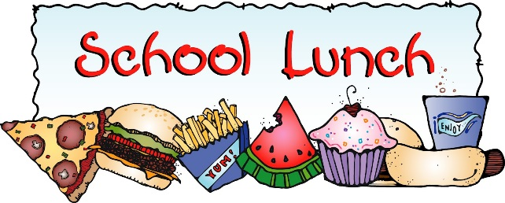

WEEK 2
2025/2026

