OPTION | MONDAY | TUESDAY | WEDNESDAY | THURSDAY | FRIDAY
A | Cheese Toastie  & Wedges | Spaghetti Bolognese  With garlic bread | Toad in the hole  with Seasonal Vegetables,  Roast & Mashed Potatoes & Gravy | Curry, Rice & Naan Bread | Chicken Burger  & Chips
B |  |  |  |  | Fish Fingers
 | Sandwich  with a choice of fillings (Cheese, Tuna Mayo or Ham) | Sandwich  with a choice of fillings (Cheese, Tuna Mayo or Ham) | Sandwich  with a choice of fillings (Cheese, Tuna Mayo or Ham) | Sandwich  with a choice of fillings (Cheese, Tuna Mayo or Ham) | Sandwich  with a choice of fillings (Cheese, Tuna Mayo or Ham)
C | Jacket Potato  with a choice of fillings (Cheese, Tuna Mayo or Baked Beans) | Jacket Potato  with a choice of fillings (Cheese, Tuna Mayo or Baked Beans) | Jacket Potato  with a choice of fillings (Cheese, Tuna Mayo or Baked Beans) | Jacket Potato  with a choice of fillings (Cheese, Tuna Mayo or Baked Beans) | Jacket Potato  with a choice of fillings (Cheese, Tuna Mayo or Baked Beans)
Dessert  Options | Ginger Biscuit | Iced Sponge | Eaton Mess | White Choc & Raspberry Muffin | Shortbread
Dessert  Options | Fresh Fruit | Fresh Fruit | Fresh Fruit | Fresh Fruit | Fresh Fruit
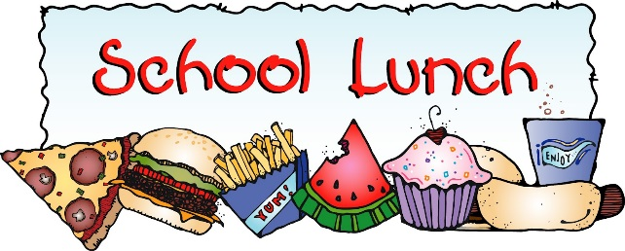

WEEK 1
2025/2026

