  Maths Test Vocabulary  Add  Addition  Altogether  Later  Total  Combined Higher than  Sum Increase  Another Longer | 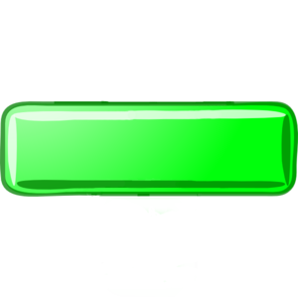  Subtract Early  Gives away Less than  How many more Left  Difference Sold  Remainder Not shaded  Narrower How much change
Times Each has  Multiplication Every  Multiply Product   | Each  Divide Remainder  Division Share equally  Half Equal parts  How many can you fill?  How many can you buy?  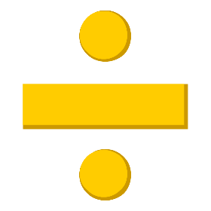  How many do you need?  How much is one?

