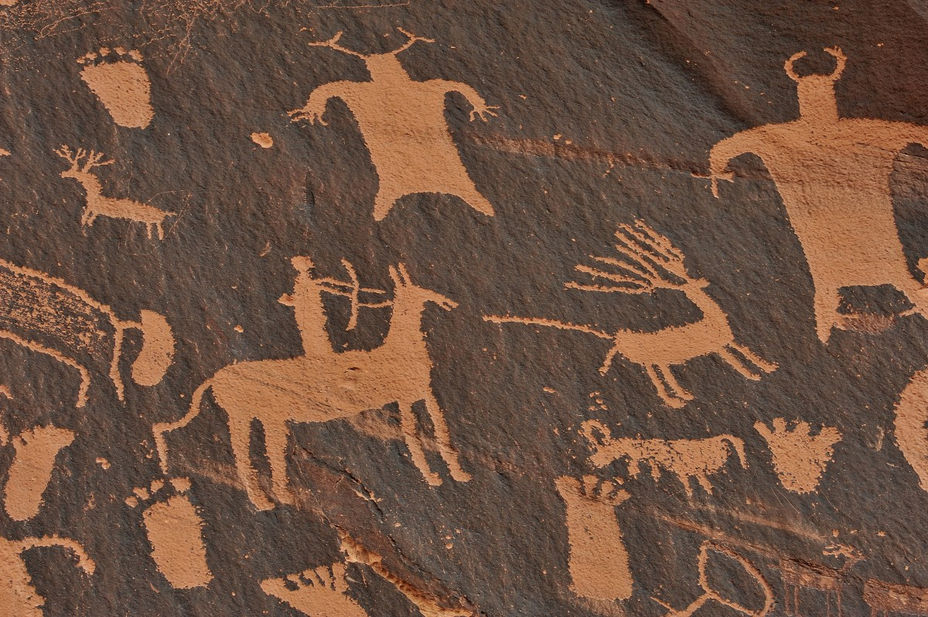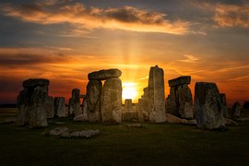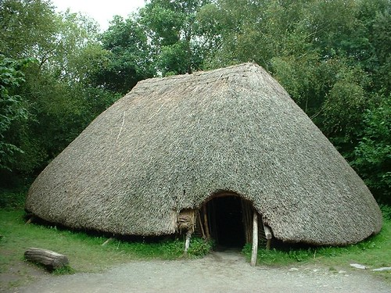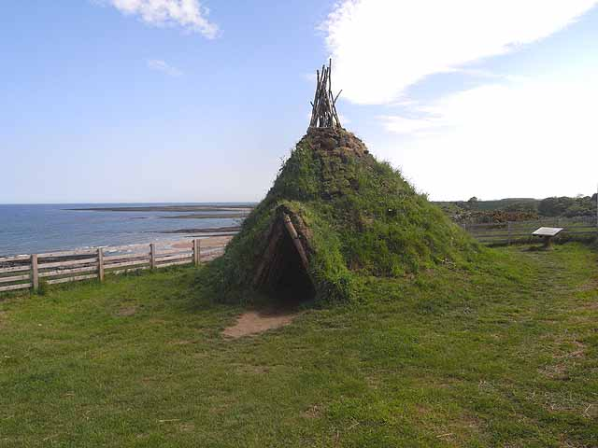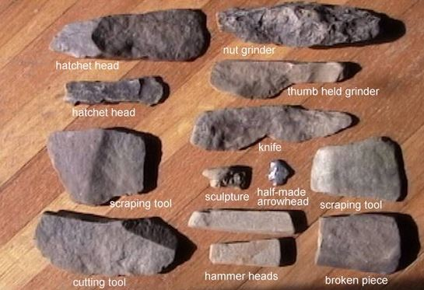

Stone Age Research Project – Year 6 Homework

You will choose one of the topics below and research it. You can present your work in one of the following ways:
- • A poster
• A digital slideshow (PowerPoint or Google Slides)
• A fact-file
• A model or diorama with an explanation – this could be lego/or made – a photo to go with the explanation would be great as storage in the classroom is tricky

Choose ONE of the following topics to research:
- Life on Doggerland: What was Doggerland? What was the landscape like? What plants, animals and people lived there? When and why did it disappear underwater?
- Stone Age Houses / Shelters: What types of shelters did people build in Palaeolithic, Mesolithic and Neolithic times? What materials did they use?
- Stone Age Weapons & Tools: What tools and weapons did people use? How did they make them? How did tools change between Stone Age periods?
- Daily Life in the Stone Age: What was a typical day like? How did people get food, make clothes, travel or trade?
- Foods, Plants & Animals: What did people eat? What plants were available? What animals did they hunt or domesticate? How did diet change over time?
- Fact File on Palaeolithic / Mesolithic / Neolithic: Create a fact file about your favourite Stone Age period. Include dates, environment, technology, and lifestyle.

Your finished work should include:
- A clear title
2. An introduction explaining which part of the Stone Age or topic you researched
3. At least 3 sub-headings (e.g. environment, housing, food, tools, animals, changes over time)
4. At least 5 interesting facts with sources or links
5. At least one picture, drawing or map
6. A short conclusion – what surprised you or what you’d like to know more about

Useful Research Links:
BBC bitesize – Stone Age
National Geographic – Life on Doggerland: https://education.nationalgeographic.org/resource/doggerland/
Wikipedia – Doggerland: https://en.wikipedia.org/wiki/Doggerland
Britannica – Stone Age: https://www.britannica.com/event/Stone-Age
English Heritage – Prehistory in England: https://www.english-heritage.org.uk/learn/story-of-england/prehistory/
Young Archaeologists’ Club – Life in the Mesolithic
The Guardian – Doggerland: ‘Lost Atlantis’: https://www.theguardian.com/science/2021/aug/01/doggerland-lost-atlantis-of-the-north-sea-gives-up-its-ancient-secrets

Questions to Help Your Research:
- When did this period happen?
- What was the climate or environment like?
- What plants and animals existed?
- How did people make their tools or weapons?
- What did they eat and how did they get food?
- What kind of shelters did they live in?
- Were they nomadic or settled?
- What changes happened during this period?
- What discoveries or artefacts have archaeologists found?
- What challenges did people face?

