
Computing
E-Safety – Purple Mash Scheme of Work
Map For Goostrey 2024-25
More detailed plans including our Year Plans, Knowledge Organisers, vocabulary, timelines, teaching points and weekly class information to be found on individual class pages.

Drivers
For Our Curriculum:
Excellence Inclusivity Community Diversity Challenging Reflective
For Our Pupils:
Knowledgeable Motivated Curious Healthy Resilient Independent Creative

Year Group | Coverage Over The Year
1 | 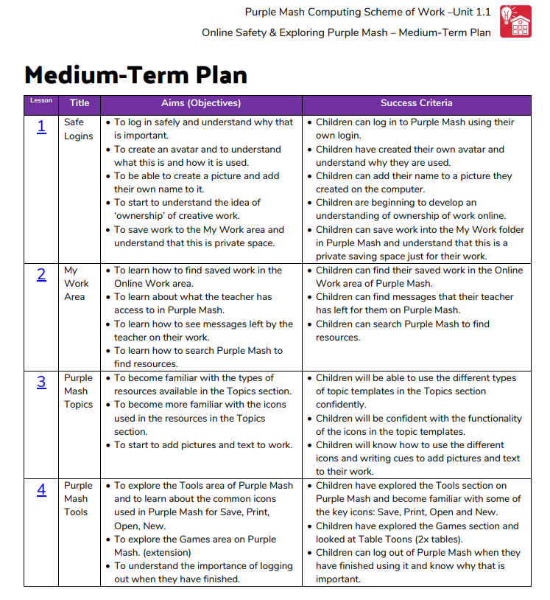
2 | 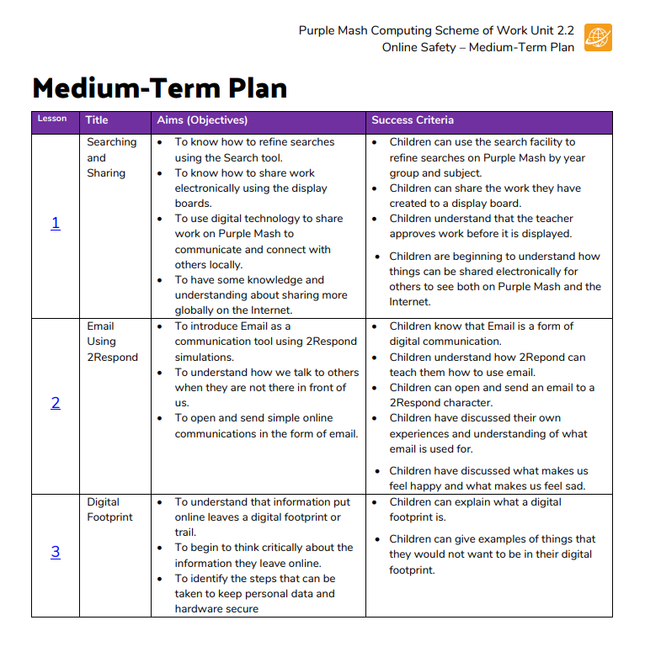
3 | 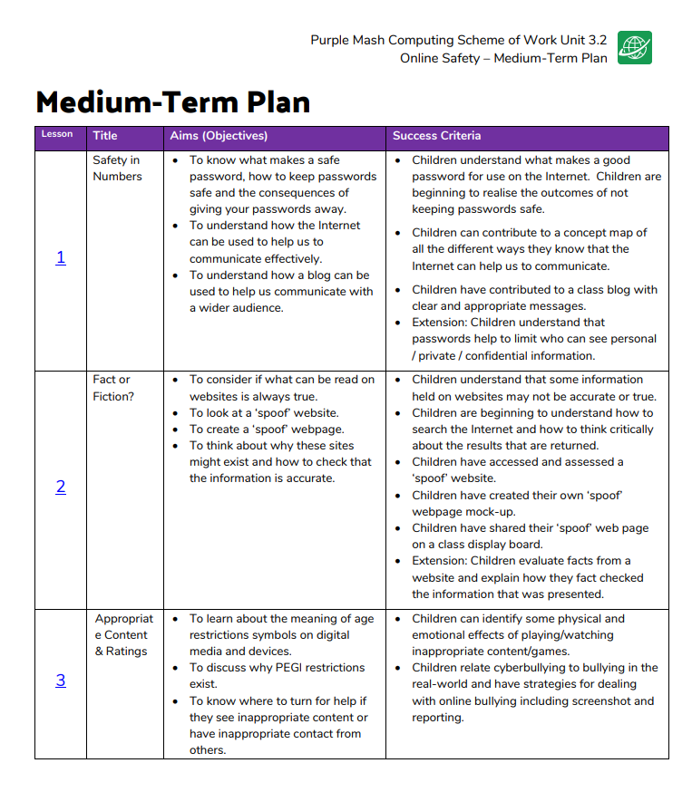
4 | 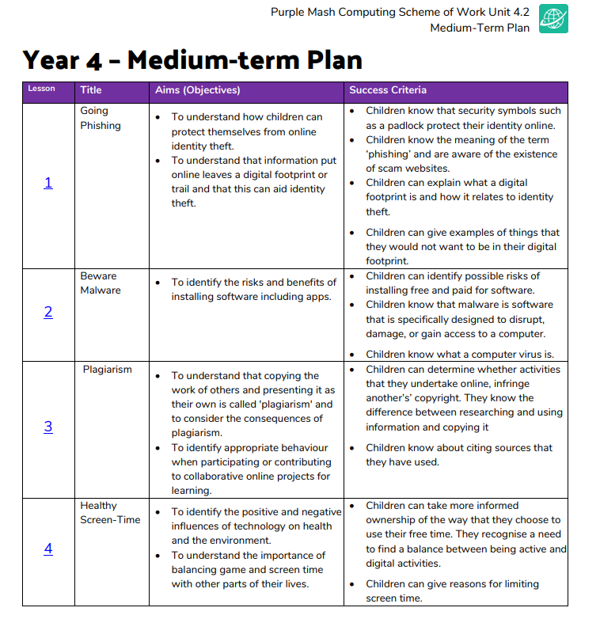
5 | 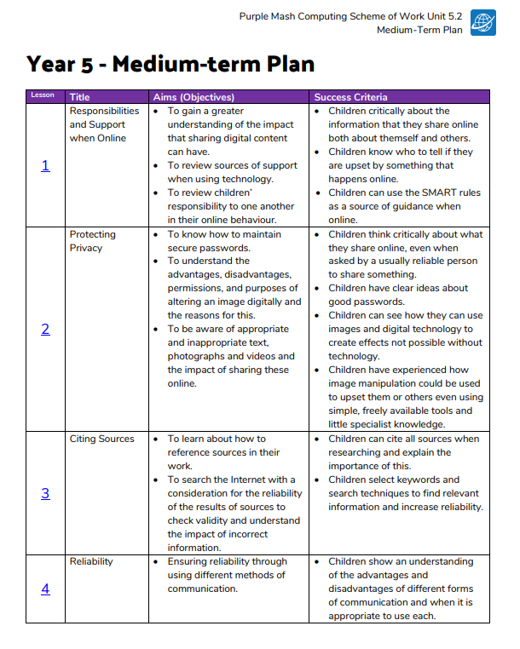
6 | 