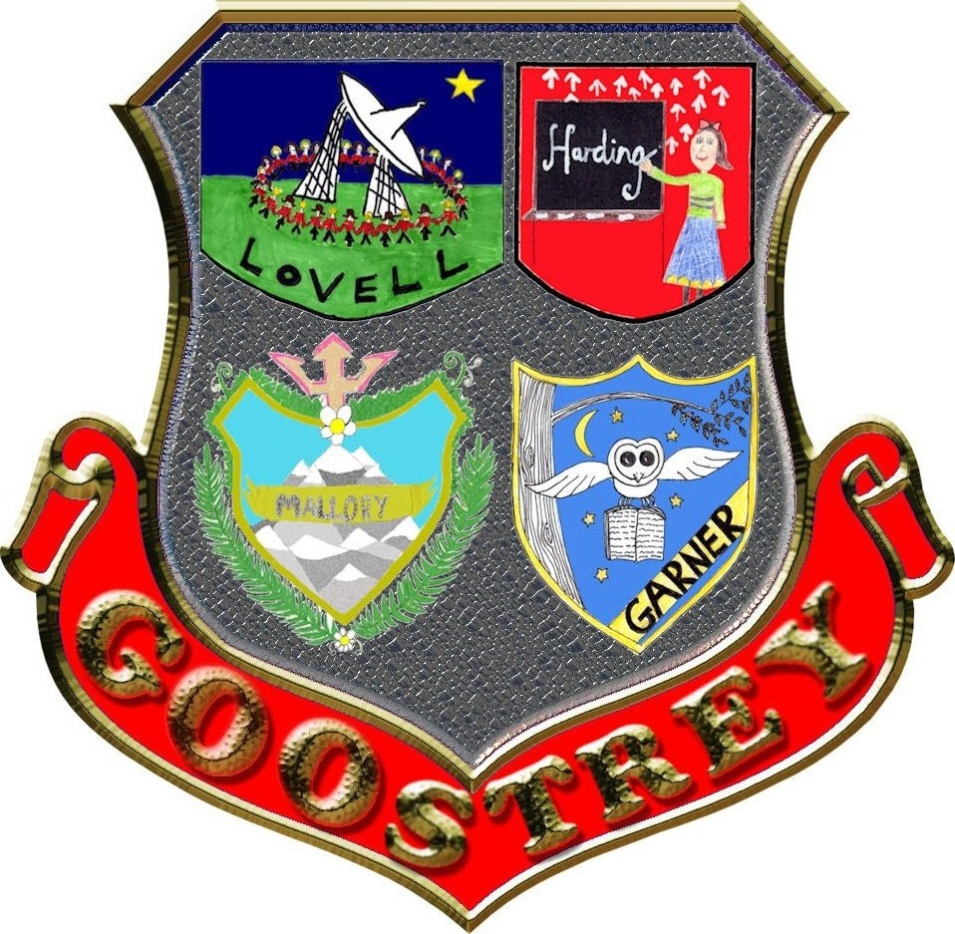
The House System At Goostrey School

Every child at Goostrey Community belongs to a house. They belong to the same house as their siblings and buddies.

The four houses are Mallory (Green), Garner (Yellow), Harding (Red) and Lovell (Blue).

The Year 6 House Captains conducted an assembly to explain, who each of the house figureheads were and some interesting facts about them. This information is also on the school website.
The pupils explained the significance of the colours of the houses.

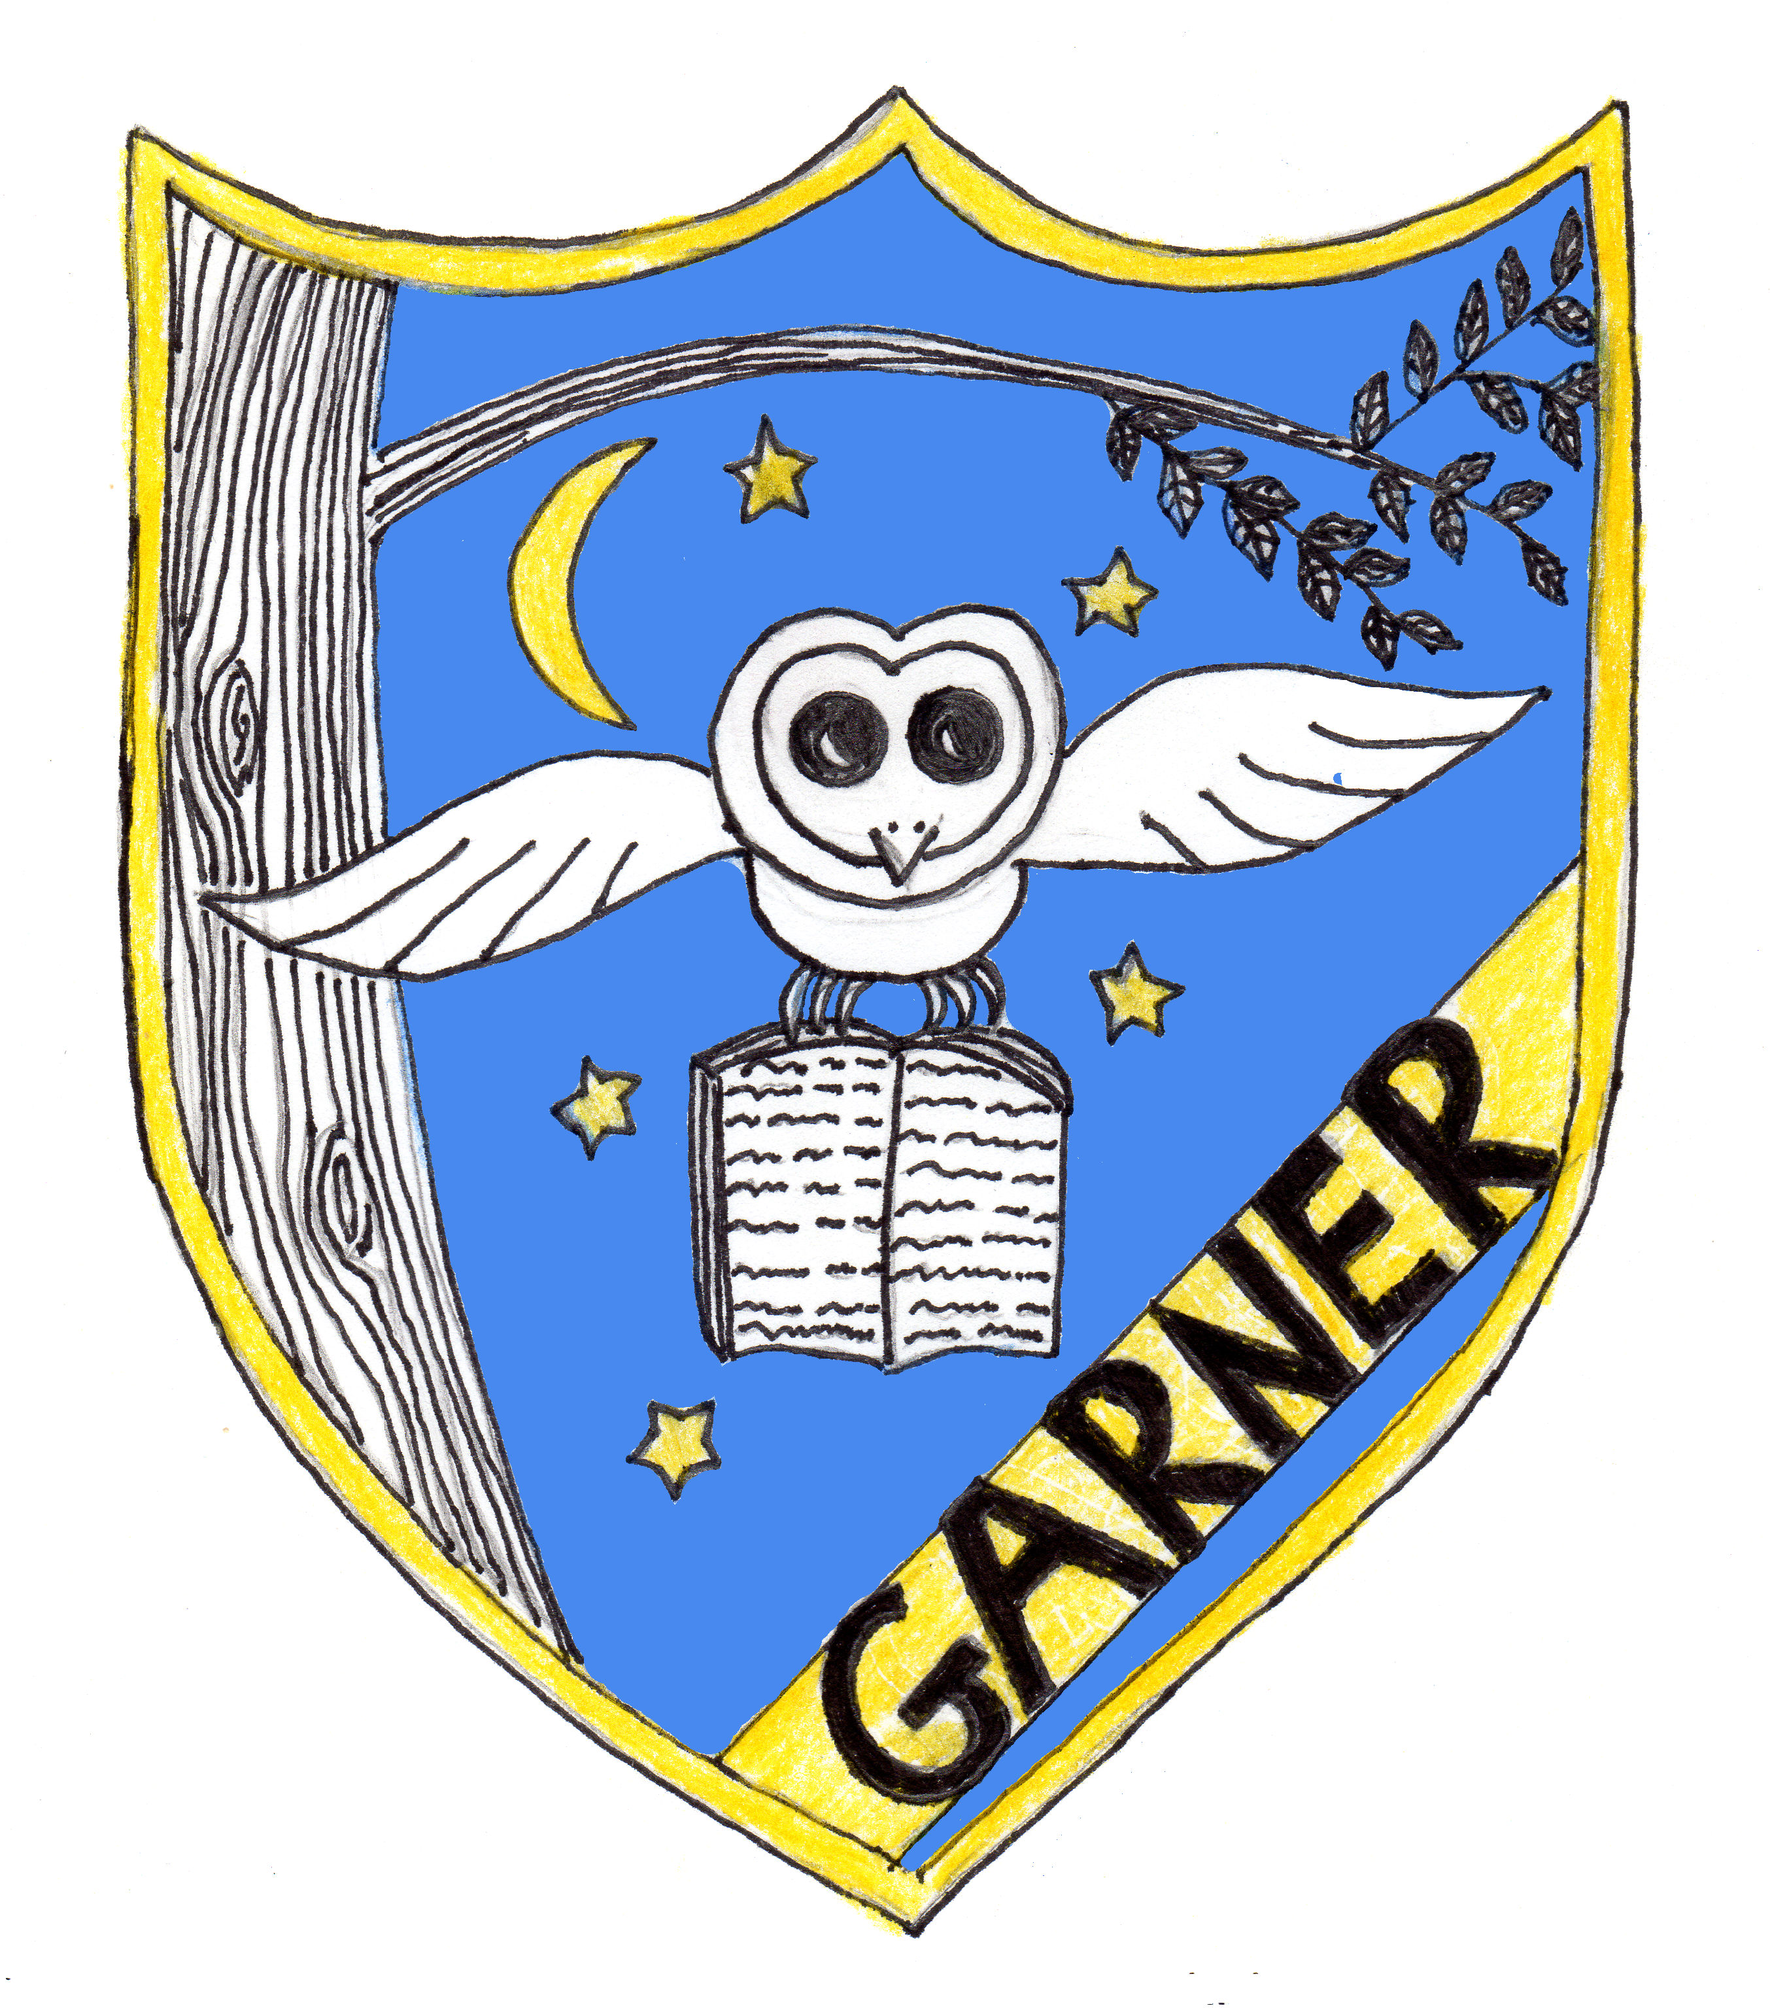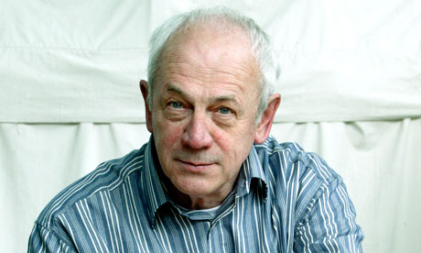

Yellow - Garner

The yellow house is named after Alan Garner, a local author. Alan Garner was born in 1934. He is an English novelist best known for his children’s fantasy novels and his retellings of traditional British folk tales. His work is based on the landscape, history and folklore of his native county Cheshire. He lives in the village of Goostrey in a house called Toad Hall. Many of his books are based on areas in our local area, such as Alderley Edge. Alan Garner was awarded an OBE in 2001 for his services to literature.

Yellow is a good colour for wizardry, potions and spells.

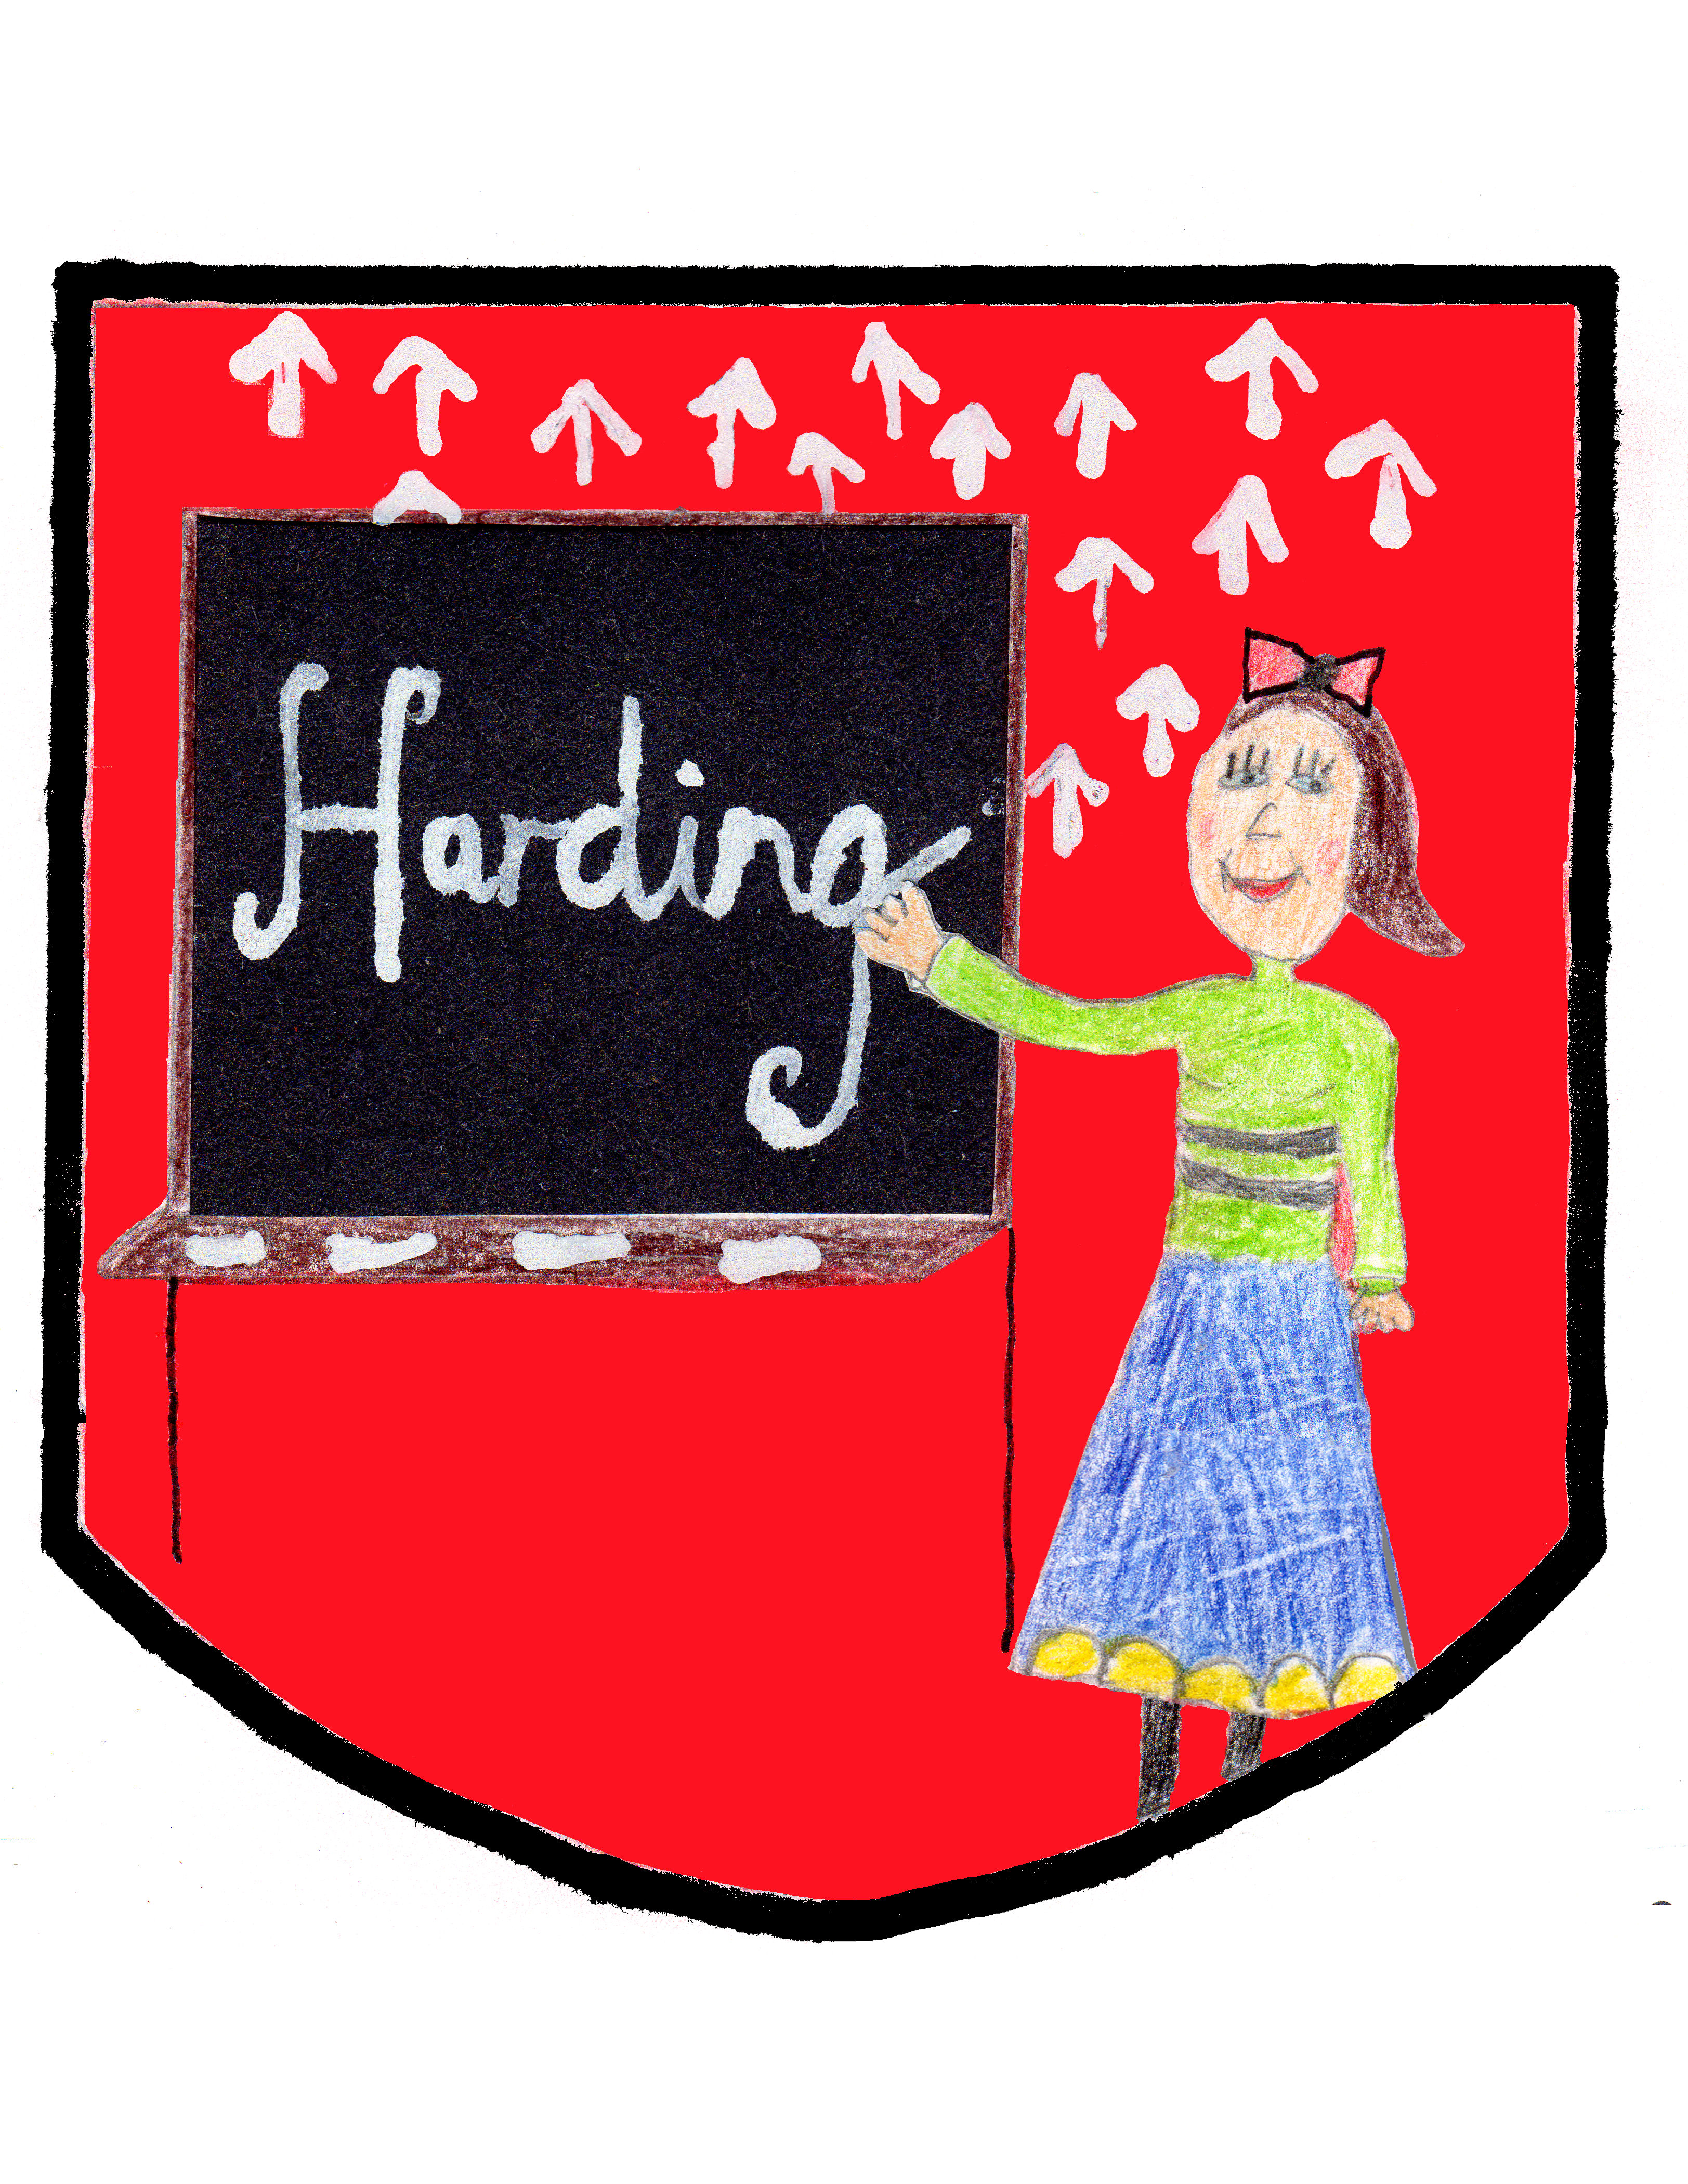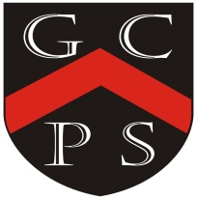

Red - Harding

The Red house is named after Miss Sarah Harding, who was the first Head teacher of our school. She was born in Macclesfield in 1820. Not much is known about Miss Harding other than she was the first mistress of Goostrey School, when the building on Main Road opened in 1856.
Red is the colour of our uniform.

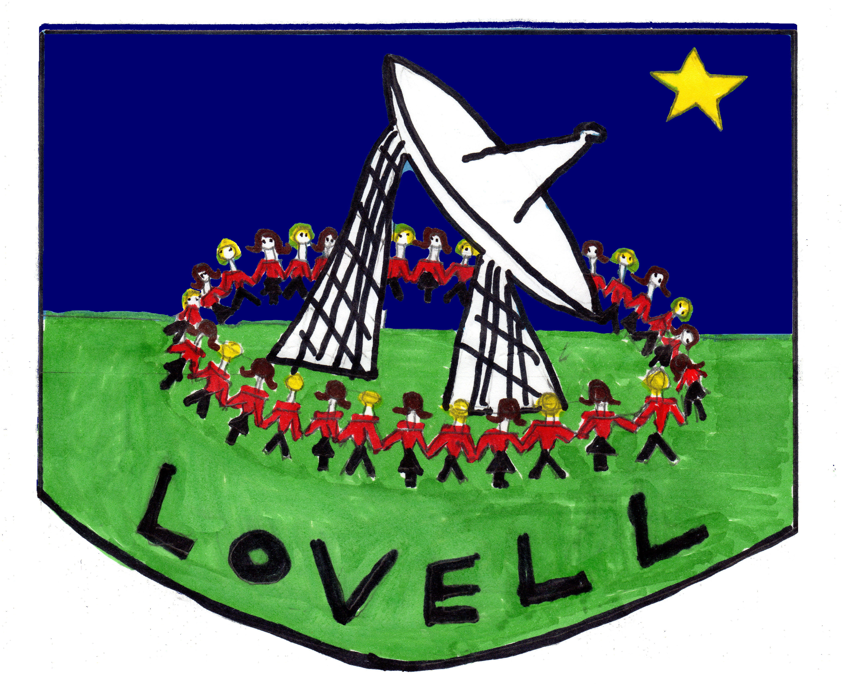

Blue - Lovell

The Lovell house is named after Sir Bernard Lovell. He developed the Jodrell Bank Observatory and he constructed the then-largest steerable radio telescope in the world, which now bears his name – the Lovell Telescope. Over 50 years later, Jodrell Bank remains a productive radio telescope, searching space for radio signals.
Lovell was knighted in 1961 for his important contributions to the development of radio astronomy. He was born in 1913 and died in 2012. The Lovell house is blue because the Lovell Telescope points to the blue sky.

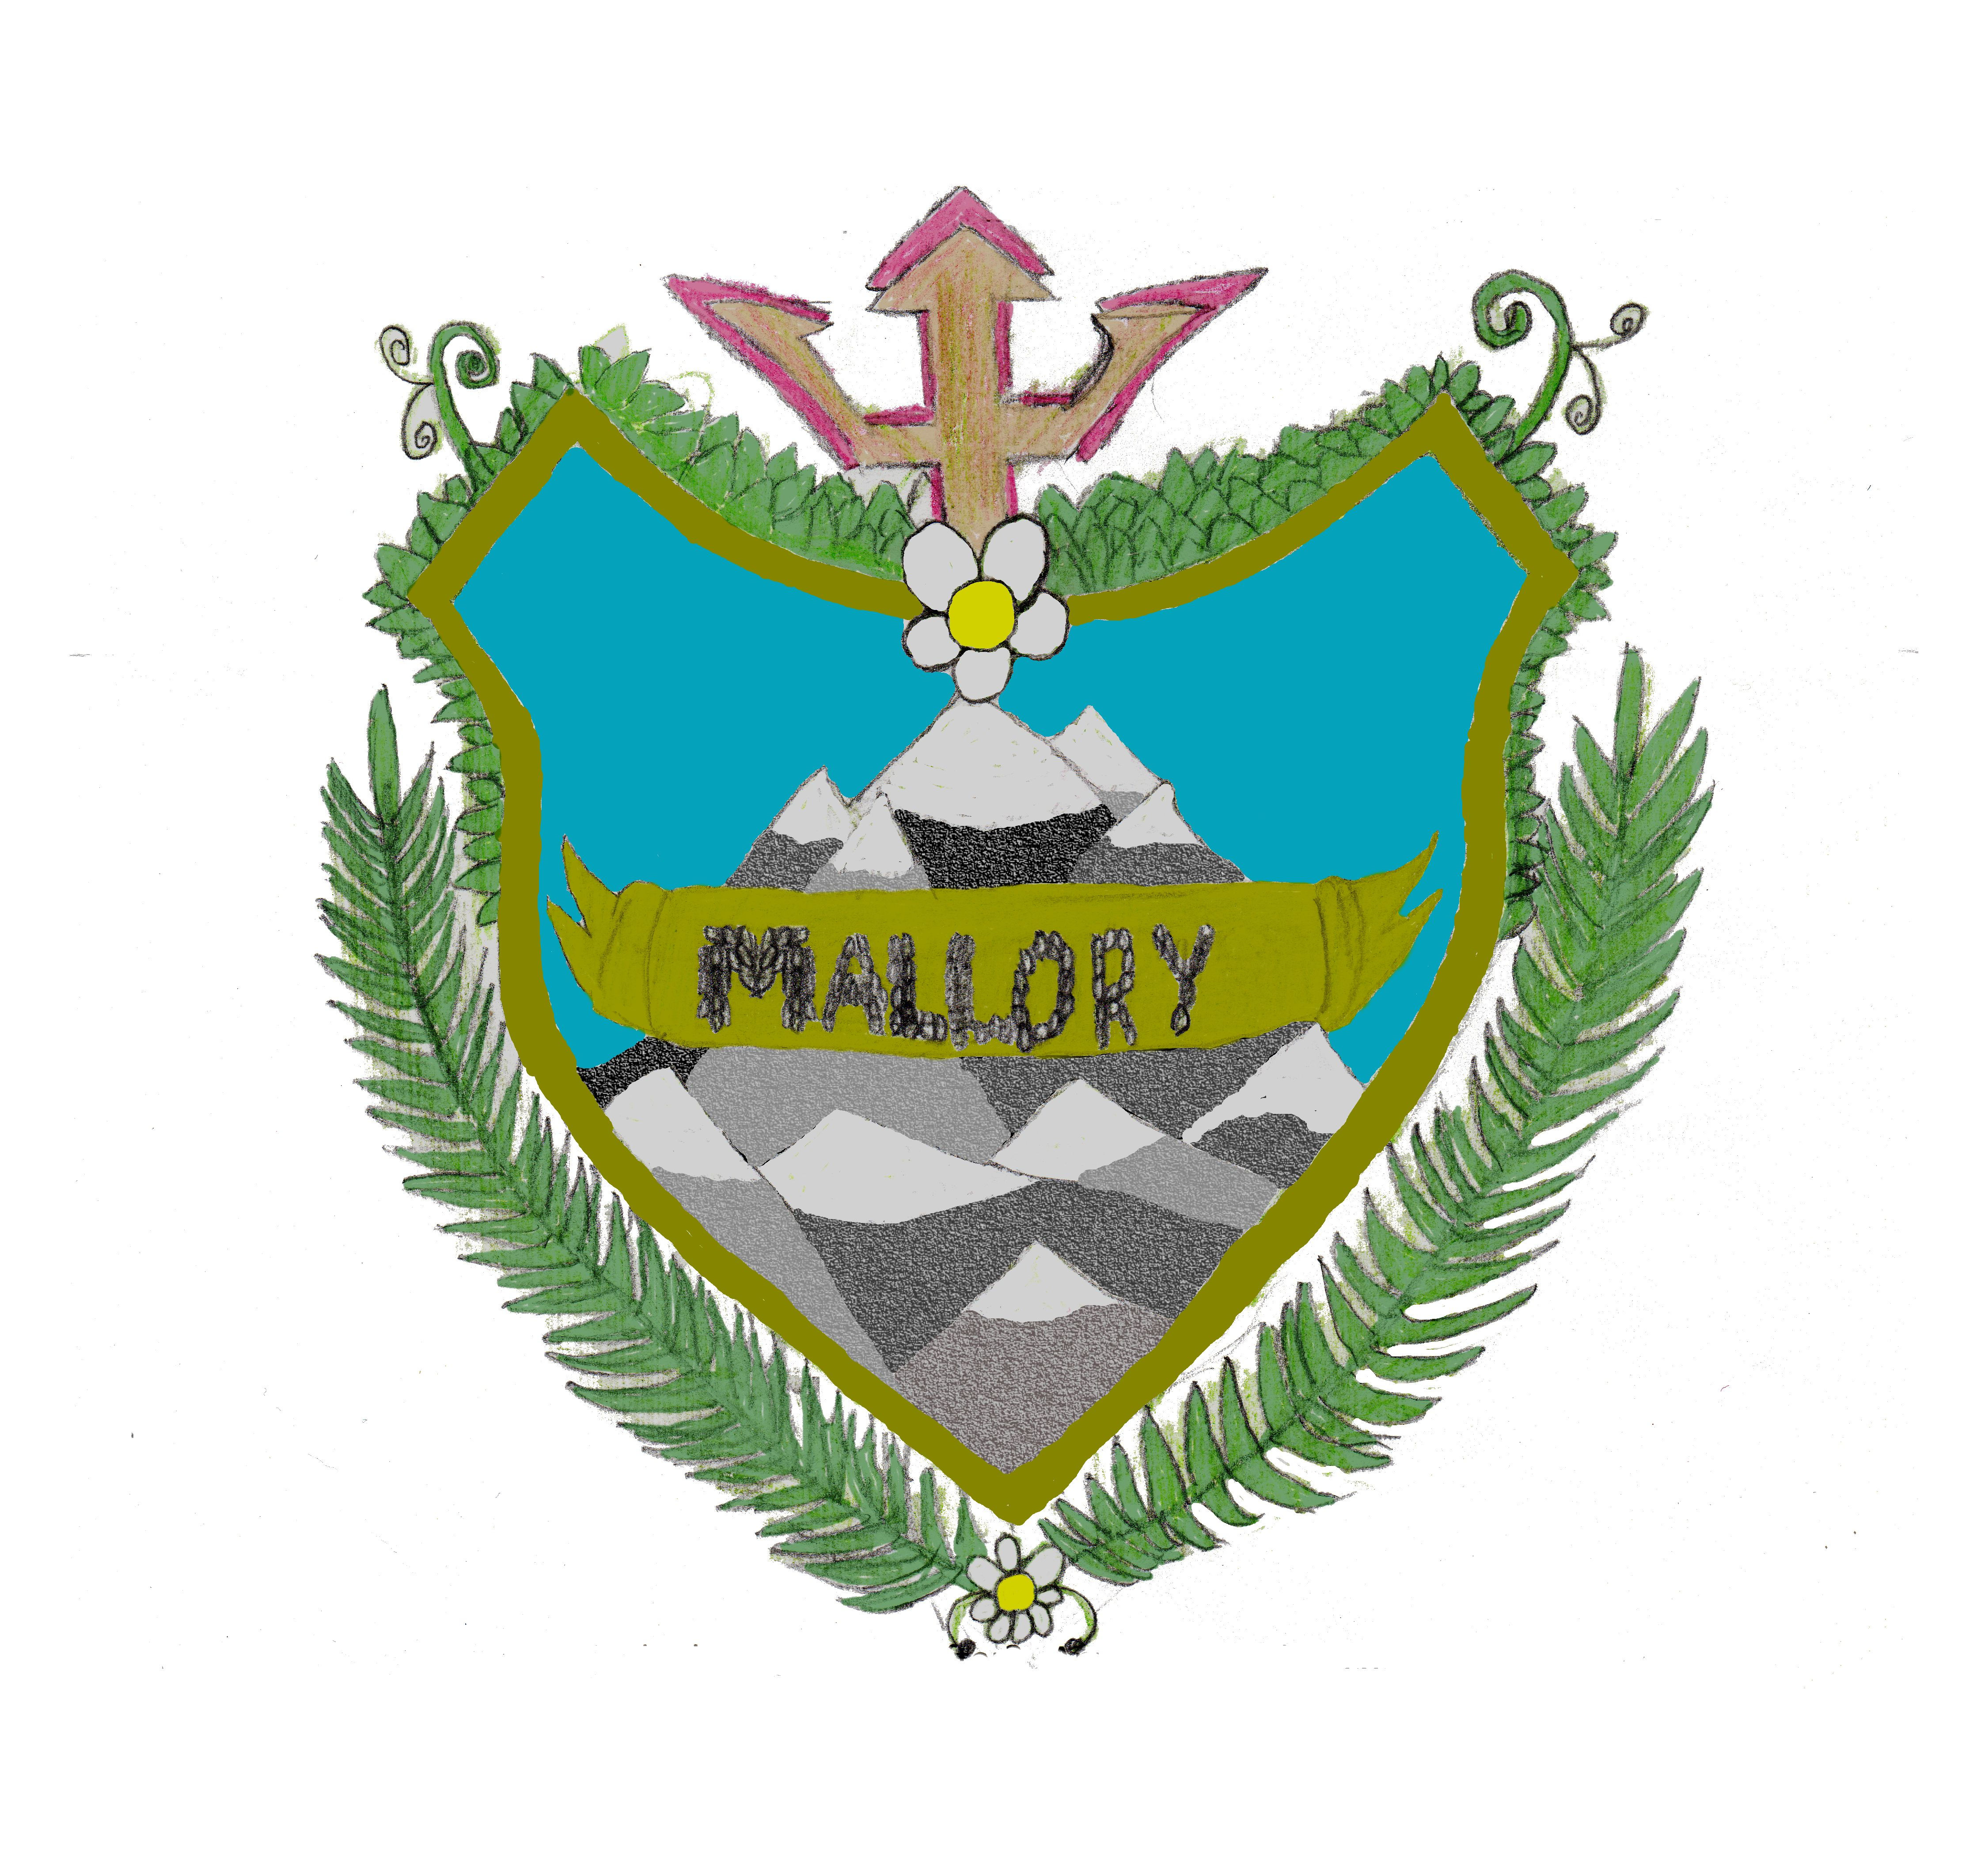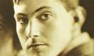

Green - Mallory

The green house is named after George Herbert Mallory. He was born in Mobberley in1886 and died in 1824. He was a mountaineer who took part in the first three British expeditions to Mount Everest in the early 1920s.
During the 1924 British Mount Everest Expedition, Mallory and his climbing partner, Irvine, both disappeared on the North-East ridge during their attempt to make the first climb of the world’s highest mountain. The pair were last seen when they were about 800 vertical feet (245m) from the summit.
Mallory’s ultimate fate was unknown for 75 years, until his body was discovered on 1 May 1999 by an expedition that had set out to search for the climber’s remains. Whether Mallory and Irvine reached the summit before they died remains a subject of speculation and continuing research, although people now believe they did reach the top.
Green is the colour of many mountains.

