
National Curriculum 2014 Planning Document
Goostrey Community Primary School
Yr 5
Maths
Appendix

Mathematics Appendix 1: Examples of formal written methods for addition, subtraction, multiplication and division

This appendix sets out some examples of formal written methods for all four operations to illustrate the range of methods that could be taught. It is not intended to be an exhaustive list, nor is it intended to show progression in formal written methods. For example, the exact position of intermediate calculations (superscript and subscript digits) will vary depending on the method and format used.
For multiplication, some pupils may include an addition symbol when adding partial products. For division, some pupils may include a subtraction symbol when subtracting multiples of the divisor.

Addition and subtraction
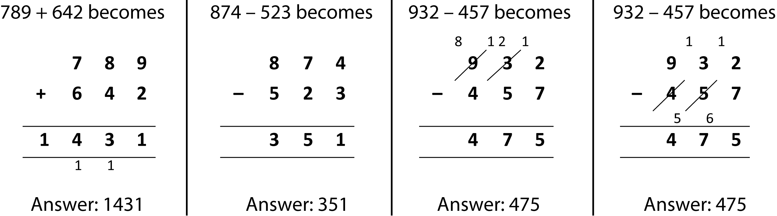

Short multiplication
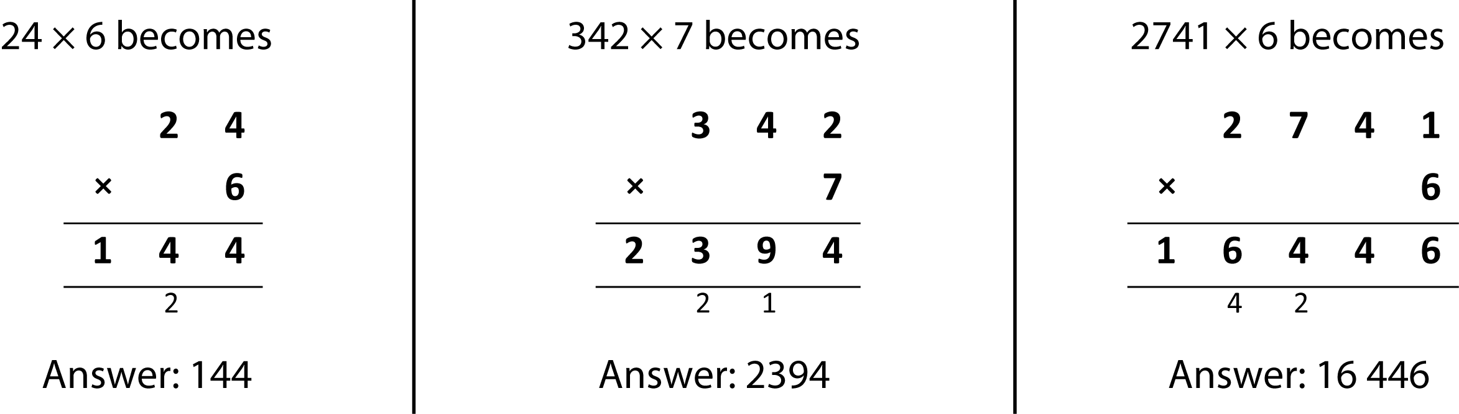

Long multiplication
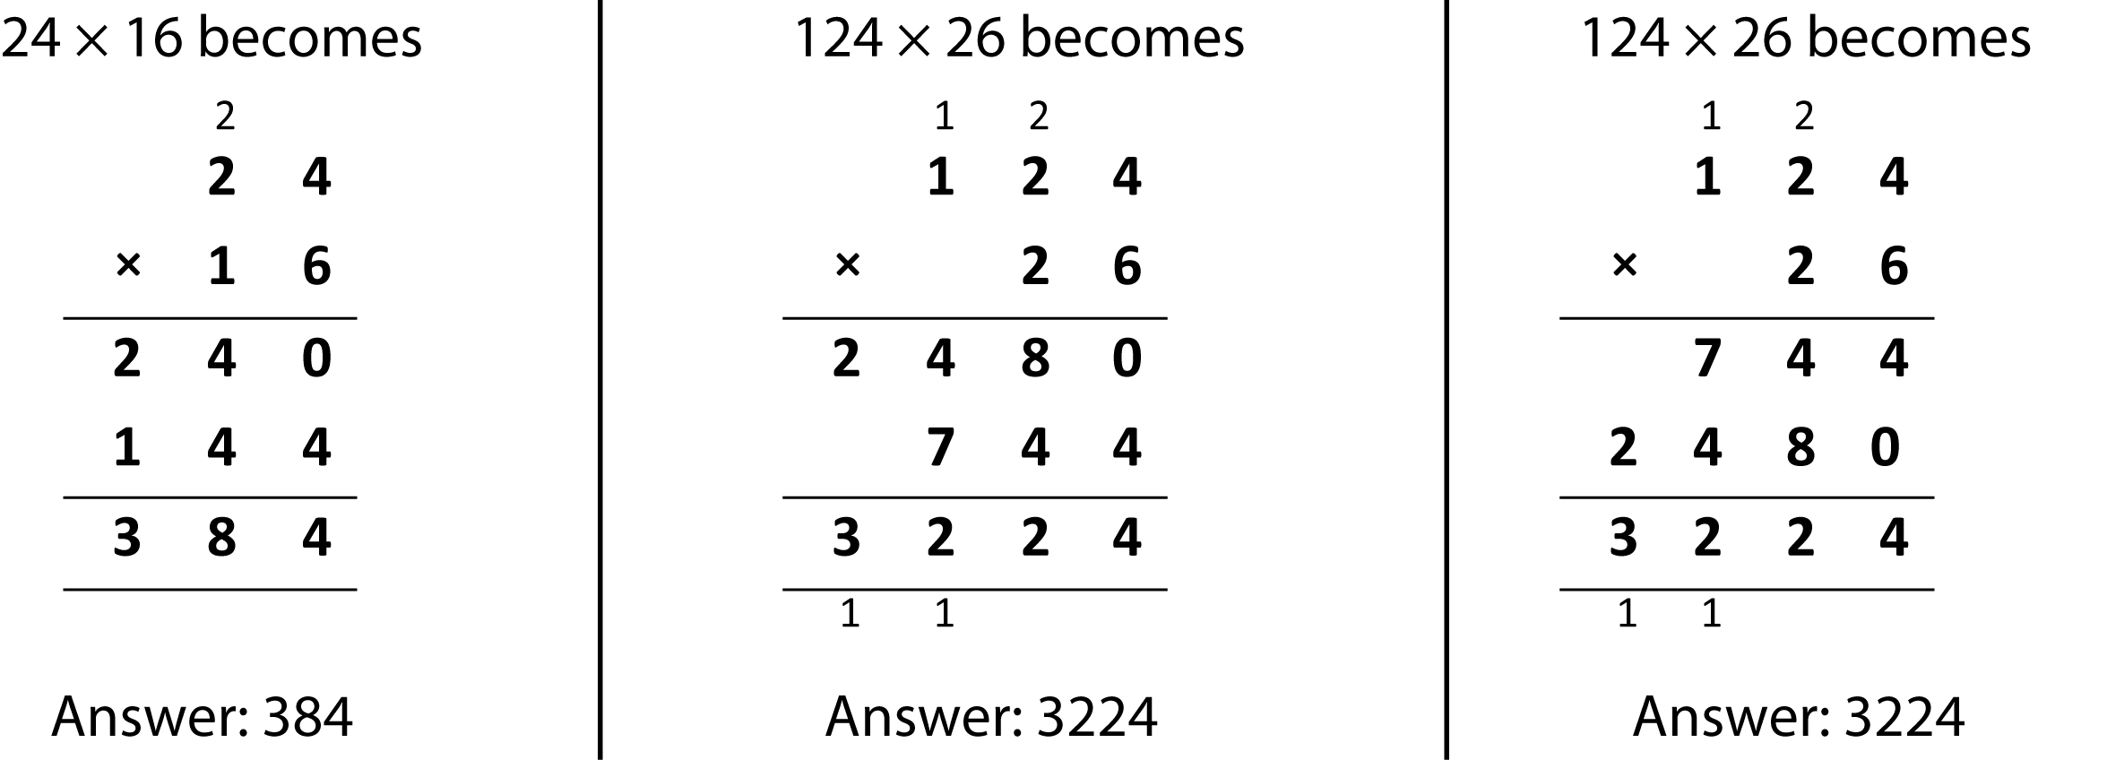

Short division
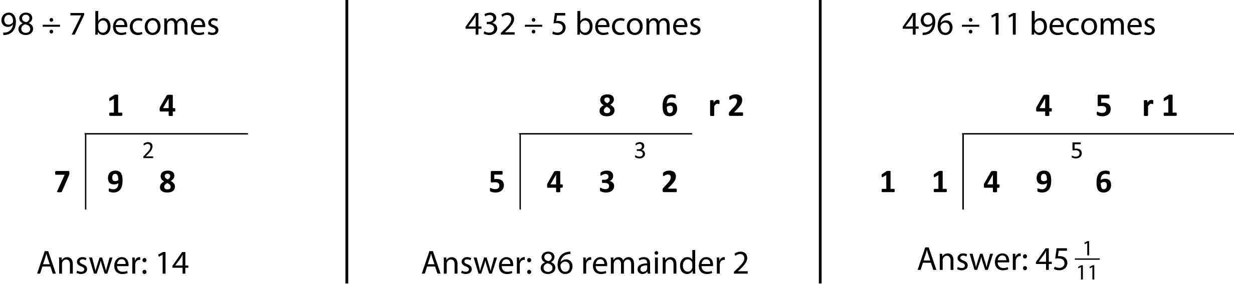

Long division
