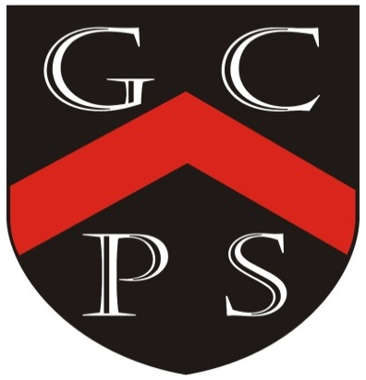

Drivers
For Our Curriculum:
Excellence Inclusivity Community Diversity
Challenging Reflective
For Our Pupils:
Knowledgeable Motivated Curious Healthy Resilient Independent Creative

Goostrey Community Primary School
Year 6 Curriculum Overview
Academic Year: 2025-2026
Teachers: Mrs Timmins and Mrs Cowell

 | Autumn 1 | Autumn 2 | Spring 1 | Spring 2 | Summer 1 | Summer 2

TOPIC | Exhibition  A Good Book  Pre-history  Stone Age  Bronze Age  Iron Age | Pre-history  Stone Age  Bronze Age  Iron Age | North America | North America | World  Geography  Locational knowledge  World climate zones |  | What A Performance!  History  Benin
ENGLISH | Exhibition Writing  Description  Fiction  Explanation | Historical Fact/  Fiction  Discovery Narrative  Explanation  Poetry  News Report  Diary | Scientific  Endurance  Narrative  Biography | Cultural Fiction  Flashback Narrative  Narrative with Dialogue  Traditional Tales  Dual Narrative  Discussion & Persuasion | Modern Fiction  Information Text  Narrative with action and description | Modern Fiction  Dialogue  Additional writing opportunities
MATHEMATICS | Number  Place Value  Addition, Subtraction, Multiplication and Division  Fractions A  Fractions B  Measurement  Converting Units |  | Number  Ratio  Algebra  Decimals  Fractions, Decimals and Percentages  Measurement  Area, Perimeter and Volume  Statistics |  | Geometry  Shape  Position and Direction  SATs Revision and National Assessments  Consolidation and Themed Projects  Bringing together all areas of the maths curriculum

Science | Scientific Enquiry Continuous
Science |  | Living things and their habitats | Evolution and Inheritance | Electricity | Light | Animals, including humans (health and circulation)
 | Digital Literacy – continuous – cross-curricular
Computing | Multi-media presentations | Branching databases – linked to science  PM | Coding  Purple Mash coding | Coding work - Micro-bits  including Nightlights | Spreadsheets using Microsoft Excel  PM | Coding work - Scratch
MFL | French 45mins a week  1.Let’s Vist a French Town  2.Let’s Go Shopping |  | French 45mins a week  3.This is France  4.All in a Day |  | French 45mins a week  5.Our Precious Planet  6.More to Explore
History | Stone Age  Bronze Age  Iron Age  Chronology – History of hats  (SR) | Stone Age  Bronze Age  Iron Age  Chronology – History of hats  (SR) |  |  |  | Benin Civilisation  – West Africa
Geography |  |  | North America  Map Reading | North America  Map Reading | Locational knowledge  Physical geography – biomes and climate zones  Links with Elizabethfontein | Benin  Nigeria – Location Study

A&D | Drawing and Painting  Printing  Stone Age art |  |  |  |  | Digital Media  Collage |  |  |  |  |  | Hats – Textiles  Sculpture  Clay work -  Benin Bronzes
D&T | History of Hats chronology  ½ term  Food Technology – Bread Making |  |  |  |  | Hats – inspiration from the greats  ½ term |  |  |  |  | Hat design and creation  Hat Walk
Music |  | Music Express  ½ term Christmas |  |  | Music Express  ½ term |  |  |  |  |  | Year 6 Performance – singing and performing  (LT, RC)
PE | Premier Sports  Friday |  | Premier Sports  Friday |  |  | Premier Sports  Friday |  |  |  | Premier Sports  Friday | Premier Sports  Swimming | Premier Sports  Friday
RE | Hinduism  How and why do Hindu’s show respect for living things?  Is the idea of God important in Hinduism |  | Christianity  Discipleship  Sermon on mount  Why do Christians believe God can be Father, Son and Holy Spirit?  Christmas. |  | Islam  What does it mean to belong to an Islamic community?  Why are the 5 Pillars of Islam important to Muslims? |  |  |  |  | Christianity  What do Christians believe about life after death? | Multi-faith  FREE CHOICE ENQUIRY  Heroes.  Past & Present? Impact? Who are heroes? Are heroes saints? What makes a hero? What impact did heroes leave on the world |  | Multi-faith  What does it mean to be human? How do beliefs shape a person’s identity?
Visits | Crucial Crewe |  | HATS – Milliner to visit |  |  | Mosque -tbc |  |  |  |  |  | Willersley  Buddy visit
PHSE | Buddy time and 7Up ongoing throughout the year
 | My Happy Mind |  |  |  |  |  |  | My Happy Mind  Human Rights |  |  | My Happy Mind  Enterprise
 | Relationships  No Outsiders  My Princess Boy |  |  | Relationships  No Outsiders  The Whisperer |  |  | Relationships  No Outsiders  The Island |  | Relationships  No Outsiders  Love You Forever |  | Relationships  No Outsiders  Dreams of Freedom | Relationships  Growing up and Moving on - transition

