Archbishop Hutton’s

VC Primary School

School Uniform Policy

September 2025

Review September 2026

Contents

Statement of Intent 4
Legal Framework 4
Key Personnel in Relation to this Policy 4
Roles and Responsibilities 5
Governing Board 5
Head Teacher 5
Teaching and support staff 5
Parents/carers 5
Pupils 5
Cost and Availability 5
Religious Clothing 6
Equality 6
Complaints and Challenges 6
School Uniform Supplier 7

Non-Compliance 7
Our Uniform 7
Our PE Kit 8
Forest School Clothing 8
Jewellery 9
School Bag 9
Water Bottle 9
Hair Styles 9
Make-Up 10
Adverse Weather 10
Hot Weather 10
Cold Weather 11
Labelling 11

Statement of Intent

Archbishop Hutton’s VC School is committed to promoting equality and value for money and to ensuring that no child is discriminated against due to their religion or belief, economic circumstances or social and cultural background. This policy contains provisions to meet these objectives and has been created with health and safety, value for money and practicality at its heart.

Additionally, it is important that our pupils feel a sense of belonging to our school. We believe that wearing a smart and practical uniform allows all children, regardless of their backgrounds, to feel equal to their peers and confident in their appearance.

We also believe it is important for children to wear clothing that is conducive to a successful learning environment, including activity-appropriate clothing, such as sports attire.

Legal Framework

This policy has due regard to all legislation including, but not limited to, the following:

- Education and Inspections Act 2006
- Education Act 2011
- Human Rights Act 1998
- Equality Act 2010
- The General Data Protection Regulation
- Data Protection Act 2018

This policy also has due regard to all relevant guidance including, but not limited to, the following:

- DfE (2014) ‘School Admissions Code’
- DfE (2013) ‘School Uniform’

This policy operates in conjunction with the following school policies and documents:

- Home-School Agreement
- Safeguarding and Child Protection Policy
- Complaints Policy
- Religious Ceremonial Wear

Key Personnel in Relation to this Policy

Name | Role(s)
Mrs Mary Jackson | Chair of Governors
Mr S Pugh | Head Teacher
Mr B McGurk | Deputy Head Teacher

Roles and Responsibilities

The Governing Board is responsible for:

- In consultation with the Head Teacher and school community, establishing a practical and smart school uniform that accurately reflects the school’s vision and values.
- Ensuring that equal opportunities are considered regarding the school’s uniform and that no person is discriminated against.
- Listening to the opinions and wishes of parents/carers, pupils and the wider school community regarding changes to the school’s uniform.
- Ensuring that the school’s uniform is accessible and affordable.

The Head Teacher is responsible for:

- Enforcing the school’s uniform on a day-to-day basis.
- Ensuring that school staff understand this policy and know what to do if a pupil is in breach of the policy.
- Listening to the opinions and wishes of the school community regarding the school’s uniform and making appropriate recommendations to the Governing Board.
- Providing pupils with exemptions as appropriate e.g. for a pupil who has a broken arm and requires a loose-fitting top.

Teaching and support staff are responsible for:

- Ensuring that pupils dress in accordance with this policy at all times.
- Taking appropriate action when pupils are in breach of this policy.
- Ensuring that pupils understand why having a consistent and practical school uniform is important e.g. to establish school identity.

Parents/carers are responsible for:

- Providing their children with the correct school uniform as detailed in this policy.
- Informing the Head Teacher if their child requires a more relaxed uniform policy for a period of time, including why.
- Ensuring that their child’s uniform is clean, presentable and the correct size.

Pupils are responsible for:

- Wearing the correct uniform at all times, unless the Head Teacher has granted an exemption.
- Looking after their uniform as appropriate.
- Respecting why a school uniform is important to the school e.g. to develop a sense of belonging.

Cost and Availability

In accordance with the School Admissions Code, Archbishop Hutton’s VC School ensures that the School Uniform Policy does not discourage parents/carers from applying for a place for their child.

The school is committed to meeting the DfE’s recommendations on costs and value for money.

Every care is taken to ensure that our uniforms are affordable for all current and prospective pupils, and that the best value for money is secured through reputable suppliers.

The school works with multiple suppliers to obtain the best value for money possible. Any savings negotiated are passed to parents where possible.

The school does not enter into exclusive single supplier contracts or cash-back arrangements.

The school does not amend uniform requirements regularly and takes the views of parents/carers and pupils into account when considering changes to school uniforms.

Where changes are required, the school ensures that assistance is provided to parents/carers struggling to meet the associated costs.

Religious Clothing / Ceremonial Wear

Some religions and beliefs require their members to conform to a specific dress code. The school does not discriminate against any religion or belief; however, the school weighs the needs and rights of individual pupils against the health and safety concerns of the entire school community.

Archbishop Hutton’s VC School endeavours to allow religious requirements to be met, wherever possible. Governors have adopted a policy for the wearing of Ceremonial Wear. Please make an appointment with the Head / Deputy to discuss the policy and to make any requests for Ceremonial wear to be worn in school.

Parents’/carers’ concerns and requests regarding religious clothing are dealt with on a case-by- case basis by the Head Teacher and Governing Board. This is always conducted in accordance with the school’s Complaints Policy.

Equality

The school is required to ensure that this policy does not discriminate unlawfully.

Every step has been taken to ensure that the cost of similar uniform items, for example, trousers versus skirts, are not disproportionate.

The school endeavours to ensure that our uniform is as gender neutral and inclusive as possible. We do not insist that children of any sex must wear specific items of clothing.

Complaints and Challenges

The school endeavours to resolve all uniform complaints and challenges locally and informally, in accordance with the school’s Complaints Policy.

To make a complaint, parents/carers should refer to the Complaints Policy and follow the stipulations outlined.

When a complaint is received, the school works with parents/carers to arrive at a mutually acceptable outcome.

Governors are willing to consider reasonable requests for flexibility to allow a pupil to accommodate particular social and cultural circumstances.

School Uniform Supplier

Our school uniform suppliers are:

The logo items of our school uniform can be purchased at The Uniform & Leisurewear Company shops in Lancaster or Morecambe and online.
Uniform is not available to purchase in school, however during term time, orders placed online can be delivered to school free of charge ready for you to collect.
The website address and shop addresses are -
http://www.ualonline.com/product-category/schoolwear/lancaster/archbishop-huttons-primary-school/
15 Common Garden Street, Lancaster, LA1 1XD - Open Monday to Saturday
60 Euston Road, Morecambe, LA4 5DG - Open Monday, Tuesday, Thursday, Friday & Saturday
Both shops can be contacted on 01524 388355

Additional book bags can also be purchased from our school office at any time.

Non-Compliance

On rare occasions, for example, if slogans on clothing are offensive, the Head Teacher and/or Deputy Head Teacher are permitted to ask a pupil to take off the clothing, such as a sweatshirt / jumper. In the event that they cannot take the clothing off, parents/carers will be contacted and they will be asked to bring in more suitable uniform/clothing.

On other occasions, for example, if a child is wearing inappropriate footwear, teaching and/or support staff will inform parents/carers by telephone or in-person.

If a child requires an item of uniform for a specific activity and no spare clothing is available in school, for example, Forest School, parents/carers may be asked to bring the item into school.

Individual family circumstances will be considered in the event that a child is not wearing the correct uniform. However, in accordance with our Safeguarding and Child Protection Policy, these should be recorded using our electronic recording system (Safeguard) where appropriate.

Sanctions for breaches of this policy are a last resort: the school endeavours to work with families to resolve breaches of this policy in a timely manner.

(All of our uniform can be purchased from High Street, Online or Supermarkets – apart from our logo sweatshirts and polos)

Our Children Wear:

- A plain royal blue sweatshirt/cardigan (with or without the school logo)
- Plain white shirts/blouses or plain white polo shirts (with or without the school logo)
- Grey or black skirts, pinafore dresses or trousers.
- Grey or black shorts can be worn in Summer
- Summer school-type dresses with either blue gingham checks or blue stripes
- Black, grey or white socks/tights
- Footwear: black or dark shoes or enclosed sandals. Black trainers are acceptable but must not be elaborately branded. All footwear should be plain and flat.
Coats:
- Pupils need to have a coat appropriate for the weather. Any colour is acceptable.
- It is important that hats, scarves and gloves are labelled with the child’s name as these are easily lost.
P.E. Kit:
(All of our PE Kit can be purchased from High Street, Online or Supermarkets – apart form our logo PE tee shirt)
- Plain black shorts
- T-shirt with school logo in a school team colour (available from our uniform supplier) or a plain tee shirt of the correct colour
- Pumps/plimsolls for indoor P.E. and trainers for outdoor P.E.
- Children may wear a tracksuit for outdoor P.E. in colder weather
- All P.E. kit needs to kept in a drawstring bag labelled with the child’s name. This will be kept on the child’s cloakroom peg.

P.E. kit should be brought to school on the first day of every half-term and left at school until the half-term holiday. P.E. kit may be sent home when it is particularly dirty.

Jewellery, watches and makeup

- No jewellery should be worn except for watches and stud earrings. These should be removed for P.E., games and swimming lessons by the child
- When children have their ears pierced, we ask parents to have this done during the summer holidays and to ensure that children know how to remove their own earrings.
- Children have to remove their earrings before both P.E. and swimming lessons. When a child is unable to remove their own earrings, then they should not wear them for school on P.E. and swimming lesson days.
- Children should not wear SMART watches as many are able to record or take photographs
- Your child should not wear make-up including nail polish to school.
- Children with long hair should have it tied back or put up.

School Bag

Pupils must use an appropriately sized waterproof bag to carry their books and equipment. It should hold children’s books and reading diaries comfortably without causing any damage.

Large bags / large rucksacks are discouraged for day-to-day lessons due to space on children’s pegs.

School bags featuring inappropriate images, slogans or phrases are not permitted.

The school encourages pupils to bring non-valuable bags to school. The school will not be liable for lost or damaged school bags.

Additional book bags can also be purchased from our school office at any time.

Water Bottle

All children should bring a water bottle into school every day: this can be refilled by children whenever necessary during the day.

Water bottles must be labelled with the pupil’s name.

Hair Styles

Hairstyles should be smart and moderate in style. Brightly coloured hair is not permitted.

Pupils with what could be deemed extreme hairstyles may be exempt from the rule above on racial or religious grounds.

The Head Teacher will take each individual pupil’s scenario into consideration.

Long hair should be tied up. This is to avoid health and safety risks and ensure that children’s vision is not impeded.

Large, excessive hair accessories should not be worn; however, small hair clips or plain headbands are acceptable.

At the Head Teacher’s discretion, there may be exceptions to the above in extreme circumstances
e.g. a pupil may be permitted to cover their hair if they have hair loss / illness etc.

Make-Up

False nails and nail extensions are not permitted. Only clear nail varnish may be worn.
Children are not allowed to wear make-up.
Pupils wearing make-up are required to remove it or, if appropriate, will be sent home to remove it. At the Head Teacher’s discretion, there may be exceptions to the above in extreme circumstances
e.g. a pupil may be permitted to cover heavy scarring/skin damage.

Adverse Weather

Hot Weather

Everyone working at/attending the school during hot weather conditions is required to wear sun-safe clothing that covers as much of their skin as possible.

This includes wearing:

  - Loose fitting tops with collars or covered necklines
  - Tops that cover the shoulder area
  - Grey or black shorts or pale blue and white summer dresses of an appropriate length (if families wish to)
  - Sun-safe hats
  - Sunglasses with UV protection
  - Sunscreen (children must be able to apply this themselves and it must be labelled and handed to the child’s class teacher)

During hot weather, lightweight clothing is required to reduce the risk of overheating. Pupils are not required to wear their jumpers/cardigans during heatwaves.

If outside during break and lunch times, pupils not wearing sun-safe clothing/sunscreen are advised to stay in an area protected from the sun.

Cold Weather

During cold weather, pupils are required to wear scarves, gloves, coats and hats when they are outside.

Additional layers underneath the usual school uniform are accepted.

Where possible, pupils not wearing warm clothing are provided with spare clothing if going outside during break and lunch times.

Labelling

School staff encourage good organisation of clothing and footwear, for example, designated spaces for children to keep belongings in and checking of labels. However, all pupils’ clothing and footwear must be clearly labelled with their name.

Clothing and footwear are the responsibility of the pupil and not the school.

If a child goes home in another child’s clothing by accident, for example, their jumper, parents/carers should send the clothing not belonging to them back into school to their child’s class teacher.

Any lost clothing is to be taken to the lost property box. All lost property is retained for a term and is disposed of if it is not collected within this time.

Appendix 1 – Quick Reference Guide to School Uniform

The images below are intended as a guide. We do allow sweatshirts/cardigans with our school logo on and plain navy ones. We also accept grey or black trousers/skirts/shorts.

For more information, please read our School Uniform Policy in full.

Winter | Summer | PE
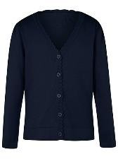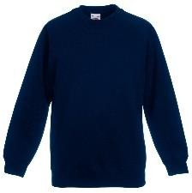  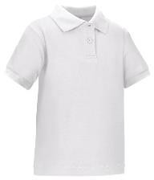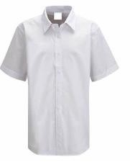  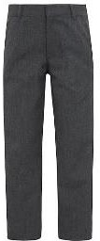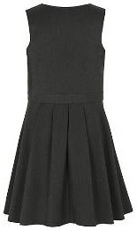  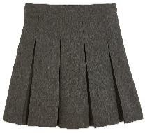  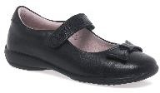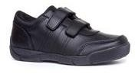  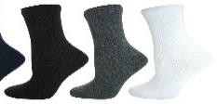  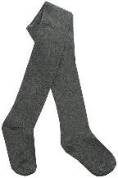 | 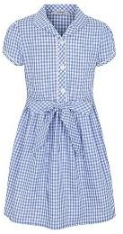  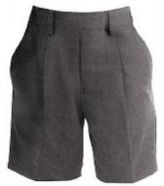 | 