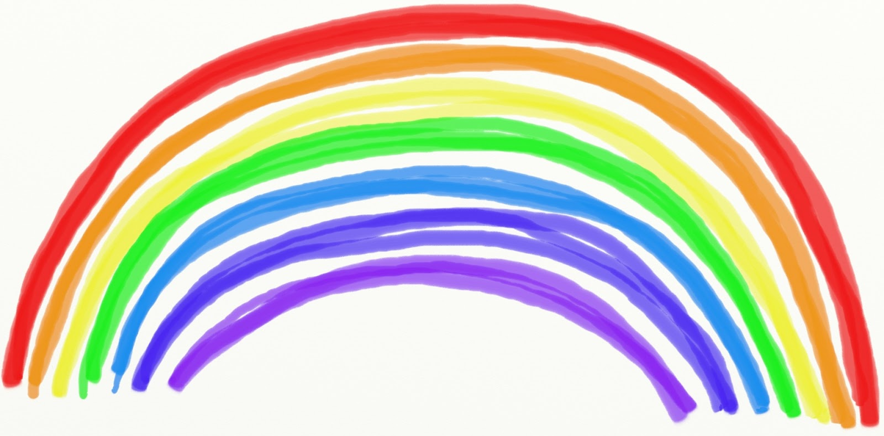
Year of the lockdown 2020
We are so proud we were your teachers,
We watched you learn and grow.
We worked so hard and had such fun,
How fast did the time go?!
The year was interrupted,
It seemed too soon to part.
But know that you will always have,
a special place in our heart!
See you next year !
Love
Your teachers x

