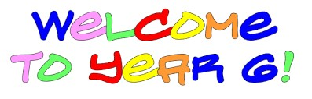
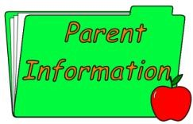
General
Just like in Year 5 your child will be given a grid with a wide range of homework tasks that you can complete. You can bring the completed tasks to school or put them on your new Year 6 Google Classroom which will be ready for you for September.
As I am sure you are aware we would normally be going on our residential trip to Cardiff in October but due to the COVID-19 pandemic this will not be possible. I would like to think we could go later in the year. As soon as I have any further informatin I will let you know.
Please work on your times-tables each week. It is really important to have learned all of the multiplication tables by Year 6 and know them really well for when you go to high school.
This term our main topic Land of My Fathers. This is a geography based topic where we will be learning about the geography of Wales. I ask the children to contribute ideas for topic learning. This has worked really well in the past. It gives them a sense of qwnership over their learning which leads to increased participation and enjoyment.

Dear Parents / Carers,
This information sheet will give you additional information regarding your child’s learning in Year Six. Should you feel you need to contact me regarding your child at any point in the school year please contact the office and I will get back to you as soon as I can. I look forward to working with you and your children.
Kind Regards
Ms. King
Reading and Spelling 
In Year 6 we do a reading task and/or a reading assessment once every fortnight. We also have a free choice reading book for when we have time for silent reading. This can be a book from school or home. We still expect children to continue to read books of their own choice at home.
We do not have weekly spelling tests in Year 6. Often children learn the words for the test and then still misspell them in their free writing. So in Year 6 we have spelling lessons and we correct any errors from our free writing.

Blwyddyn 6 2020/2021
Autumn Term
PE Kits
In Year Six our PE days are Wednesday and Friday. Please send a note with your child if they are unable to do PE for any reason. For health and safety reasons all earrings must be removed for PE lessons and long hair tied back.
Collecting your child from school
If you wish your child to walk home on their own in September or walk to meet you the other side of the fence this needs to be put into writing to me.
Thank you for your co-operation with this.

