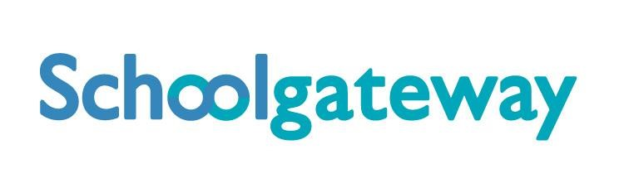


Visit the website: www.schoolgateway.com

June 2020

SCHOOL COMMS

You can make online payments to school via credit or debit card

Introducing the School Gateway App or website. This means you will be able to make online payments via the School Gateway smartphone app or website for school meals and educational visits.

The school has a separate account for school meals, only meal payments can be made here. You will be able to view school meal balances and top them up at any time to keep your account in credit.

Educational trips, snack etc can also be paid online and will be linked to your child’s account.

Aside from saving the school time and money on administration, School Gateway will also make it easier for parents to pay any time 24-7 and reduce the amount of cash being carried by children on school premises.

What you need to do now

Activate your School Gateway account. It’s quick and easy to do. All you need are your email address and mobile number that school holds on record for you.

• Download the app: If you have a smartphone, please download School Gateway from your app store (Android and iPhone).

OR

• Visit the website: www.schoolgateway.com and click on ‘New User’. You’ll receive a text message with a PIN number. Use this PIN to log into School Gateway.

If you’re having trouble logging in, it may be because the school doesn’t have your current email and mobile phone number on record. Please call the school and we’ll update the details on our system.
We hope you will find School Gateway to be a fast and easy way to pay for school items.

