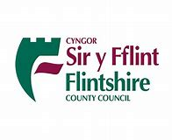
**Heriau Cymraeg Challenges** @CymraegSyFflint
Her 1  Canwch efo fi! Sing with me! Dilynwch y linc. Follow the link.  Cyd-ganwch-beth am recordio’ch hunain ac anfonwch trydar atom!  Sing along – why not record yourself and send us a tweet!  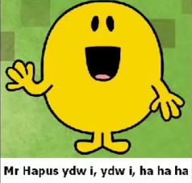  Mr Hapus ydw i! | Her 2  Amser Stori! Story Time!  Watch and listen to the story Salad Ffrwythau then try the interactive games. Gwyliwch a gwrandewch ar y stori Salad Ffrwythau, wedyn trïwch y gemau rhyngweithiol.  Salad Ffrwythau.  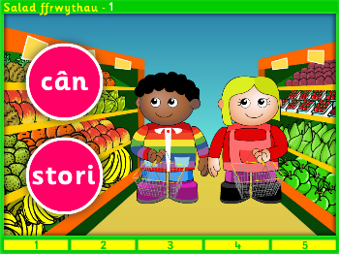 | Her 3  Amser Gwneud! Time to Make!  After reading the story Salad Ffrwythau, why not make your own fruit salad? Ar ôl darllen stori Salad Ffrwythau, beth am wneud salad ffrwythau eich hyn? Tynnwch lun! Take a picture and show us on twitter! |   Her 4  Canwch efo fi! Sing with me! Counting to 10 yn Gymraeg. Cyfri i10 yn Gymraeg.  Cyd-ganwch - Beth am recordio’ch hunain ac anfowch trydar atom!  Sing along – why not record yourself and send us a tweet!  Can y cyfri!  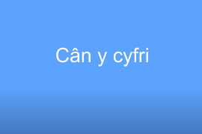 | Her 5  Gwyliwch efo fi! Watch with me!  Watch an episode of Fflic a Fflac. Gwyliwch raglen Fflic a Fflac.  In this episode Fflic a Fflac write a letter to Elin and create their own postbox. Mae Fflic a Fflac yn ysgrifennu llythyr at Elin ac yn creu blwch post.  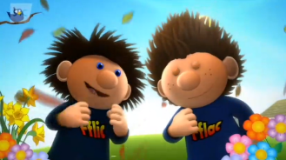  Y Llythyr .
Her 6  Amser Darganfod! Time to Discover!  Collect 10 things in your house that are the same colour. Can you name them all yn Gymraeg? Casglwch 10 peth o’r run lliw o amgylch y tŷ. Gallwch chi enwi nhw i gyd yn Gymaeg? Tynnwch lun a dangoswch i ni! Take a picture and show us on Twitter!  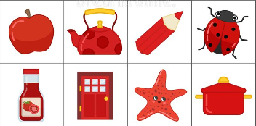 | Her 7  Canwch efo fi! Sing with me! Practising the Alphabet yn Gymraeg & learning the signs. Ymarfer yr Wyddor yn Gymraeg a dysgu’r synnau.  Sing and sign along – why not record yourself and send us a tweet!  Yr Wyddor!  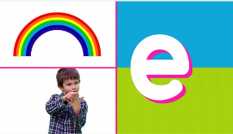 | Her 8  Amser Ysgrifennu! Time to Write!  Can you write to a family member or friend to say hello? Use some familiar welsh phrases. Gallwch chi ysgrifennwch at ffrind neu deulu i ddweud helo? Defnyddiwch frawddegau gyfarwydd. Why not use j2e or Adobe Spark on Hwb. Take a picture and show us on twitter what you’ve written!  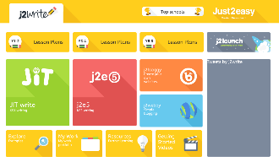 | Her 9  Dewch i Ddawnsio! Come and Dance! Sing and dance along to the Cyw and Friends song. Dawnsiwch a chanwch i gân Cyw a’i Ffrindiau. Sing and dance along – why not record yourself and send us a tweet!  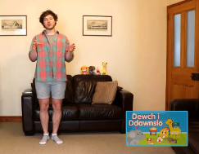  Cân Cyw a’i Ffrindiau. | Her 10  Amser Chwarae Gemau! Time to Play Games!  Llawrlwythwch app Cyw – chwaraewch y gemau. Pa un wyt ti’n hoffi? Download the app Cyw – play the games. Which do you like?  Tell us on twitter using “Dwi’n hoffi…achos mae’n…”  CYW App  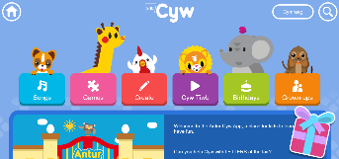
Her 11  Amser Stori! Story Time!  Watch and listen to the story Ynys Hwyl a Sbri then try the interactive games. Can you find the treasure? Gwyliwch a gwrandewch ar y stori Ynys Hwyl a Sbri, wedyn trïwch y gemau rhyngweithiol. Gallwch chi ddarganfod y trysor?  Stori Ynys Hwyl a Sbri.  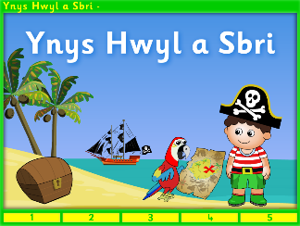 | Her 12  Amser Gwneud! Time to Make!  After reading the story Ynys Hwyl a Sbri, why not make your treasure map? Ar ôl darllen stori Ynys Hwyl a Sbri, beth am wneud map trysor eich hyn? Tynnwch lun! Take a picture and show us on twitter! | Her 13  Canwch efo fi! Sing with me! Practising the Days of the Week yn Gymraeg. Ymarfer Dyddiau’r Wythnos yn Gymraeg.  Cyd-ganwch-beth am recordio’ch hunain ac anfowch trydar atom!  Sing along – why not record yourself and send us a tweet!  Diwrnodau’r Wythnos!  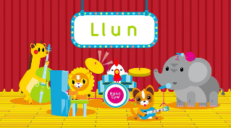 | Her 14  Amser Darganfod! Time to Discover!  Collect 10 things in your house that start with one letter of the Welsh alphabet. Can you name them all yn Gymraeg? Casglwch 10 peth yn dechrau gyda’r run lythyren yn yr wyddor Gymraeg? Gallwch chi enwi nhw i gyd yn Gymaeg? Tynnwch lun a dangoswch i ni! Take a picture and show us on Twitter!  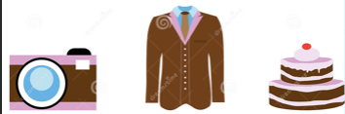 | Her 15  Canwch efo fi! Sing with me! Say thank you to our Essential Workers by singing the Diolch i Chi song! Dywedwch diolch i’n gweithwyr allweddol drwy ganu’r cân Diolch i Chi!  Sing along – why not record yourself and send us a tweet!  Cân Diolch i Chi.  