L.O. Multiplying and Dividing by 10, 100 and 1000 16.07.15
REMEMBER! When you multiply your digits move left and when you divide your digits move right. The distance they move depends on the amount of zeros in your number. If you are multiplying by 100 they move left, 2 spaces because 100 has 2 zeros! The decimal point does not move!
MULTIPLY

10
100
1000?
DIVIDE ÷
MULTIPLY x
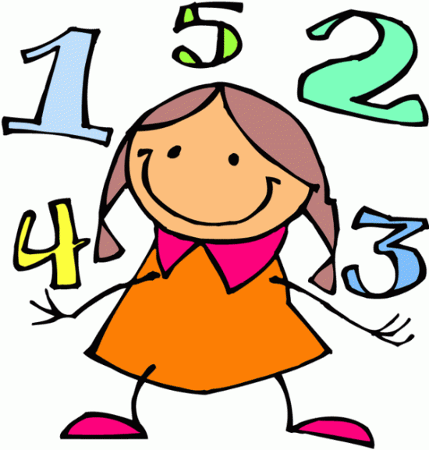
- 39 ÷ 10 = …………….
- 410 ÷ 100 = …………….
- 654 ÷ 1000 = …………….
- 8.3 ÷ 10 = …………….
- 342.5 ÷ 100 = …………….
- 0.23 ÷ 100 = …………….

- 68 x 100 = …………….
- 3.4 x 100 = …………….
- 9.83 x 10 = …………….
- 0.24 x 100 = …………….
- 321.45 x 1000 = …………….
- 43 x 10 = …………….
- 789 x 100 = …………….
- 3.5 x 100 = …………….
- 58.3 x 10 = …………….
- 0.324 x 1000 = …………….
- 2.098 x 100 = …………….
f) 98.02 x ………… = 98020
g) 9.002 ÷ ……… = 0.09002
h) 2.0901 x ……….. = 2090.1
i) 0.124 ÷ …………. = 0.00124
j) 18.9802 ÷ …….. = 1.89802
a) 73 x ………… = 7300
b) 873 ÷ ……….. = 87.3
c) 0.802 x 100 = …………
d) …….......÷ 1000 = 42.09
e) 9.231 x ………. = 923.1



- I start with the number 324. I subtract 268 from this and divide this answer by 10. What number do I end up with? …………….
- I start with the number 24. I multiply this by 36. I divide my answer by 100. What is my final number? ………..
- I think of a number. I add 7 to it and then divide it by 10. My answer is 3.8. What number did I start with? ………….

