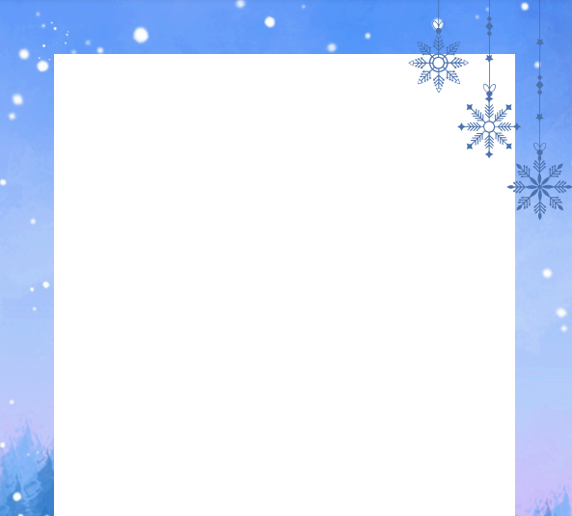

Reception Newsletter Spring Term 1
Topic
This half term our topic is all about the chilly wonders of winter, titled 'Brrr...It's Cold!'. We will be exploring the four seasons, with a special focus on Winter. The children will learn about different types of clothes we wear in each season and how the weather changes throughout the year.
Our first story focus this half term is One Snowy Night, where the children will be introduced to Percy the Park Keeper and the woodland animals in his care. We'll also explore how different animals adapt to the cold and learn about hibernation.
As we near the end of the half term, we'll be comparing where we live to the Polar Regions. We'll take a look at the climate and the animals that call this frosty place home, giving the children a chance to explore and compare these places to where they live.
Maths
This half term we will continue to develop the children’s understanding of addition, exploring a range of fun and practical methods they can use to solve problems. We will then begin to introduce subtraction, using practical activities to help the children understand the concept, before moving on to recording their ideas as number sentences.
Language
In language the children will be using their phonic knowledge to begin sounding out words phonetically as they write. We will be using the story One Snowy Night to describe some of the characters, encouraging the children to include tricky words they have been learning. The children will also be focusing on remembering and using correct letter formations, using the phrases they have learnt to support them. In addition, the children will be writing their own animal fact files, with a focus on Arctic animals.
Snack
We will also be introducing rolling snack this half term. This means the children will be able to choose when they have their snack throughout the morning. A member of staff will always be available to support the children at the snack station, but this approach helps to encourage independence as the children learn to access their own snack, recycle their milk bottles and food waste and tidy away after themselves. Rolling snack also provides a great opportunity to develop social skills and promote the use of Welsh.
Thank you for your continued support,
Mrs Taylor, Mrs Meyrick and Mrs Cleave
