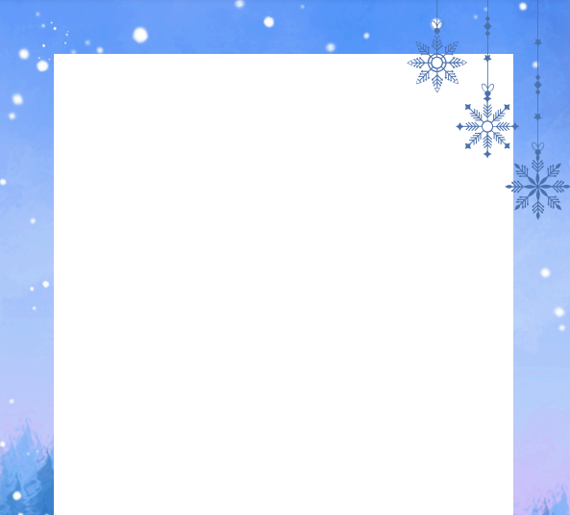

Nursery Newsletter Spring Term 1
Topic
This half term our topic is all about the chilly wonders of winter, titled 'Brrr...It's Cold!'. We will be exploring the four seasons, with a special focus on Winter. The children will learn about different types of clothes we wear in each season and how the weather changes throughout the year.
Our first story focus this half term is One Snowy Night, where the children will be introduced to Percy the Park Keeper and the woodland animals in his care. We'll also explore how different animals adapt to the cold and learn about hibernation.
As we near the end of the half term, we'll be comparing where we live to the Polar Regions. We'll take a look at the climate and the animals that call this frosty place home, giving the children a chance to explore and compare these places to where they live.
Phonics
We will be starting our phonic sessions this half term. Each week we will focus on a new sound, introducing fun songs and phrases to help the children remember the letter sounds and learn how they are formed. Throughout our provision areas the children will take part in a range of activities to help reinforce the sounds they are learning.
Maths
In maths, we will continue to develop the children’s understanding of numbers. We will be focusing on number recognition, counting, and ordering numbers. The children will also begin learning about one more and one less than a given number through practical activities.
Snack
We will also be introducing rolling snack this half term. This means the children will be able to choose when they have their snack throughout the morning. A member of staff will always be available to support the children at the snack station, but this approach helps to encourage independence as the children learn to access their own snack, recycle their milk bottles and food waste and tidy away after themselves. Rolling snack also provides a great opportunity to develop social skills and promote the use of Welsh.
If your child brings their own snack, please could you continue to ensure that snack boxes and food items are clearly labelled where possible.
Thank you for your continued support,
Mrs Taylor, Mrs Morgan, Mrs Hughes and Miss Morgan
