
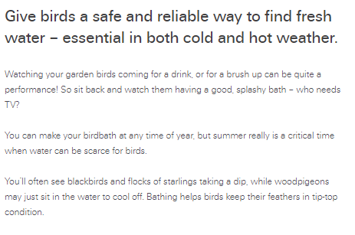

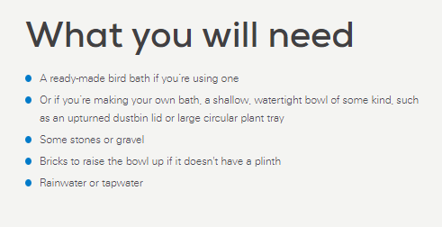

Step by step guide
- The golden rules for birdbaths.
Too many birdbaths are just not the shape that birds like. It should:
  - have very shallow sloping sides
  - have a maximum depth of only 10cm or so
  - be as wide as possible, ideally more than 30cm across.
- Make your bird bath. Lay out four bricks on a piece of open lawn or border, where the birds will have a good view all around but can dart into the cover of bushes or trees nearby if they need to. If you have cats visit your garden, make sure there is nowhere they can hide within pouncing distance.
- Then put an upturned old, galvanised dustbin lid on top of the bricks. Make sure it is stable.
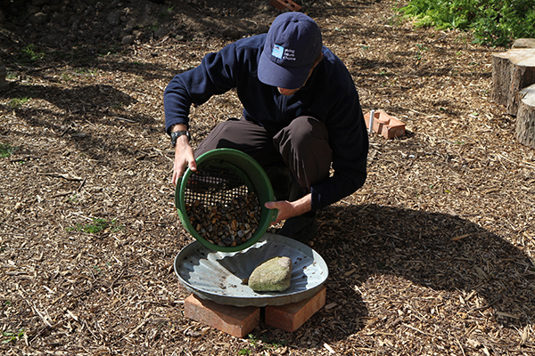
- Is the bird bath slippy? Feel if the inside of the bird bath is too smooth. If it is, the birds might slip into the water. Put some pebbles or rocks in the water to give them a better grip.
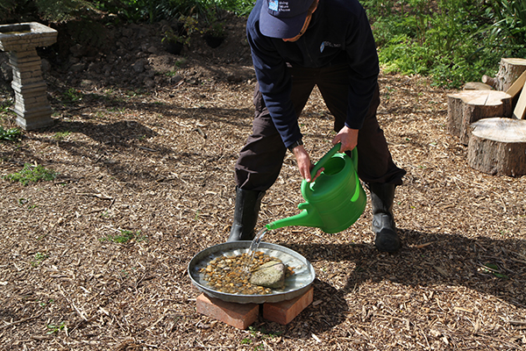
- Fill with water (tapwater is fine) and watch! Birds most water when the weather is very hot or very cold. You’ll need to keep the bird bath well topped-up in summer and ice-free in winter.
In frosty weather, you should never use salt or de-icer. Pour in warm (not hot) water, or gently knock the ice out and replace with fresh water from the tap.
- What you'll see. Blackbirds, robins, sparrows and starlings love a quick dip, while woodpigeons may just sit in the water to cool off! You'll even see bumblebees coming for a drink! Bathing helps birds keep their feathers in tip-top condition. If you see a bird having a bath in your creation and you have a camera to hand, take a picture and share it.

