Lesson 3- How do we use mobile phones safely?
Talk to your grown up- What is a mobile phone? What are they for? Can you do any other things on a mobile phone? What is good about mobile phones? What is bad about mobile phones?
Task 1- Fill in the table below. Why are mobile phones good thing and why can they be a bad thing?

Good  | Bad 

Task 2- Talk to your grown up- How can you keep yourself safe when using a mobile phone?
Create a poster telling people how to keep themselves safe when using a mobile phone. You may want to include rules. Make sure you make you poster eye catching so people will want to read what it says.
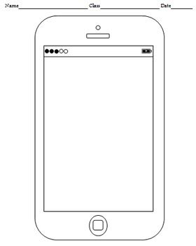
You could use the mobile phone template below or create your own ideas!

