Mount Primary School
Computing
Curriculum Design
Long Term Plan & Progression
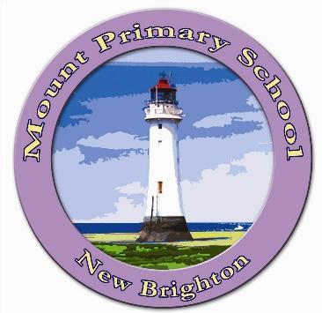

Computing Intent
The intent of our computing curriculum at Mount Primary School is to help pupils become independent, creative, safe, respectful and problem-solving digital citizens with a broad and transferrable skillset. At Mount, we make use of Connected Computing Curriculum which helps to make computing fun for pupils, inspiring them to develop skills beyond the classroom, as well as building an awareness of all the opportunities the subject provides.
Our Computing long term plan has been designed to make sure pupils learn computing skills from the three recognised aspects of computing (below) within each year of their primary education. This means that pupils will build upon skills and concepts they established from the previous year and develop them further in the current and subsequent year. The curriculum will be taught in a two year cycle making sure that all elements of the curriculum are covered in each academic year.
The three aspects of Computing are:
- Computer Science- this covers programming (both block-based and text-based), including computational thinking using web-based software such as code.org and a variety of apps. Pupils across Key Stage 1 and 2 will write code to program physical and on-screen objects, interactive games and use text-based language. Pupils in Key Stage 1 will use Bee Bots for Physical Coding with Key Stage 2 using Micro:bits
- Information Technology- This covers the use of a variety of applications to create digital content, including document creation and editing, video making, digital art, graphic design, animation, 3D modelling and website building.
- Digital Literacy- Using Common Sense Media, pupils will cover all aspects of the Online Safety Curriculum.

Online Safety

A key part of implementing our computing curriculum is to ensure that safety of our pupils is paramount. We take online safety very seriously and we aim to give children the necessary skills to keep themselves safe online. Children build online resilience through the use of the Common Sense Media framework. The framework aims to support and broaden the provision of online safety education, so that it is empowering, builds resilience and effects positive culture change. The objectives promote the development of safe and appropriate long-term behaviours, and support educators in shaping the culture within their setting and beyond.

Computing Implementation
Our progressive medium and short term planning ensures that pupils develop subject knowledge and their computing skills as they work through sequences of lessons, revisiting and building on prior learning.
The Connected Computing Curriculum includes activity packs with step-by-step, easy to follow planning, presentations and resources. This has many advantages including:
- Pupils can learn computing skills at their own pace, developing independent learning skills with opportunities to continually review and revisit the skills covered.
- In Key Stage 1 pupils will use iPads to access a variety of apps and websites. Teachers will record observations through Google Classroom ie pictures, videos and screenshots.
- Key Stage 1 teachers will ensure that pupils are provided with consistent verbal feedback throughout the lessons and assess through pictures and recordings.
- In Key Stage 2 pupils will use chromebooks and iPads to access the curriculum. Teachers will assign work on Google Classroom as an online portfolio. Where appropriate pupils will hand in on Google Classroom work for the teacher to measure the impact of the lesson.
- Key Stage 2 pupils will reflect on their work through verbal or written feedback on Google Classroom, work can be returned and edited.
- All pupils will access code.org for their computer science work. Each pupil will have their own login and data will be recorded on the website.
- All pupils will complete an end of unit assessment through Wayground.
- EYFS will access a range of apps to ensure that pupils enter Year 1 with a strong foundation in computing.

Computing Impact
Our children enjoy and value computing and know why they are doing things, not just how. Children will understand and appreciate the value of computing in the context of their personal wellbeing and the technological, creative and cultural industries and their many career opportunities.

Progress in computing is demonstrated through regularly reviewing and scrutinising children’s work. Using Google Classroom as a digital portfolio allows teachers to see their learning journey over time. Pupil voice interviews are also an important part of assessing the impact of our curriculum. These will be done regularly. The computing curriculum will contribute to children’s personal development in creativity, independence, judgement and self-reflection. This would be seen in them being able to talk confidently about their work, and sharing their work with others.

∙ Our aim is for our exciting and engaging computing curriculum to have direct impact on the lives of our children, inspiring them to pursue the digital careers of the future.
∙ Finding the right balance of integrating technology into the pupils lives is also important and through our Online Safety objectives, our children will be able to monitor and assess their own screen time and online behaviours.
∙ Impact of teaching and learning is measured by end of topic assessments and audio-visual evidence collated through the children’s Google Classroom.
∙ We hope to have great impact on our pupils lives and we are continually adapting and honing our curriculum to meet their needs in the ever changing world of the internet.

Long term plan:
EYFS:
To ensure that pupils enter Year 1 with a strong foundation of key skills and knowledge in computing they will access the following areas through a range of apps and activities.
Computer Science
Physical Computing: Bee Bots
Problem Solving
Directional Language
Co-ordination
Digital Literacy
Taking Photographs
Digital Art
Typing
Digital Music
Online Safety
Caring for Devices
Imagine Safety

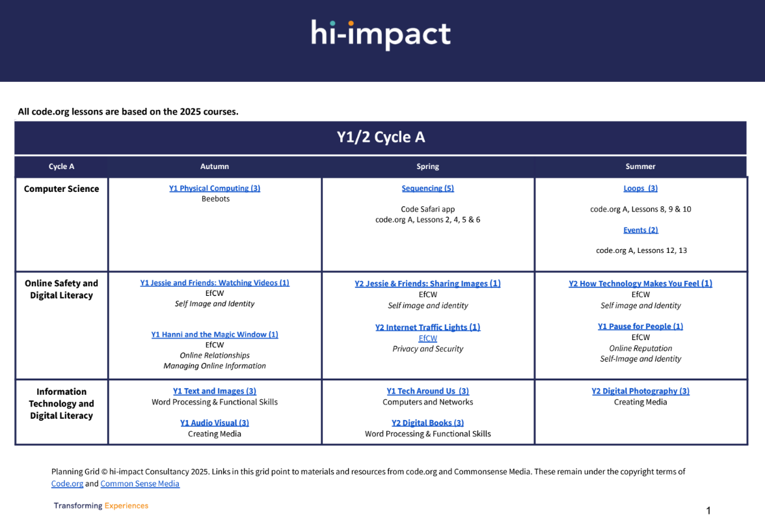

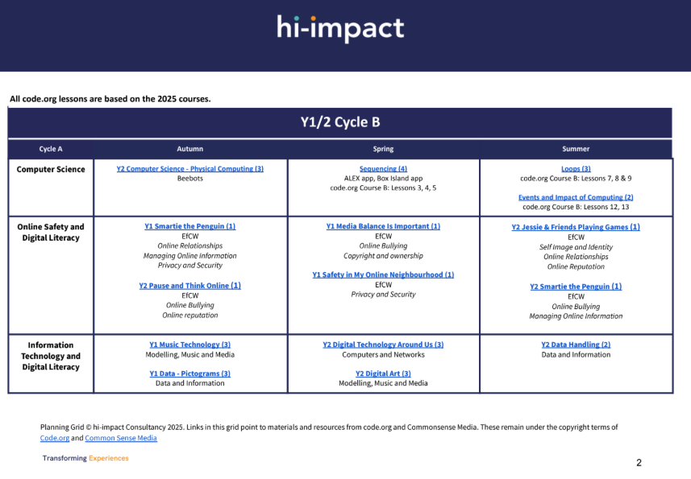
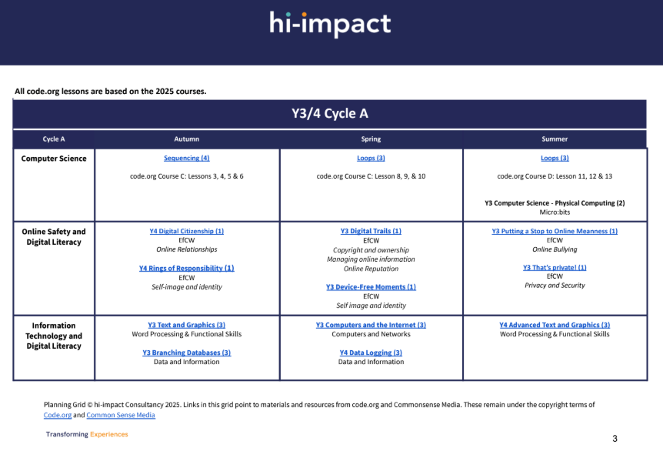
Statutory Coverage
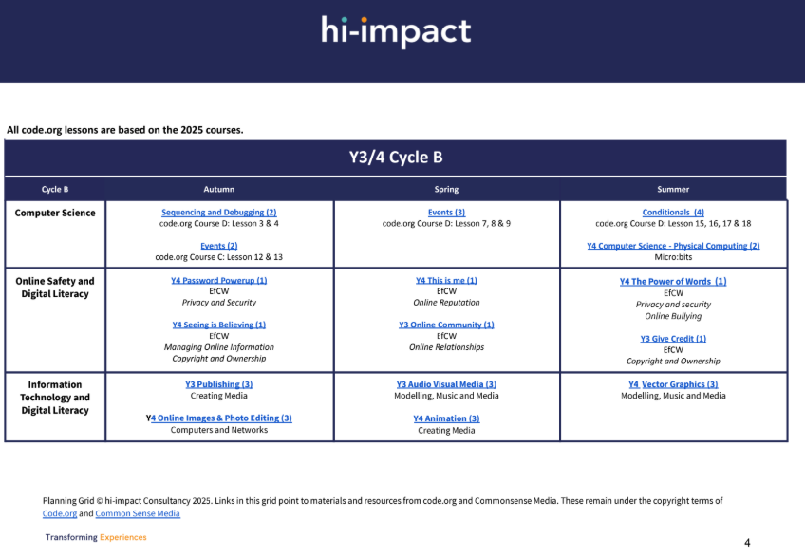

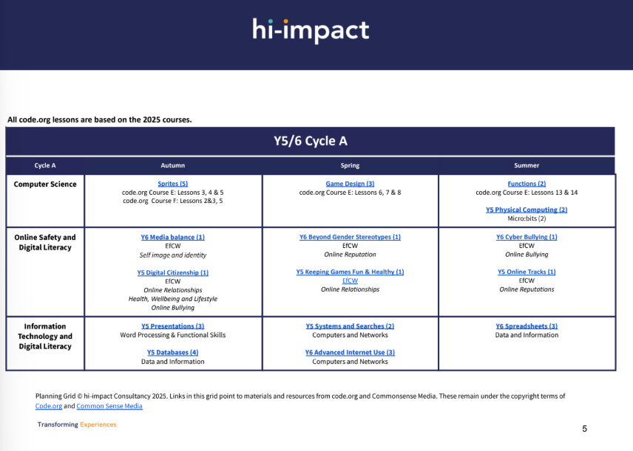

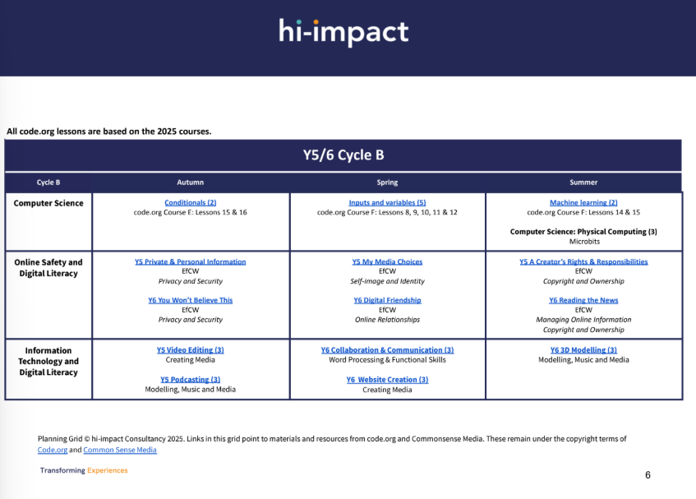
National Curriculum & EYFS | F2 | KS1 | KS2
National Curriculum & EYFS | Personal, Social, and Emotional Development  Show resilience and perseverance in the face of a challenge. Know and talk about different factors that support their overall health and well-being. Sensible amounts of screen time.  Physical Development  Develop their small motor skills so that they can use a range of tools competently, safely and confidently. Expressive Arts and Design  Explore use and refine a variety of artistic effects to express their ideas and feelings.  ELG  Personal, Social and Emotional Development- Managing Self  Be confident to try new activities and show independence, resilience and perseverance in the face of challenge. Explain the reasons for rules, know right from wrong and try to behave accordingly.  Expressive Arts and Design- Creating with Materials  Safely use and explore a variety of materials, tools and techniques, experimenting with colour, design, texture, form and function. | Pupils should be taught to:  ∙ Understand what algorithms are; how they are implemented as programs on digital devices; and that programs execute by following precise and unambiguous instructions  ∙ Create and debug simple programs  ∙ Use logical reasoning to predict the behaviour of simple programs  ∙ Use technology purposefully to create, organise, store, manipulate and retrieve digital content  ∙ Recognise common uses of information technology beyond school  ∙ Use technology safely and respectfully, keeping personal information private; identify where to go for help and support when they have concerns about content or contact on the internet or other online technologies | Pupils should be taught to:  ∙ Design, write and debug programs that accomplish specific goals, including controlling  ∙ Or simulating physical systems; solve problems by decomposing them into smaller parts  ∙ Use sequence, selection, and repetition in programs; work with variables and various forms of input and output  ∙ Use logical reasoning to explain how some simple algorithms work and to detect and correct errors in algorithms and programs  ∙ Understand computer networks including the internet; how they can provide multiple services, such as the world wide web; and the opportunities they offer for communication and collaboration  ∙ Use search technologies effectively, appreciate how results are selected and ranked, and be discerning in evaluating digital content  ∙ Select, use and combine a variety of software (including internet services) on a range of digital devices to design and create a range of programs, systems and content that accomplish given goals, including collecting, analysing, evaluating and presenting data and information  ∙ Use technology safely, respectfully and responsibly; recognise acceptable/unacceptable behaviour; identify a range of ways to report concerns about content and contact.

Progression Map – Key Vocab
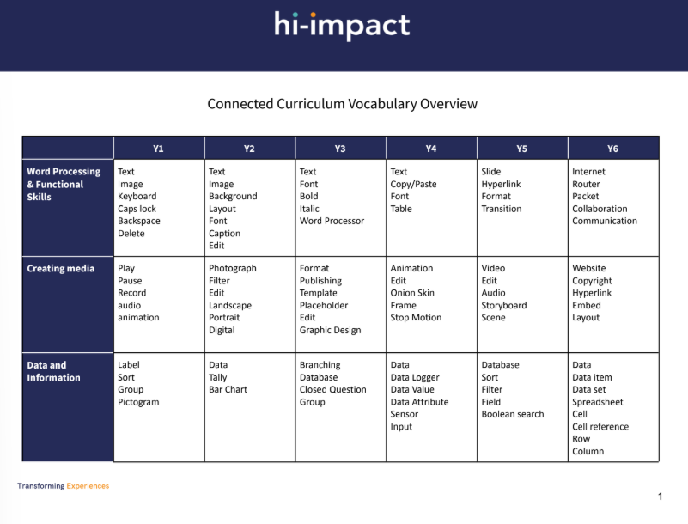

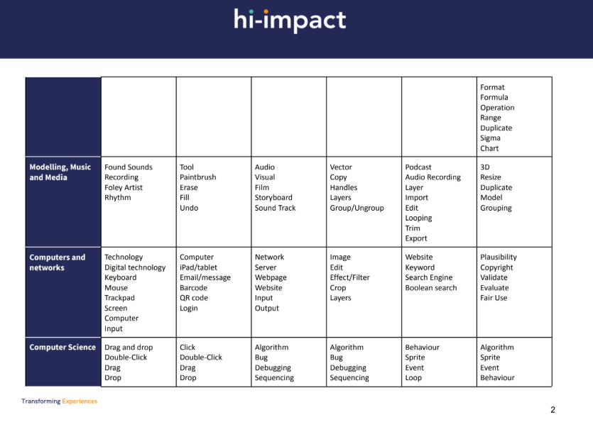
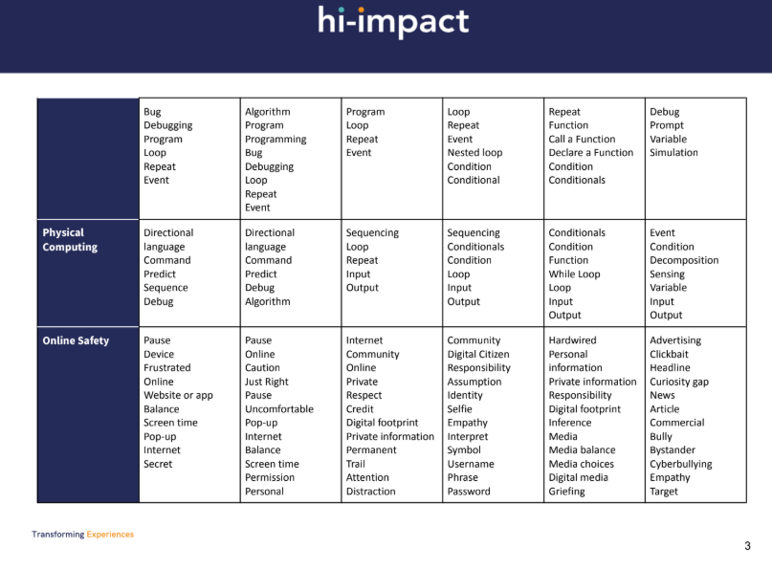
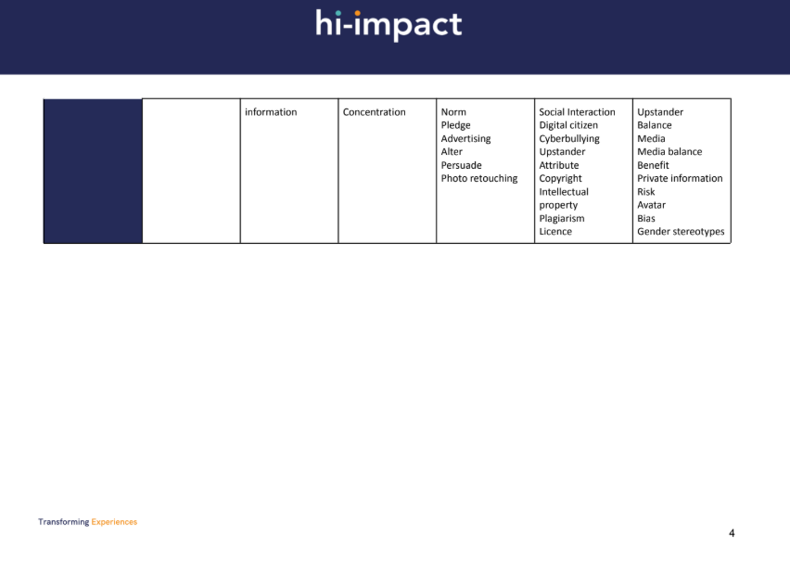
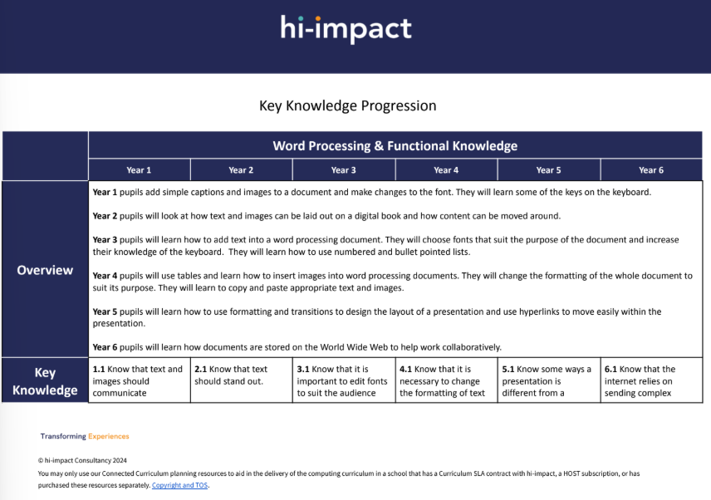
Key Knowledge Progression:

