Year 5/6 Science: Earth and Space
The statutory requirements are that children are taught to:
• describe the movement of the Earth, and other planets, relative to the Sun in the solar system
• describe the movement of the Moon relative to the Earth
• describe the Sun, Earth and Moon as approximately spherical bodies
• use the idea of the Earth’s rotation to explain day and night and the apparent movement of the sun across the sky.
As a ‘hook’ into learning, why not create a model solar system? Styrofoam balls have been used here, but children can be resourceful and present it how they like. Maybe they could use balloons, different pieces of fruit or different sized spherical objects.
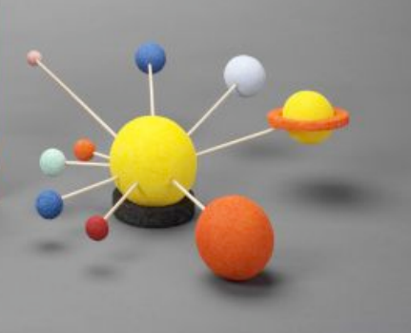
Q: Can they recognize the planets without their names? Q: Why are the planets different colours? What can we learn about planets from their appearance? What could aliens tell about Earth?
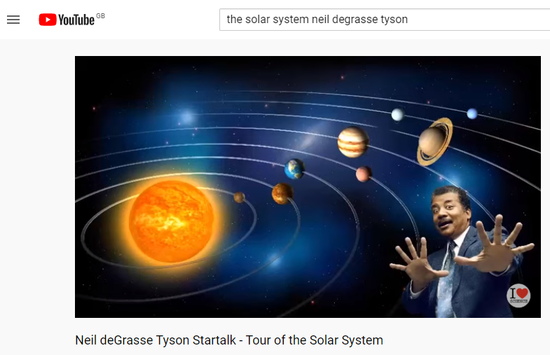
Alternatively, you could do this at the end of the topic to assess their learning

There are also, so many good podcasts, videos, and lectures on Youtube by top scientists like Neil DeGrasse Tyson, Bill Nye and Brian Greene.

Earth and Space
The planets
Our Solar System formed about 4.6 billion years ago from a large cloud of gas and dust called a nebula. At the centre is our closest star, the Sun. Orbiting around the Sun are eight planets. In order from the closest to the Sun they are: Mercury, Venus, Earth, Mars, Jupiter, Saturn, Uranus and Neptune The planets can be placed into two distinct groups. The four planets closest to the Sun are small and rocky and are often referred to as the inner, or terrestrial, planets (Figure 1). The outer four planets are much larger and very cold. These are the giant planets (Figure 2). Jupiter and Saturn are known as the gas giants. Uranus and Neptune are referred to as the ice giants.
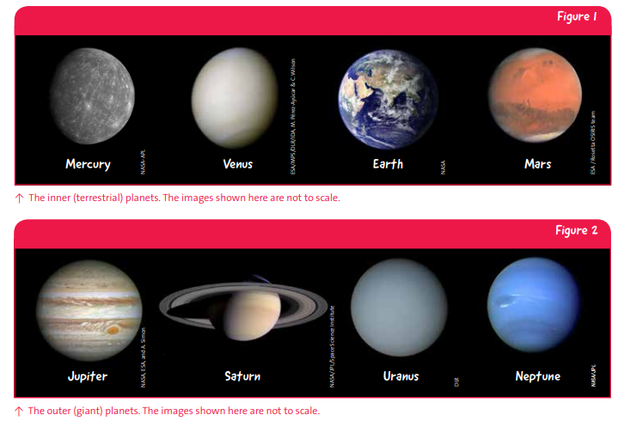
Rings
All of the giant planets have rings. The most spectacular are Saturn’s rings which are the largest in the Solar System (Figure 2). Saturn’s rings are made up of billions of small pieces of water ice with traces of rocky material. These pieces range in size from micrometres* to metres across. As the rings are mostly made of ice they reflect the Sun’s light and are therefore bright and easy to observe. * Micrometre: A micrometre, or micron, is a tiny fraction of a metre (1 millionth of a metre). If 1 meter was equal to the length of one football field (~100 metres), 1 micrometre would be about the width of a human hair.
The rings around Jupiter, Uranus and Neptune are much smaller, darker and fainter than the rings around Saturn. They are also made of very different material. The rings of Jupiter and Neptune contain a lot of tiny dust particles. The rings of Uranus consist of larger material, typically around 20 centimetres to 20 metres across. The darkest ring systems are around Uranus and Neptune. The very dark colour of these rings is due to the kind of material they are made of.

Moons
As well as the planets, there are many smaller objects in the Solar System. The most well known group of small objects are moons. A moon is an object that orbits a planet and accompanies the planet on its own orbit around the Sun. Not all planets have a moon. Everyone is familiar with Earth’s Moon that is clearly visible in the sky. The other planets with moons are Mars, Jupiter, Saturn, Uranus and Neptune. Some moons are large and spherical like Earth’s Moon, such as the four largest moons of Jupiter (the Galilean moons – Io, Europa, Ganymede and Callisto; see Figure 3). These moons are thought to have formed alongside their parent planets. Many other moons, such as the two moons of Mars (Phobos and Deimos), are smaller and have a more irregular shape. Smaller moons, like those of Mars, are thought to be asteroids which were ‘captured’ by the planet at a later time (Figure 3).
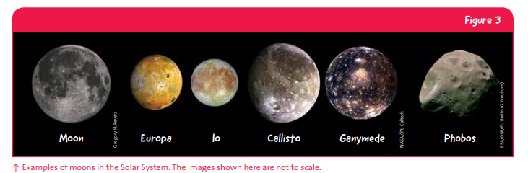

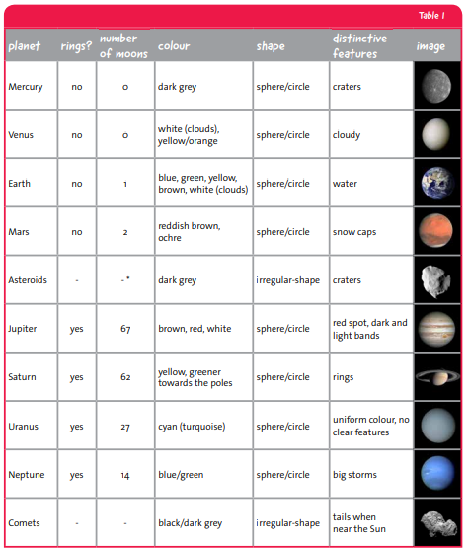
The order of the planets – Mnemonics, a fun way to remember the order of the planets is to come up with a rhyme using the first letters of the planet names. Have a go at coming up with your own mnemonic. Here is an example.
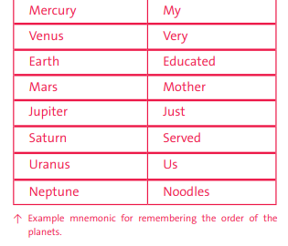
Task 1
1. Colour (or write down the colours) in the circles in the correct colour for each planet or object.
2. Add rings to the planets that have them.
3. Write down how many moons each planet has.
4. Show any other special features. The Earth has been completed for you.
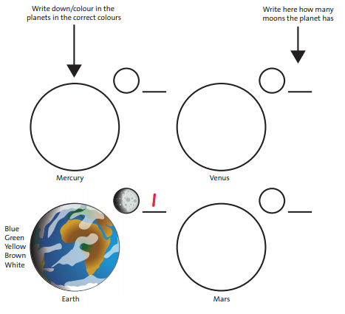

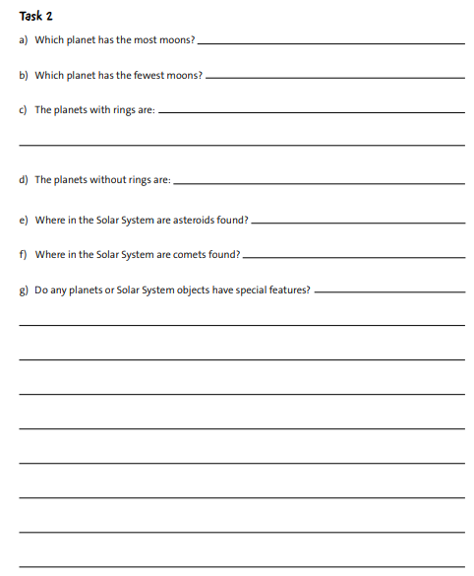

Task 3
Write down the names of the planets and other Solar System objects in the spaces provided.
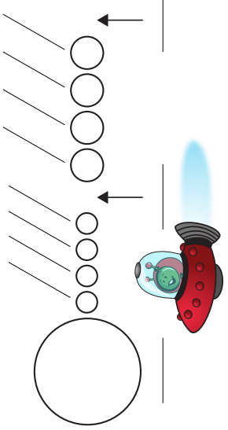

Task 4
Using this video clip and the diagram below have a go at creating a diagram to represent the phases of the moon using biscuits of your choice. Oreos work really well.
On the 14th April the Wirral began the third quarter of the moon’s phase. See if you can observe and record the missing dates for the next new moon and the date of the next first quarter.
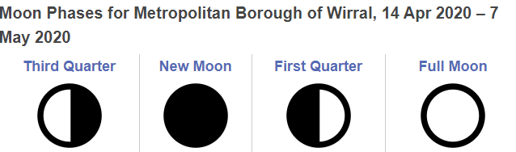
14th April |  |  | 7th May

https://nasaeclips.arc.nasa.gov/video/ourworld/our-world-moon-phases

