KS1 – Christianity

Enquiry questions: Why do Christians celebrate the Pentecost? How does celebrating Pentecost remind Christians that God is with them always?

- Watch this video.

https://www.youtube.com/watch?v=_rjQ_XDPIis&safe=true

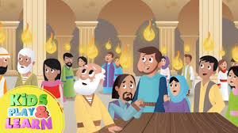
Can you create a story board with the key events in the clip?

- Research the Pentecost festival.
Design and make a Pentecost Festival banner using symbols and appropriate colours.

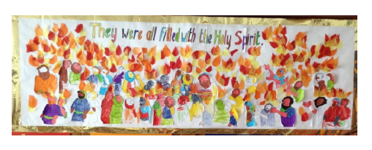

- Read the Ascension story from a children’s bible.
https://www.twinkl.co.uk/resource/t-re-535-ks1-ascension-day-information-powerpoint

Use feelings faces help the children to consider how people were feeling.
Create a feeling board for different parts of the story.

