20 Books to Read
Before you Leave Y2
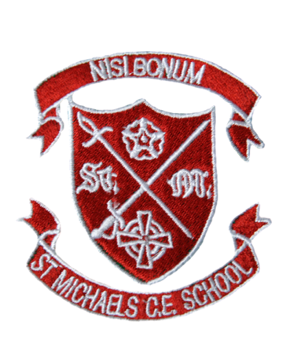
Here’s a list of books to try and read in Year 2. Your challenge is to try and read half of them before the end of the year (if you’ve already read them, you can tick them off, but they don’t count towards this year!)
The first row are books you may read as part of your curriculum, so please only read them when your teacher gives them to you or after the term it is used! The other 3 rows are a mixture of genres, themes and classic or modern stories. Try to mix up your choices and then post a review on your class’s reading blog. Every half term the best reviews will win a prize!

Guided Reading | The Dark at the Top of the Stairs  by Sam McBratney | A Squash and a Squeeze  by Julia Donaldson | The Owl Who Was Afraid of the Dark by Jill Tomlinson | Mousehole Cat  by Antonia Barber | The Enormous Crocodile  by Roald Dahl
Guided Reading | 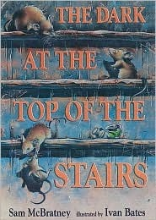 | 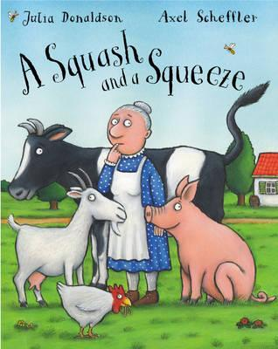 | 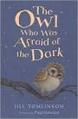 | 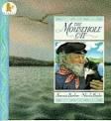 | 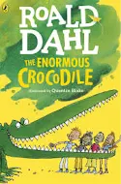
Guided Reading | I Read/Read to Me: | I Read/Read to Me: | I Read/Read to Me: | I Read/Read to Me: | I Read/Read to Me:
Free Choice | The Day the Crayons Quit  by Oliver Jeffers | The Snail and the Whale  by Julia Donaldson | Alien’s Love Underpants  by Claire Freedman | The Tiger Who Came to Tea  By Judith Kerr | Avocado Baby  By John Burningham
Free Choice | 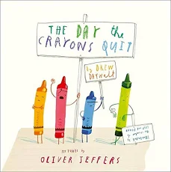 | 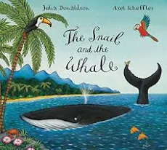 | 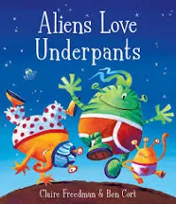 | 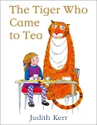 | 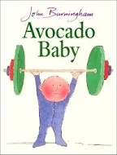
Free Choice | I Read/Read to Me: | I read/Read to me: | I Read/Read to me: | I Read/Read to me: | I Read/Read to me:
Free Choice |  |  |  | PSHE | Science Animals inc. Humans
Free Choice | The Wind in the Willows (Kenneth Greene) Ladybird Classic - Joan Collins | The Name Jar  By Yangsook Choi | Traction Man  By Mini Grey | If You Give a Mouse a Cookie  By Laura Numeroff | Oliver Twist  By Charles Dickens
Free Choice | 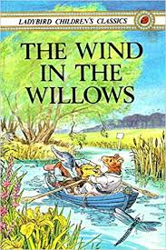 | 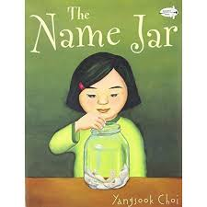 | 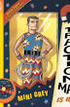 |  | 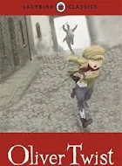
Free Choice | I Read/Read to me: | I Read/Read to me: | I Read/Read to me: | I Read/Read to me: | I Read/Read to me:
Free Choice |  | Stories from Other Cultures |  |  | Victorians Autumn Term 2
Free Choice | Princess Smartypants  By Babette Cole | Amazing Grace  By Mary Hoffman | Fantastic Mr Fox  By Roald Dahl | I was a Rat  By Phillip Pullman | Nim’s Island  By Wendy Orr
Free Choice | 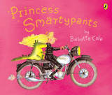 |  | 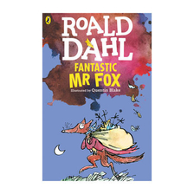 | 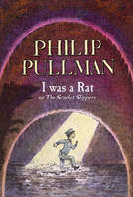 | 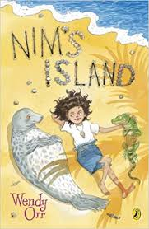
Free Choice | I Read/Read to me: | I Read/Read to me: | I Read/Read to me: | I Read/Read to me: | I Read/Read to me:

