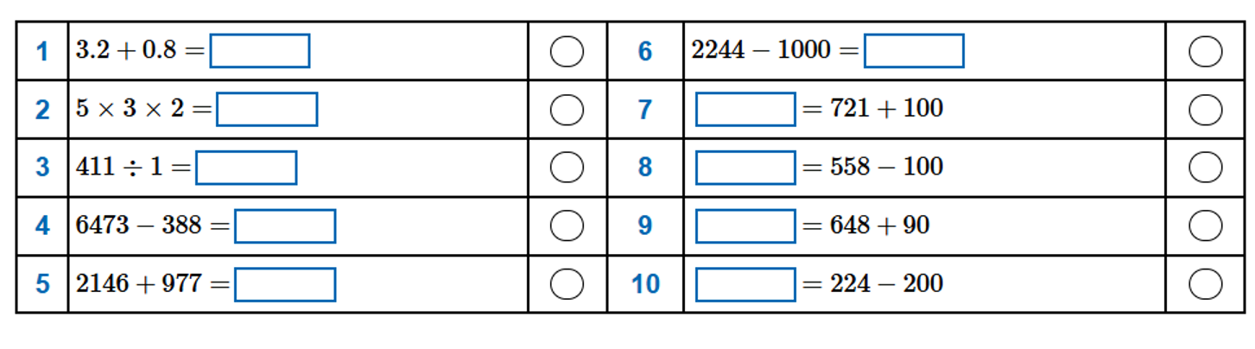
Remember to keep practicing your times tables on Times Tables Rock Star as well!

