|  |  |  |  |  |  |  |
| --- | --- | --- | --- | --- | --- | --- |
| Marvellous Me! | | | | | | |
| Term | Autumn 1 | | | Number of Weeks: | | 5 |
| **Objectives** | | | | Outcomes | | |
| **Week** | **Subject Area** | | | **Your child will:** | | |
| **1** | **UTW & PSED**   * What does your family look like? * To show an awareness of different families. To talk about own family and compare with others. | | | Book – The family book by Todd Parr   * Draw a picture of their family and label with adult scribing. | | |
| **2** | **UTW**   * Identify the significant individuals in your life * To recognise simple feelings. To identify people who help/support them. | | | **Owl Babies by Martin Waddell**   * Draw a picture of a special person with caption “My special person is…”. | | |
| **3** | **UTW**   * How have I changed? * To develop self-confidence, recognising their own achievements. To talk about past and present in their own lives. | | | Once There Were Giants by Martin Waddell   * To sequence personal photos (baby, toddler, now) into a simple timeline with labels. | | |
| **4** | **PSED & EA&D**   * What makes me special? * To develop self-awareness, recognising own strengths. To create a self-portrait using media and materials. | | | * Elmer by David McKee * To paint/create a self-portrait with the caption “I am special because…”. | | |
| **5** | **PSED & UTW**   * What makes other people special? * To learn to respect and celebrate others. To recognise similarities/differences between people. | | | * Something Else by Kathryn Cave * To share with a partner something special about themselves and their friend. We will make a class display. | | |
| **Key Vocabulary** | | | | **End products** | | |
| Family Special  Different Same  Love Care  Friend Grow  Change Unique  Respect | |  | | * Family portraits * “My Special Person” class book * Personal life timelines * Self-portraits with “I am special because…” * Class “We are all special” Friendship display | | |
| **Links to our School Values** | | | | **Links to British Values** | | |
| Communication  Compassion  Honesty  Resilience | | | | * Individual liberty * Rule of Law * Mutual respect & tolerance | | |
| Cross Curricular Opportunities | | | Enhancements | | Misconceptions | |
|  | | |  | |  | |
| Literacy, C&L | | |  | |  | |

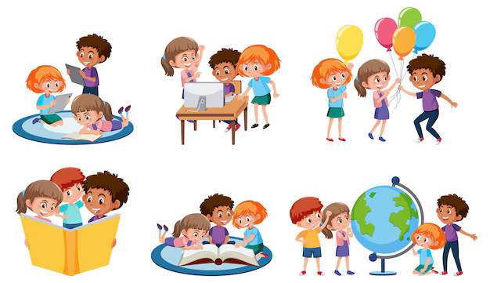**Our Learning Journey through the Topic**

Week 1: What does your family look like?

Week 2: Identify the significant individuals in your life.

Week 3: How have I changed?

Week 4: What makes me special?

Week 5: What makes other people special?

**Marvellous Me!**