Around the World
Week 5
Forest: Make a bug house

Week 4
What would be a good house for a minibeast?

Week 3
What are houses like in different continents?
Week 2
What are the different types of weather?
Week 1
What are the 7 continents?
What is the climate like on each continent?
Our Learning Journey through the Topic

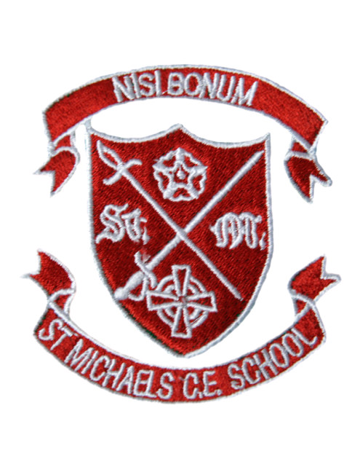
Around the World
Term |  |  | Autumn 1 | Number of Weeks: | 6
Objectives |  |  |  | Outcomes
Week | Subject |  |  | Your child will:
1 | Geography  - Use a range of sources such as simple maps, globes, atlases and images to compare hot and cold countries  - Know that symbols mean something on maps.  - Describe some similarities and differences when studying places and features e.g. hot and cold places of the world. |  |  | - Use a map to locate the 7 continents  - Locate the equator on map  - Identify different climates in each continent – eg hot/cold
2 | Geography/Science  - Observe and describe daily weather patterns. |  |  | - Identify different types of weather
3 | Design Technology  - Use pictures and words to convey what they want to design / make.  - Select pictures to help develop ideas. |  |  | - Research types of houses around the world.  - Will design a house for a child from a chosen country.  - Explain the reason for their choice of design.
4 | Design Technology  - Use pictures and words to convey what they want to design / make.  - Select pictures to help develop ideas. |  |  | - Explore house suitable for different mini beasts  - Use their knowledge of houses and materials to design a bug house
5 | DT  - Use mock-ups e.g. recycled material trial models to try out their ideas.  - Select materials from a limited range.  - Explain what they are making.  - Name the tools they are using.  - Explore existing products and investigate how they have been made.  - Talk about their design as they develop and identify good and bad points.  - Say what they like and do not like about items they have made and attempt to say why.  - Start to use technical vocabulary  - Join materials in a variety of ways (year 1 and 2).  - Decorate using a variety of techniques. (1&2)  - Know some ways of making structures stronger.  - Show how to stiffen some materials.  - Know how to make a simple structure more stable.  - Say what they like and do not like about items they have made and attempt to say why. |  |  | - Will visit the forest and use found materials to create a bug house  - Explain to the class their choices and which bug it would be suitable for.
 | Key Vocabulary |  |  | End Products
 | - Continent  - Hot and cold  - Temperature  - Weather  - Seasons  - Structure  - Secure | - Material  - Appropriate  - Waterproof  - Rigid  - Transparent  - Types of houses- Teepee, Igloo, Cabin, Brick house, Villa, Hut, Stilted house, Yurt etc |  | - A map of the world highlighting hot and cold countries  - A detailed house design with reasoning.  - A model of the house they have designed.  - An evaluation of their model.
 | Links to our School Values |  |  | Links to British Values
 | Compassion – Children will be evaluating each other’s work.  Resilient – As the children will be using different materials to build their house, they will build resilience e.g. if part of the house falls or the material is not suitable.  To try your best- As the children will be using a range of materials to design and create their houses, they will be encouraged to try their best, which will benefit the group. |  |  | - Being part of Britain – Comparison of Polynesia, China and Lapland. What does it mean to be British?  Tolerance of those of different faiths and beliefs – Discussion of the main religion in South Africa – enhancement day Black History Month
 | Cross Curricular Opportunities |  |  | Enhancements
 | English-  Twisted Tales  The Three Little Wolves and the Big Bad Pig  Labels and Captions  Maths-  Weight of the Materials- Heavy and Light  3D shapes  Measuring length and height  Science  Explore different seasons |  |  | Forest School  Mini-beast hunt  Little wolf house  Bug houses

