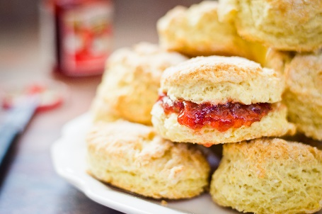
Baking
In these challenging times, it’s a great idea to take some time out to relax and BAKE!
On Friday the whole country celebrated VE day. Research what people would have ate in their street parties 75 years ago, how does it compared to what we have today?
Then with your adult, make one of the recipes you have found. Will it be a yummy pie or a delicious jam filled cake?

PE
Keep fit, active and bust a move during this time away from school!
Your keeping moving challenge if you chose to accept it is…

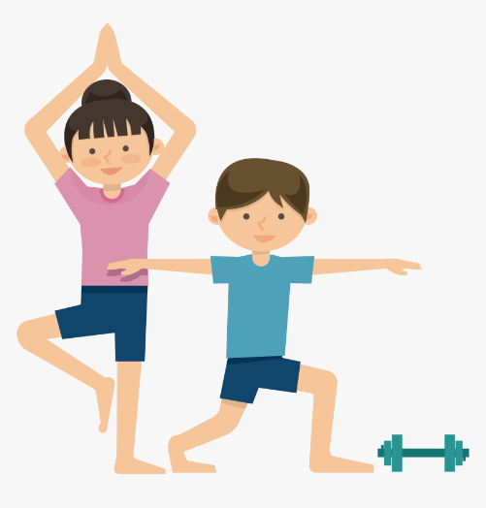
- Can you train like your favourite footballer using the videos from the premier league
to perfect your training skills? https://plprimarystars.com/resources/train-like-a-footballer
Keep it challenging, invent your own training circuit.
Can you get your adult to complete all of the skills?

- Follow the Disney dance along, can you master the footwork and wiggling
like seaweed? Your challenge is after trying the dances from Disney, pick
your favourite Disney song and choreograph a dance and then teach your
dance to your family members. https://www.youtube.com/playlist?list=PLblqtunh34T0RaoTyPoQDtPLov5_tAcMx

Science
Living things and their habitats
Look outside what living animals can you see from your window? Make a list of ever living thing you can identify. Can you put these things into categories?
Pick one from your list and create a fact file all about your chosen living thing. Make sure you include; name, species, habitat and any interesting facts about your living thing.
