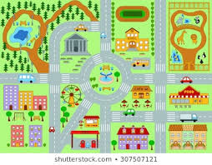
Did you know?
Spain is home to numerous impressive churches and cathedrals. There are over 4,000 places of worship in Spain.
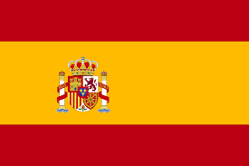
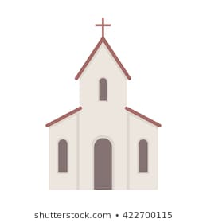
la oficina de correos (post office)
el mercado (market)
el parque (park)
el restaurante (restaurant)
la iglesia (church)
la panadería (bakery)

Important Vocabulary
¿Dónde está? Está + directions (Where is…?)
¿Qué hay …….? (What is there..?)
a la derecha (on the right)
a la izquierda (on the left)
todo recto (straight on)
¿Dónde está? (Where is it?)

Year 5 Knowledge Organiser Spring Term Spanish
During the Spring Term, Year 5 children will read and create simple sentences about places in a town. They will create a dialogue with a partner, focusing on their pronunciation of new Spanish vocabulary. During the second part of the term, they will do some descriptive work, looking at some examples of Spanish art and describing a scene.

