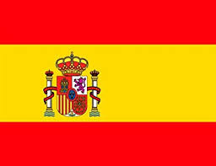
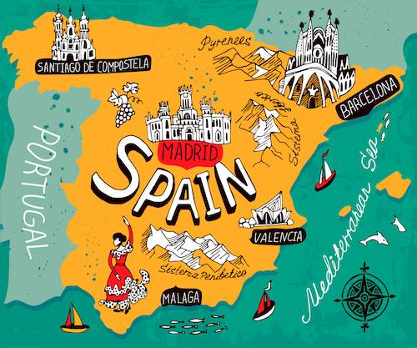
Numbers 1-20
1= uno
2 = dos
3 = tres
4 = cuatro
5 = cinco
6 = seis
7 = siete
8 = ocho
9 = nueve
10 = diez
11 = once
12 = doce
13= trece
14 = catorce
15 = quince
16 = dieciséis
17 = dieciseite
18 = dieciocho 30= treinta
19 = diecinueve 40= cuarenta
20 = veinte 50= cincuenta
Classroom Commands:
escucha, escuchad (Listen)
mira, mirad, (Look)
siéntate, sentaos, (Sit down)
levántate, levantaos (Stand up)
During the Autumn Term, Year 3 children will discuss where Spanish is spoken and will great each other in Spanish. They will learn to count up to at least 50, say their age and understand simple classroom commands.
Did you know?
- The Spanish name for Spain is España
- Spain is located in Europe
- It is a developed country with a high quality of life
- The largest city and capital of Spain is Madrid
Year 3 Knowledge Organiser Autumn Term
Spanish
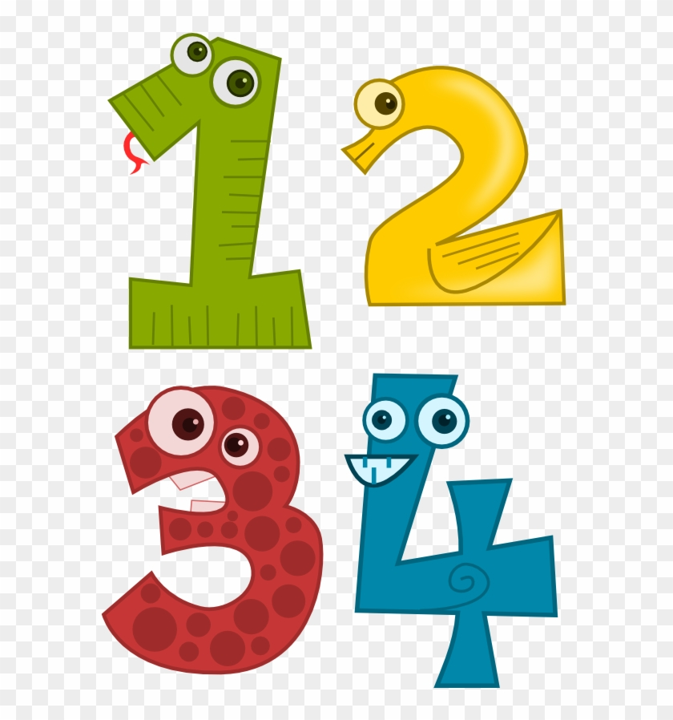
Important Vocabulary
- Hola; adiós; hasta luego
- ¡Buenos días! ¡Buenas tardes! ¡Buenas noches! (Greetings)
- ¿Cómo te llamas? (What is your name?) Me llamo ….
- ¿Qué tal? (How are you?) Bien, muy bien, regular, mal, fatal, fenomenal

