Los meses del año (months of the year)
enero (January)
febrero (February)
marzo (March)
abril (April)
mayo (May)
junio (June)
julio (July)
agosto
septiembre
octubre
noviembre
diciembre

Year 2 Knowledge Organiser Autumn Term Spanish
During this term, Year 2 children will revise numbers up to 20, then will learn numbers up to 31. They will be able to say the date and month of their birthday and will read a birthday story. They will focus on trying to improve their pronunciation of new vocabulary.
21-vientiuno
22-vientidos
23-vientitres
24-vienticuatro
25-vienticinco
26-vientiséis
27-vientisiete
28-vientiocho
29-veintinueve
30-treinta
31-treinta y uno

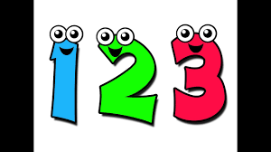
¿Cuándo es tu cumpleaños?
(When is your birthday?)
Mi cumpleaños es en marzo.
(My birthday is in March)


Did you know?
Spain is a popular country to visit. It has beautiful cities, interesting countryside with mountains, beaches and a warm climate in summer.

